Drug List Application Assessment

For Argus Health

By Hengtian Software Ltd.

06/25/2013

Revision History

|  |  |  |  |  |
| --- | --- | --- | --- | --- |
| Version | Comment | Revised By | Approved By | Date |
| 1.0 | Corporate reviewed | Shmily | Wells | 2013/6/28 |

Table of Contents

1. Executive Summary 4

2. Drug List Code Analysis 5

3. Drug List Performance Assessment 7

3.1 Performance Issue Investigation 8

3.1.1 Investigation Methodology 8

Environment Setup 8

3.1.2 Issue Categorization 8

3.1.3 Data Transfer 9

3.1.4 Complex data table rendering 13

3.1.5 No backend interaction 21

3.1.6 Unnecessary SQL execution 27

3.1.7 Misc 34

3.2. Summary of Recommendations 41

Appendix A DurgList Issues 04/10 version 42

# 

# 1. Executive Summary

The Drug List application is a JSF/Primefaces application that was recently modernized as a straight port from an existing Argus Flex application. During Argus’s internal UAT release, several performance issues occurred which impacted the overall delivery of the project. In order to secure the final delivery, Hengtian’s team was asked to assist in the resolution of these performance issues. This document provides an overall assessment of the initial development quality for the Drug List application including the code and performance quality and to document Hengtian’s findings and recommendations for the root cause and solutions to resolve the issues.

Code analysis was conducted by the Hengtian team with objectives to locate potential issues on security, performance, system maintainability and if software engineering best practices are followed. Findings included potential security flaw like SQL Injection; maintenance risk like not following Argus implementation standards, poor JSF/Primefaces implementation, unnecessary EJB invocation ...etc.

In total, 50 performance issues were discovered which categorized into high/medium/low as shown in the Appendix A. Hengtian finished fixing all the top priority issues and provided the technical suggestions to avoid the future repetition of these issues.

# 2. Drug List Code Analysis

A team of 3 engineers led by the senior software architect has participated in the Drug List Code analysis. The team spent 3 days preparing for the code analysis. The planning session was first started with outlining the objectives and defining the scope with benchmarks. Objectives were clearly defined to:

* Identify the potential security flaw
* Determine the root cause of performance issues
* Review the structure of source code against best practices

Following benchmarks were being adopted to classify findings into different category of severity. This provided better decision support in prioritization for future correction.

* Top severity issues included: Security flaw, Poor JSF/Primefaces coding which causes performance issue, Not standard way to implement functions ...etc.
* Medium severity issues included: Unnecessary EJB invocation, inefficient SQL usage, failed unit testing ...etc.
* Low severity issues included: Not fixed checkstyle and findbugs issues ...etc.

Execution of the source code analysis were automated with tools like FindBugs and CheckStyles. Each of the tools scanned the source codes with different objectives. FindBugs provided a full picture of malicious codes, like potential backdoor, safe multi-threading etc., whereas CheckStyles was used to validate coding style consistency and improper coding convention comparing to common practices.

Following table consists of the results generated by the code analysis tools and were reviewed by the team, then categorized into different degree of severity.

Table Static Code Analysis Result

|  |  |  |  |  |  |
| --- | --- | --- | --- | --- | --- |
| **Application** | **Category** | **Severity** | | | **Total** |
| **High** | **Mid** | **Low** |
| druglist-ejb | checkstyle | 36 | 602 | 1907 | 2545 |
| findbugs | 23 | 21 | 0 | 44 |
| druglist-web | checkstyle | 37 | 214 | 1538 | 1789 |
| findbugs | 2 | 1 | 0 | 3 |

# 3. Drug List Performance Assessment

Because of the nature of the browser rendering technologies, the Flex applications usually has better performance (shorter response time… etc) than the JSF/Primefaces applications in most scenarios. This is also reflected from the UAT testing results which, however, are far from the acceptable criteria. Appendix A shows the performance issues reported by UAT team and the tuning results. The Hangzhou team was mainly focused on these examples of performance issues to

1) Determine the root causes of the performance issues as they relate to:

* Technology stack
* Data retrieve related
* Front end coding
* Business design

2) Find out the best approaches to:

* Optimize database performance
* Optimize network performance
* Improve front end coding
* Unify (or standardize) page design

The following chapters are the high-level issue analysis for all the performance issues.

## 3.1 Performance Issue Investigation

### 3.1.1 Investigation Methodology

Upon the request of the resolution of the Performance issues, Hangzhou team organized a small group dedicated for the problem resolving. With the guidance of the local Arch team the group took following sequential steps in the investigation:

1. Local recreation of the issues.
2. Scenario analysis of each issue.
3. Categorization of the issues by the root causes.
4. Difference analysis between Flex and JSF technologies, DrugList and other JSF applications.
5. Proposal of the solutions to these issues.
6. Solution verification by the testing against the issues.

### Environment Setup

Each issue was recreated in the local environment; the team was using local Glassfish as the testing server connecting to the remote database with high network latency. **So the server execution time will be much greater than the time reported on UAT environment, but it should be comparable between the applications before and after tuning under the same condition.**

The ZDEV DO2/DO3 was used as the environment to verify the solutions, which is similar with the UAT environment. The server execution time should be very close to the UAT environment, but the time spent on data [transmission](app:ds:transmission) from US to China will be longer.

### 3.1.2 Issue Categorization

The issues listed in Appendix A can be categorized by the following groups by its cause and symptom,

Table 2 Issue Category

|  |  |  |  |
| --- | --- | --- | --- |
| **No.** | **Category** | **Description** | **Cause** |
| **1** | Data transfer | The data transferring is slower and impacts the application performance | Lack of control of resource files transferred by HTTP |
| **2** | Complex data table rendering | The complicated data table rendering is slower than Flex application. Once the page has such kind of table, the response time will be longer. | The screen design is more like Flex style, which affects the performance in JSF. |
| **3** | No backend interaction | Some operations will be much faster using pure frontend technology. | Lack of controls of the page behaviors with the considerations of system performance. |
| **4** | Unnecessary SQL execution | Backend invocation will increase the response time significantly. Some operation doesn't need backend invocation. | Lack of controls on SQL queries and backend invocation at code level. |
| **5** | Unnecessary update areas for JSF | JSF needs developer to control precisely on the update areas for each operation in order to avoid unnecessary server and browser burden. Misuse of update in the code will affect performance a lot. | Lack of control on the update in JSF at code level. |

The following chapter describes the analysis on the issue categorization and the approaches to solve them. Note: c2 and c5 are in the same chapter.

### 3.1.3 Data Transfer

**Symptom Analysis**

While analyzing the request in HttpWatch, it indicates that the resource files were not well cached in IE upon the first http request, which causes data transfer overhead to create redundant resource files like Javascript, CSS, image ...etc.

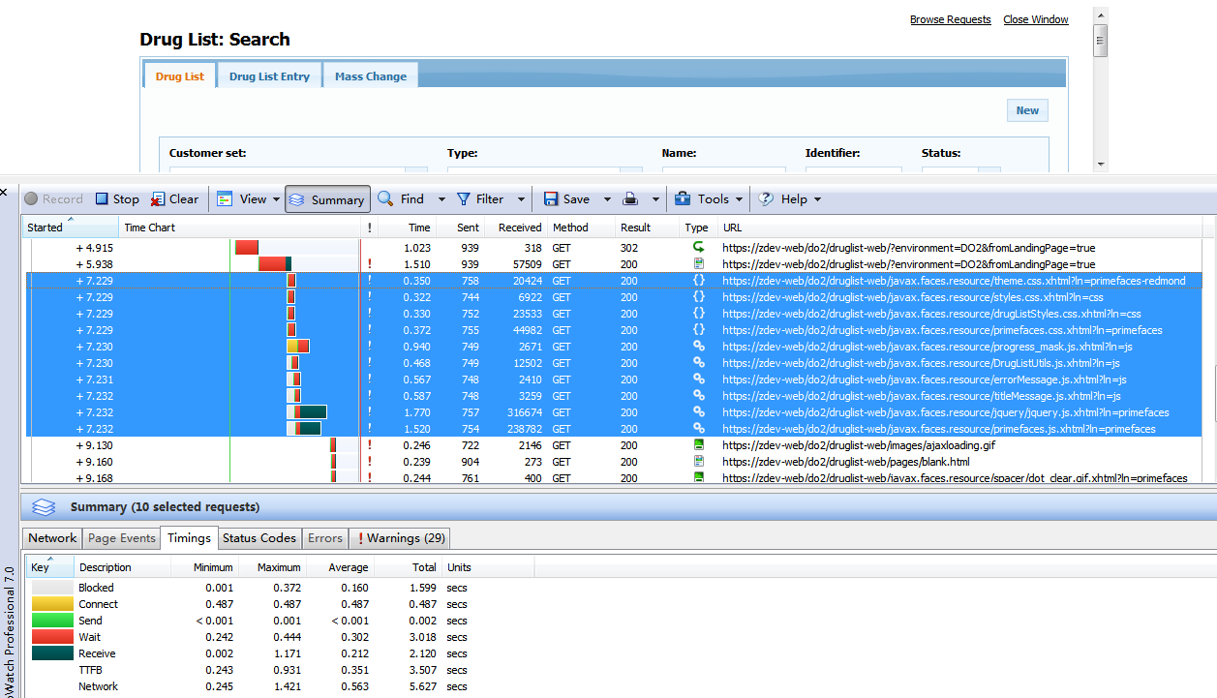

Figure 1 Http Traffic for a Common Request

As shown in above figure, the files highlighted are requested every time when the user browses this page, which causes additional response time for the client, which could be a problem.

**Technical Analysis**

It is known that the mechanism for the browser to retrieve resource files is that the browser will allocate socket and create the connection to the server for each resource file. Usually the best practice on this is to combine the resource files as much as possible so that it can save the browser’s resources and allocation time. It is very common to improve enterprise application’s performance like this.

**Solutions and Verification**

In the team’s investigation, almost every issue is more or less related to this issue. Therefore it can be solved by

1. Reducing the number of the created socket connections
2. Minimizing the volume of the transferred data
3. Reduce the necessity of the data transferring by caching mechanism

In the implementation of the solution, the team combined the same type of resource files into one file so that the number of the socket connections are reduced and that the browser’s resouces can be saved. In the meanwhile the team compressed the Javascript and CSS with OmniFaces – a utility project for JSF – thus the transferred data can be minimized.

Below is the quick verification of the resource file optimization:

***Before tuning***, the time to load CSS and JS files when first login to Drug List. The home page of Drug List has a total number of 10 CSS and JS files, so there are 10 requests to the server for these files.



Figure 2 Http Traffic for Druglist Before Tuning

Below is the table for the detail time spend,

Table 4 Waiting and Receiving Time Before Tuning

|  |  |  |  |
| --- | --- | --- | --- |
|  | **Waiting** | **Receive** | **Total** |
| 1 | 2.865 | 2.005 | 4.87 |
| 2 | 3.715 | 2.689 | 6.404 |
| 3 | 2.788 | 2.712 | 5.5 |
| 4 | 2.64 | 2.217 | 4.857 |
| 5 | 3.801 | 2.493 | 6.294 |
| 6 | 2.746 | 2.511 | 5.257 |
| 7 | 3.034 | 2.754 | 5.788 |
| 8 | 2.994 | 3.142 | 6.136 |
| 9 | 2.785 | 1.763 | 4.548 |
| 10 | 2.702 | 2.272 | 4.974 |
| AVG | 3.007 | 2.4558 | 5.4628 |

***After tuning,*** the time to load CSS and JS files with resource combination when first login to Drug List. All JS files are combined to one JS file, whereas all CSS files are combined to one CSS file. So there are just two requests for JS and CSS resource files.

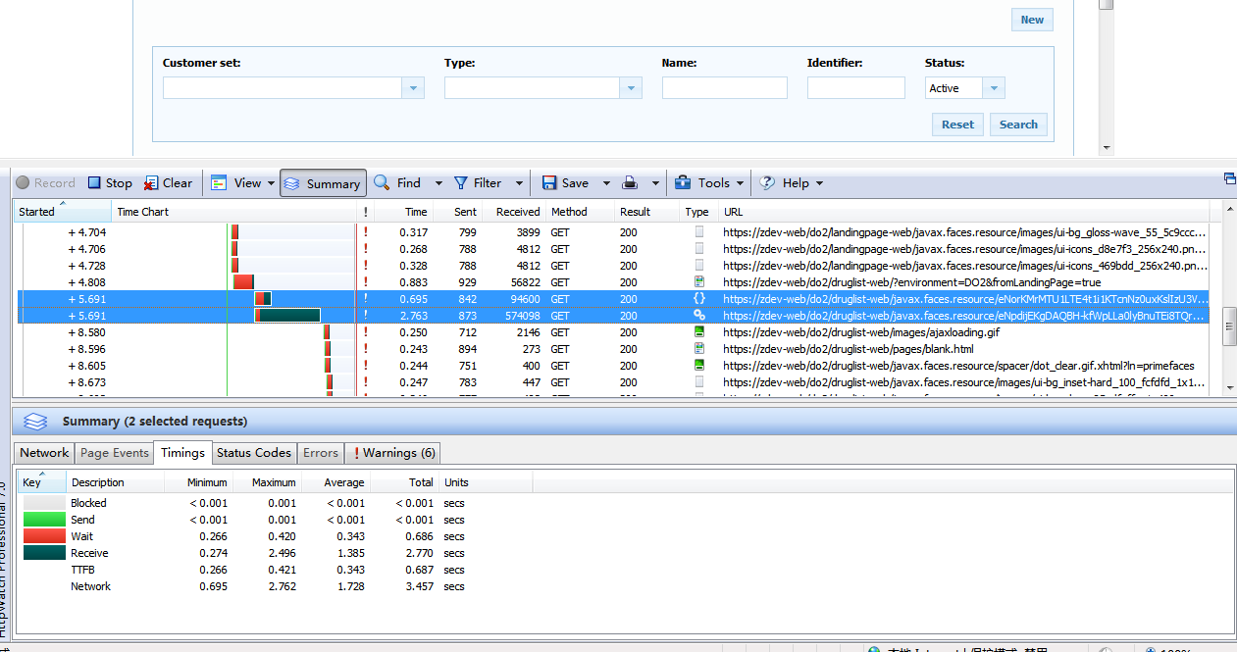

Figure 3 Http Traffic for Druglist After Tuning

Below is the table for the detail time spend,

Table 5 Waiting and Receiving Time After Tuning

|  |  |  |  |
| --- | --- | --- | --- |
|  | Waiting | Receive | Total |
| 1 | 0.64 | 2.884 | 3.524 |
| 2 | 0.64 | 2.916 | 3.556 |
| 3 | 0.762 | 2.702 | 3.464 |
| 4 | 0.63 | 3.136 | 3.766 |
| 5 | 0.603 | 3.125 | 3.728 |
| 6 | 0.66 | 2.657 | 3.317 |
| 7 | 0.674 | 2.709 | 3.383 |
| 8 | 0.703 | 2.672 | 3.375 |
| 9 | 0.648 | 2.676 | 3.324 |
| 10 | 0.686 | 2.77 | 3.456 |
| AVG | 0.665,  reduced by 78% | 2.8247 | 3.4893,  reduced by 36.2% |

### 3.1.4 Complex data table rendering

**Symptom Analysis**

It was observed that some issues in the issue list are related to the retrieve of large amounts of data and display it in the data table on the page, the performance gap between Flex and JSF application is very large for these issues.

The team took in-depth root cause analysis on these issues.

***Issue #6 Analysis:***

Selecting a list with approximately 1,300 entries in JSF with comparison to the time the page opens with the entries displaying in

|  |  |
| --- | --- |
| Flex Application: | JSF Application: |
| Figure 4 HttpWatch for Selecting List Operation in Flex | Figure 5 HttpWatch for Selecting List Operation in JSF |

As shown in Figure 4 and 5, it takes 12.5 seconds for the Flex application to display the data table, but 27 seconds for the JSF application in HttpWatch, and 28 seconds in stopwatch to render about 20 rows in the data table. A log was put in FacesServlet to record time cost on the backend, which shows 16.48 seconds on the backend.It means more than 11 seconds were spent on data transfer and page rendering (since the Glassfish server is in the local environment, the data transfer time can be ignored).

To understand the performance impact due to the number of records on the browser, the team did an experiment. The figure below shows if the records were reduced to 1, then 14 seconds are for the backend and only 5.5 seconds are for the page rendering, which is dramatically reduced. It indicates that the performance gap between Flex and JSF application is on the front end, since JSF is much slower in rendering a large amount of data on the data table.

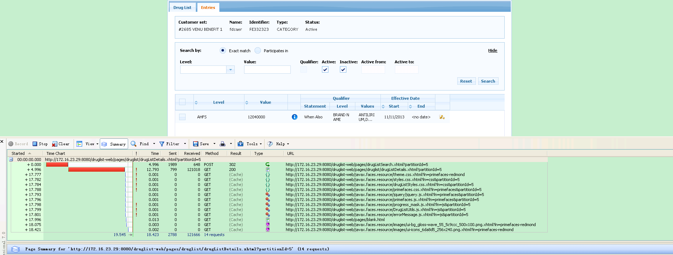

Figure 6 Response Time after Reducing Record Number

**Tech Stack Analysis**

It is known that Flex front end component is pre-complied into a Flash file which is loaded at the first time the user enters the page, the snapshot below is the page when Flash is loaded into the page.

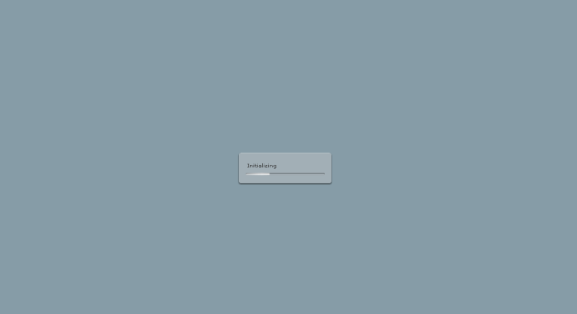

Figure 7 Flex Loading

So every time Flex renders the page, it uses native component, which is very fast. Also the data returned from the server is pure XML data (shown below) which is as minimal as to display on the page.

<ns1:Result xmlns:ns1=*"http://datatype.client.processing.argushealth.com"*><ns1:errors /><ns1:numPages>1</ns1:numPages><ns1:responseObject xmlns:ns2=*"http://druglist.argushealth.com"* xmlns:ns3=*"http://www.w3.org/2001/XMLSchema-instance"* ns3:type=*"ns2:ArrayOfEntry"*><ns2:Entry><ns2:dateRange><ns2:beginDate><ns2:errorCodeList /><ns2:value>04/10/2013</ns2:value></ns2:beginDate><ns2:endDate><ns2:errorCodeList /><ns2:value>12/31/9999</ns2:value></ns2:endDate><ns2:errorCodeList /></ns2:dateRange><ns2:drugListId>335</ns2:drugListId><ns2:drugListType><ns2:id>2</ns2:id><ns2:errorCodeList /><ns2:indicatorRequired>false</ns2:indicatorRequired><ns2:internal>false</ns2:internal><ns2:model>CAT</ns2:model><ns2:name>CATEGORY</ns2:name></ns2:drugListType><ns2:entryId>365407</ns2:entryId><ns2:internal>false</ns2:internal><ns2:levelAssociatedDrugListId xmlns:ns4=*"http://www.w3.org/2001/XMLSchema-instance"* ns4:nil=*"true"* /><ns2:levelType><ns2:booleanOnlyLevelValue>false</ns2:booleanOnlyLevelValue><ns2:id>8</ns2:id><ns2:errorCodeList /><ns2:model></ns2:model><ns2:name>AHFS</ns2:name></ns2:levelType><ns2:levelValue><ns2:description xmlns:ns4=*"http://www.w3.org/2001/XMLSchema-instance"* ns4:nil=*"true"* /><ns2:errorCodeList /><ns2:value>040408</ns2:value></ns2:levelValue><ns2:maintenanceInformation><ns2:lastMntTs>04/12/2013 03:38:36 PM</ns2:lastMntTs><ns2:lastMntId>CHARLES</ns2:lastMntId></ns2:maintenanceInformation><ns2:priority xmlns:ns4=*"http://www.w3.org/2001/XMLSchema-instance"* ns4:nil=*"true"* /><ns2:qualifierConditionCode xmlns:ns4=*"http://www.w3.org/2001/XMLSchema-instance"* ns4:nil=*"true"* /><ns2:qualifierType xmlns:ns4=*"http://www.w3.org/2001/XMLSchema-instance"* ns4:nil=*"true"* /><ns2:version>2013-04-12 15:38:36.125</ns2:version><ns2:drugList xmlns:ns4=*"http://www.w3.org/2001/XMLSchema-instance"* ns4:nil=*"true"* /><ns2:errorCodeList /><ns2:levelAssociatedDrugList xmlns:ns4=*"http://www.w3.org/2001/XMLSchema-instance"* ns4:nil=*"true"* /><ns2:maintenanceTrackingEventId>650515</ns2:maintenanceTrackingEventId><ns2:qualifierValues /><ns2:trackingId xmlns:ns4=*"http://www.w3.org/2001/XMLSchema-instance"* ns4:nil=*"true"* /><ns2:trackingNotes xmlns:ns4=*"http://www.w3.org/2001/XMLSchema-instance"* ns4:nil=*"true"* /><ns2:trackingReason xmlns:ns4=*"http://www.w3.org/2001/XMLSchema-instance"* ns4:nil=*"true"* /></ns2:Entry><ns2:Entry><ns2:dateRange><ns2:beginDate><ns2:errorCodeList /><ns2:value>04/08/2013</ns2:value></ns2:beginDate><ns2:endDate><ns2:errorCodeList /><ns2:value>12/31/9999</ns2:value></ns2:endDate><ns2:errorCodeList /></ns2:dateRange><ns2:drugListId>335</ns2:drugListId><ns2:drugListType><ns2:id>2</ns2:id><ns2:errorCodeList /><ns2:indicatorRequired>false</ns2:indicatorRequired><ns2:internal>false</ns2:internal><ns2:model>CAT</ns2:model><ns2:name>CATEGORY</ns2:name></ns2:drugListType><ns2:entryId>365408</ns2:entryId><ns2:internal>false</ns2:internal><ns2:levelAssociatedDrugListId xmlns:ns4=*"http://www.w3.org/2001/XMLSchema-instance"* ns4:nil=*"true"* /><ns2:levelType><ns2:booleanOnlyLevelValue>false</ns2:booleanOnlyLevelValue><ns2:id>8</ns2:id><ns2:errorCodeList /><ns2:model></ns2:model><ns2:name>AHFS</ns2:name></ns2:levelType><ns2:levelValue><ns2:description xmlns:ns4=*"http://www.w3.org/2001/XMLSchema-instance"* ns4:nil=*"true"* /><ns2:errorCodeList /><ns2:value>040420</ns2:value></ns2:levelValue><ns2:maintenanceInformation><ns2:lastMntTs>04/12/2013 03:39:18 PM</ns2:lastMntTs><ns2:lastMntId>CHARLES</ns2:lastMntId></ns2:maintenanceInformation><ns2:priority xmlns:ns4=*"http://www.w3.org/2001/XMLSchema-instance"* ns4:nil=*"true"* /><ns2:qualifierConditionCode xmlns:ns4=*"http://www.w3.org/2001/XMLSchema-instance"* ns4:nil=*"true"* /><ns2:qualifierType xmlns:ns4=*"http://www.w3.org/2001/XMLSchema-instance"* ns4:nil=*"true"* /><ns2:version>2013-04-12 15:39:18.765</ns2:version><ns2:drugList xmlns:ns4=*"http://www.w3.org/2001/XMLSchema-instance"* ns4:nil=*"true"* /><ns2:errorCodeList /><ns2:levelAssociatedDrugList xmlns:ns4=*"http://www.w3.org/2001/XMLSchema-instance"* ns4:nil=*"true"* /><ns2:maintenanceTrackingEventId>650516</ns2:maintenanceTrackingEventId><ns2:qualifierValues /><ns2:trackingId xmlns:ns4=*"http://www.w3.org/2001/XMLSchema-instance"* ns4:nil=*"true"* /><ns2:trackingNotes xmlns:ns4=*"http://www.w3.org/2001/XMLSchema-instance"* ns4:nil=*"true"* /><ns2:trackingReason xmlns:ns4=*"http://www.w3.org/2001/XMLSchema-instance"* ns4:nil=*"true"* /></ns2:Entry><ns2:Entry><ns2:dateRange><ns2:beginDate><ns2:errorCodeList /><ns2:value>04/11/2013</ns2:value></ns2:beginDate><ns2:endDate><ns2:errorCodeList /><ns2:value>12/31/9999</ns2:value></ns2:endDate><ns2:errorCodeList /></ns2:dateRange><ns2:drugListId>335</ns2:drugListId><ns2:drugListType><ns2:id>2</ns2:id><ns2:errorCodeList /><ns2:indicatorRequired>false</ns2:indicatorRequired><ns2:internal>false</ns2:internal><ns2:model>CAT</ns2:model><ns2:name>CATEGORY</ns2:name></ns2:drugListType><ns2:entryId>365409</ns2:entryId><ns2:internal>false</ns2:internal><ns2:levelAssociatedDrugListId xmlns:ns4=*"http://www.w3.org/2001/XMLSchema-instance"* ns4:nil=*"true"* /><ns2:levelType><ns2:booleanOnlyLevelValue>false</ns2:booleanOnlyLevelValue><ns2:id>8</ns2:id><ns2:errorCodeList /><ns2:model></ns2:model><ns2:name>AHFS</ns2:name></ns2:levelType><ns2:levelValue><ns2:description xmlns:ns4=*"http://www.w3.org/2001/XMLSchema-instance"* ns4:nil=*"true"* /><ns2:errorCodeList /><ns2:value>081207</ns2:value></ns2:levelValue><ns2:maintenanceInformation><ns2:lastMntTs>04/12/2013 03:40:10 PM</ns2:lastMntTs><ns2:lastMntId>CHARLES</ns2:lastMntId></ns2:maintenanceInformation><ns2:priority xmlns:ns4=*"http://www.w3.org/2001/XMLSchema-instance"* ns4:nil=*"true"* /><ns2:qualifierConditionCode xmlns:ns4=*"http://www.w3.org/2001/XMLSchema-instance"* ns4:nil=*"true"* /><ns2:qualifierType xmlns:ns4=*"http://www.w3.org/2001/XMLSchema-instance"* ns4:nil=*"true"* /><ns2:version>2013-04-12 15:40:10.942</ns2:version><ns2:drugList xmlns:ns4=*"http://www.w3.org/2001/XMLSchema-instance"* ns4:nil=*"true"* /><ns2:errorCodeList /><ns2:levelAssociatedDrugList xmlns:ns4=*"http://www.w3.org/2001/XMLSchema-instance"* ns4:nil=*"true"* /><ns2:maintenanceTrackingEventId>650517</ns2:maintenanceTrackingEventId><ns2:qualifierValues /><ns2:trackingId xmlns:ns4=*"http://www.w3.org/2001/XMLSchema-instance"* ns4:nil=*"true"* /><ns2:trackingNotes xmlns:ns4=*"http://www.w3.org/2001/XMLSchema-instance"* ns4:nil=*"true"* /><ns2:trackingReason xmlns:ns4=*"http://www.w3.org/2001/XMLSchema-instance"* ns4:nil=*"true"* /></ns2:Entry><ns2:Entry><ns2:dateRange><ns2:beginDate><ns2:errorCodeList /><ns2:value>04/09/2013</ns2:value></ns2:beginDate><ns2:endDate><ns2:errorCodeList /><ns2:value>12/31/9999</ns2:value></ns2:endDate><ns2:errorCodeList /></ns2:dateRange><ns2:drugListId>335</ns2:drugListId><ns2:drugListType><ns2:id>2</ns2:id><ns2:errorCodeList /><ns2:indicatorRequired>false</ns2:indicatorRequired><ns2:internal>false</ns2:internal><ns2:model>CAT</ns2:model><ns2:name>CATEGORY</ns2:name></ns2:drugListType><ns2:entryId>365410</ns2:entryId><ns2:internal>false</ns2:internal><ns2:levelAssociatedDrugListId xmlns:ns4=*"http://www.w3.org/2001/XMLSchema-instance"* ns4:nil=*"true"* /><ns2:levelType><ns2:booleanOnlyLevelValue>false</ns2:booleanOnlyLevelValue><ns2:id>8</ns2:id><ns2:errorCodeList /><ns2:model></ns2:model><ns2:name>AHFS</ns2:name></ns2:levelType><ns2:levelValue><ns2:description xmlns:ns4=*"http://www.w3.org/2001/XMLSchema-instance"* ns4:nil=*"true"* /><ns2:errorCodeList /><ns2:value>081208</ns2:value></ns2:levelValue><ns2:maintenanceInformation><ns2:lastMntTs>04/12/2013 03:40:32 PM</ns2:lastMntTs><ns2:lastMntId>CHARLES</ns2:lastMntId></ns2:maintenanceInformation><ns2:priority xmlns:ns4=*"http://www.w3.org/2001/XMLSchema-instance"* ns4:nil=*"true"* /><ns2:qualifierConditionCode xmlns:ns4=*"http://www.w3.org/2001/XMLSchema-instance"* ns4:nil=*"true"* /><ns2:qualifierType xmlns:ns4=*"http://www.w3.org/2001/XMLSchema-instance"* ns4:nil=*"true"* /><ns2:version>2013-04-12 15:40:32.453</ns2:version><ns2:drugList xmlns:ns4=*"http://www.w3.org/2001/XMLSchema-instance"* ns4:nil=*"true"* /><ns2:errorCodeList /><ns2:levelAssociatedDrugList xmlns:ns4=*"http://www.w3.org/2001/XMLSchema-instance"* ns4:nil=*"true"* /><ns2:maintenanceTrackingEventId>650518</ns2:maintenanceTrackingEventId><ns2:qualifierValues />

2000

<ns2:trackingId xmlns:ns4=*"http://www.w3.org/2001/XMLSchema-instance"* ns4:nil=*"true"* /><ns2:trackingNotes xmlns:ns4=*"http://www.w3.org/2001/XMLSchema-instance"* ns4:nil=*"true"* /><ns2:trackingReason xmlns:ns4=*"http://www.w3.org/2001/XMLSchema-instance"* ns4:nil=*"true"* /></ns2:Entry><ns2:Entry><ns2:dateRange><ns2:beginDate><ns2:errorCodeList /><ns2:value>04/15/2013</ns2:value></ns2:beginDate><ns2:endDate><ns2:errorCodeList /><ns2:value>12/31/9999</ns2:value></ns2:endDate><ns2:errorCodeList /></ns2:dateRange><ns2:drugListId>335</ns2:drugListId><ns2:drugListType><ns2:id>2</ns2:id><ns2:errorCodeList /><ns2:indicatorRequired>false</ns2:indicatorRequired><ns2:internal>false</ns2:internal><ns2:model>CAT</ns2:model><ns2:name>CATEGORY</ns2:name></ns2:drugListType><ns2:entryId>365411</ns2:entryId><ns2:internal>false</ns2:internal><ns2:levelAssociatedDrugListId xmlns:ns4=*"http://www.w3.org/2001/XMLSchema-instance"* ns4:nil=*"true"* /><ns2:levelType><ns2:booleanOnlyLevelValue>false</ns2:booleanOnlyLevelValue><ns2:id>8</ns2:id><ns2:errorCodeList /><ns2:model></ns2:model><ns2:name>AHFS</ns2:name></ns2:levelType><ns2:levelValue><ns2:description xmlns:ns4=*"http://www.w3.org/2001/XMLSchema-instance"* ns4:nil=*"true"* /><ns2:errorCodeList /><ns2:value>081212</ns2:value></ns2:levelValue><ns2:maintenanceInformation><ns2:lastMntTs>04/12/2013 03:40:43 PM</ns2:lastMntTs><ns2:lastMntId>CHARLES</ns2:lastMntId></ns2:maintenanceInformation><ns2:priority xmlns:ns4=*"http://www.w3.org/2001/XMLSchema-instance"* ns4:nil=*"true"* /><ns2:qualifierConditionCode xmlns:ns4=*"http://www.w3.org/2001/XMLSchema-instance"* ns4:nil=*"true"* /><ns2:qualifierType xmlns:ns4=*"http://www.w3.org/2001/XMLSchema-instance"* ns4:nil=*"true"* /><ns2:version>2013-04-12 15:40:43.767</ns2:version><ns2:drugList xmlns:ns4=*"http://www.w3.org/2001/XMLSchema-instance"* ns4:nil=*"true"* /><ns2:errorCodeList /><ns2:levelAssociatedDrugList xmlns:ns4=*"http://www.w3.org/2001/XMLSchema-instance"* ns4:nil=*"true"* /><ns2:maintenanceTrackingEventId>650519</ns2:maintenanceTrackingEventId><ns2:qualifierValues /><ns2:trackingId xmlns:ns4=*"http://www.w3.org/2001/XMLSchema-instance"* ns4:nil=*"true"* /><ns2:trackingNotes xmlns:ns4=*"http://www.w3.org/2001/XMLSchema-instance"* ns4:nil=*"true"* /><ns2:trackingReason xmlns:ns4=*"http://www.w3.org/2001/XMLSchema-instance"* ns4:nil=*"true"* /></ns2:Entry><ns2:Entry><ns2:dateRange><ns2:beginDate><ns2:errorCodeList /><ns2:value>04/09/2013</ns2:value></ns2:beginDate><ns2:endDate><ns2:errorCodeList /><ns2:value>12/31/9999</ns2:value></ns2:endDate><ns2:errorCodeList /></ns2:dateRange><ns2:drugListId>335</ns2:drugListId><ns2:drugListType><ns2:id>2</ns2:id><ns2:errorCodeList /><ns2:indicatorRequired>false</ns2:indicatorRequired><ns2:internal>false</ns2:internal><ns2:model>CAT</ns2:model><ns2:name>CATEGORY</ns2:name></ns2:drugListType><ns2:entryId>365412</ns2:entryId><ns2:internal>false</ns2:internal><ns2:levelAssociatedDrugListId xmlns:ns4=*"http://www.w3.org/2001/XMLSchema-instance"* ns4:nil=*"true"* /><ns2:levelType><ns2:booleanOnlyLevelValue>false</ns2:booleanOnlyLevelValue><ns2:id>8</ns2:id><ns2:errorCodeList /><ns2:model></ns2:model><ns2:name>AHFS</ns2:name></ns2:levelType><ns2:levelValue><ns2:description xmlns:ns4=*"http://www.w3.org/2001/XMLSchema-instance"* ns4:nil=*"true"* /><ns2:errorCodeList /><ns2:value>081216</ns2:value></ns2:levelValue><ns2:maintenanceInformation><ns2:lastMntTs>04/12/2013 03:40:58 PM</ns2:lastMntTs><ns2:lastMntId>CHARLES</ns2:lastMntId></ns2:maintenanceInformation><ns2:priority xmlns:ns4=*"http://www.w3.org/2001/XMLSchema-instance"* ns4:nil=*"true"* /><ns2:qualifierConditionCode xmlns:ns4=*"http://www.w3.org/2001/XMLSchema-instance"* ns4:nil=*"true"* /><ns2:qualifierType xmlns:ns4=*"http://www.w3.org/2001/XMLSchema-instance"* ns4:nil=*"true"* /><ns2:version>2013-04-12 15:40:58.01</ns2:version><ns2:drugList xmlns:ns4=*"http://www.w3.org/2001/XMLSchema-instance"* ns4:nil=*"true"* /><ns2:errorCodeList /><ns2:levelAssociatedDrugList xmlns:ns4=*"http://www.w3.org/2001/XMLSchema-instance"* ns4:nil=*"true"* /><ns2:maintenanceTrackingEventId>650520</ns2:maintenanceTrackingEventId><ns2:qualifierValues /><ns2:trackingId xmlns:ns4=*"http://www.w3.org/2001/XMLSchema-instance"* ns4:nil=*"true"* /><ns2:trackingNotes xmlns:ns4=*"http://www.w3.org/2001/XMLSchema-instance"* ns4:nil=*"true"* /><ns2:trackingReason xmlns:ns4=*"http://www.w3.org/2001/XMLSchema-instance"* ns4:nil=*"true"* /></ns2:Entry><ns2:Entry><ns2:dateRange><ns2:beginDate><ns2:errorCodeList /><ns2:value>04/16/2013</ns2:value></ns2:beginDate><ns2:endDate><ns2:errorCodeList /><ns2:value>12/31/9999</ns2:value></ns2:endDate><ns2:errorCodeList /></ns2:dateRange><ns2:drugListId>335</ns2:drugListId><ns2:drugListType><ns2:id>2</ns2:id><ns2:errorCodeList /><ns2:indicatorRequired>false</ns2:indicatorRequired><ns2:internal>false</ns2:internal><ns2:model>CAT</ns2:model><ns2:name>CATEGORY</ns2:name></ns2:drugListType><ns2:entryId>365413</ns2:entryId><ns2:internal>false</ns2:internal><ns2:levelAssociatedDrugListId xmlns:ns4=*"http://www.w3.org/2001/XMLSchema-instance"* ns4:nil=*"true"* /><ns2:levelType><ns2:booleanOnlyLevelValue>false</ns2:booleanOnlyLevelValue><ns2:id>8</ns2:id><ns2:errorCodeList /><ns2:model></ns2:model><ns2:name>AHFS</ns2:name></ns2:levelType><ns2:levelValue><ns2:description xmlns:ns4=*"http://www.w3.org/2001/XMLSchema-instance"* ns4:nil=*"true"* /><ns2:errorCodeList /><ns2:value>081220</ns2:value></ns2:levelValue><ns2:maintenanceInformation><ns2:lastMntTs>04/12/2013 03:41:14 PM</ns2:lastMntTs><ns2:lastMntId>CHARLES</ns2:lastMntId></ns2:maintenanceInformation><ns2:priority xmlns:ns4=*"http://www.w3.org/2001/XMLSchema-instance"* ns4:nil=*"true"* /><ns2:qualifierConditionCode xmlns:ns4=*"http://www.w3.org/2001/XMLSchema-instance"* ns4:nil=*"true"* /><ns2:qualifierType xmlns:ns4=*"http://www.w3.org/2001/XMLSchema-instance"* ns4:nil=*"true"* /><ns2:version>2013-04-12 15:41:14.942</ns2:version><ns2:drugList xmlns:ns4=*"http://www.w3.org/2001/XMLSchema-instance"* ns4:nil=*"true"* /><ns2:errorCodeList /><ns2:levelAssociatedDrugList xmlns:ns4=*"http://www.w3.org/2001/XMLSchema-instance"* ns4:nil=*"true"* /><ns2:maintenanceTrackingEventId>650521</ns2:maintenanceTrackingEventId><ns2:qualifierValues /><ns2:trackingId xmlns:ns4=*"http://www.w3.org/2001/XMLSchema-instance"* ns4:nil=*"true"* /><ns2:trackingNotes xmlns:ns4=*"http://www.w3.org/2001/XMLSchema-instance"* ns4:nil=*"true"* /><ns2:trackingReason xmlns:ns4=*"http://www.w3.org/2001/XMLSchema-instance"* ns4:nil=*"true"* /></ns2:Entry><ns2:Entry><ns2:dateRange><ns2:beginDate><ns2:errorCodeList /><ns2:value>04/11/2013</ns2:value></ns2:beginDate><ns2:endDate><ns2:errorCodeList /><ns2:value>12/31/9999</ns2:value></ns2:endDate><ns2:errorCodeList /></ns2:dateRange><ns2:drugListId>335</ns2:drugListId><ns2:drugListType><ns2:id>2</ns2:id><ns2:errorCodeList /><ns2:indicatorRequired>false</ns2:indicatorRequired><ns2:internal>false</ns2:internal><ns2:model>CAT</ns2:model><ns2:name>CATEGORY</ns2:name></ns2:drugListType><ns2:entryId>365414</ns2:entryId><ns2:internal>false</ns2:internal><ns2:levelAssociatedDrugListId xmlns:ns4=*"http://www.w3.org/2001/XMLSchema-instance"* ns4:nil=*"true"* /><ns2:levelType><ns2:booleanOnlyLevelValue>false</ns2:booleanOnlyLevelValue><ns2:id>8</ns2:id><ns2:errorCodeList /><ns2:model></ns2:model><ns2:name>AHFS</ns2:name></ns2:levelType><ns2:levelValue><ns2:description xmlns:ns4=*"http://www.w3.org/2001/XMLSchema-instance"* ns4:nil=*"true"* /><ns2:errorCodeList /><ns2:value>081224</ns2:value></ns2:levelValue><ns2:maintenanceInformation><ns2:lastMntTs>04/12/2013 03:42:08 PM</ns2:lastMntTs><ns2:lastMntId>CHARLES</ns2:lastMntId></ns2:maintenanceInformation><ns2:priority xmlns:ns4=*"http://www.w3.org/2001/XMLSchema-instance"* ns4:nil=*"true"* /><ns2:qualifierConditionCode xmlns:ns4=*"http://www.w3.org/2001/XMLSchema-instance"* ns4:nil=*"true"* /><ns2:qualifierType xmlns:ns4=*"http://www.w3.org/2001/XMLSchema-instance"* ns4:nil=*"true"* /><ns2:version>2013-04-12 15:42:08.601</ns2:version><ns2:drugList xmlns:ns4=*"http://www.w3.org/2001/XMLSchema-instance"* ns4:nil=*"true"* /><ns2:errorCodeList /><ns2:levelAssociatedDrugList xmlns:ns4=*"http://www.w3.org/2001/XMLSchema-instance"* ns4:nil=*"true"* /><ns2:maintenanceTrackingEventId>650522</ns2:maintenanceTrackingEventId><ns2:qua

2000

lifierValues /><ns2:trackingId xmlns:ns4=*"http://www.w3.org/2001/XMLSchema-instance"* ns4:nil=*"true"* /><ns2:trackingNotes xmlns:ns4=*"http://www.w3.org/2001/XMLSchema-instance"* ns4:nil=*"true"* /><ns2:trackingReason xmlns:ns4=*"http://www.w3.org/2001/XMLSchema-instance"* ns4:nil=*"true"* /></ns2:Entry><ns2:Entry><ns2:dateRange><ns2:beginDate><ns2:errorCodeList /><ns2:value>04/11/2013</ns2:value></ns2:beginDate><ns2:endDate><ns2:errorCodeList /><ns2:value>12/31/9999</ns2:value></ns2:endDate><ns2:errorCodeList /></ns2:dateRange><ns2:drugListId>335</ns2:drugListId><ns2:drugListType><ns2:id>2</ns2:id><ns2:errorCodeList /><ns2:indicatorRequired>false</ns2:indicatorRequired><ns2:internal>false</ns2:internal><ns2:model>CAT</ns2:model><ns2:name>CATEGORY</ns2:name></ns2:drugListType><ns2:entryId>365415</ns2:entryId><ns2:internal>false</ns2:internal><ns2:levelAssociatedDrugListId xmlns:ns4=*"http://www.w3.org/2001/XMLSchema-instance"* ns4:nil=*"true"* /><ns2:levelType><ns2:booleanOnlyLevelValue>false</ns2:booleanOnlyLevelValue><ns2:id>8</ns2:id><ns2:errorCodeList /><ns2:model></ns2:model><ns2:name>AHFS</ns2:name></ns2:levelType><ns2:levelValue><ns2:description xmlns:ns4=*"http://www.w3.org/2001/XMLSchema-instance"* ns4:nil=*"true"* /><ns2:errorCodeList /><ns2:value>081228</ns2:value></ns2:levelValue><ns2:maintenanceInformation><ns2:lastMntTs>04/12/2013 03:42:39 PM</ns2:lastMntTs><ns2:lastMntId>CHARLES</ns2:lastMntId></ns2:maintenanceInformation><ns2:priority xmlns:ns4=*"http://www.w3.org/2001/XMLSchema-instance"* ns4:nil=*"true"* /><ns2:qualifierConditionCode xmlns:ns4=*"http://www.w3.org/2001/XMLSchema-instance"* ns4:nil=*"true"* /><ns2:qualifierType xmlns:ns4=*"http://www.w3.org/2001/XMLSchema-instance"* ns4:nil=*"true"* /><ns2:version>2013-04-12 15:42:39.849</ns2:version><ns2:drugList xmlns:ns4=*"http://www.w3.org/2001/XMLSchema-instance"* ns4:nil=*"true"* /><ns2:errorCodeList /><ns2:levelAssociatedDrugList xmlns:ns4=*"http://www.w3.org/2001/XMLSchema-instance"* ns4:nil=*"true"* /><ns2:maintenanceTrackingEventId>650523</ns2:maintenanceTrackingEventId><ns2:qualifierValues /><ns2:trackingId xmlns:ns4=*"http://www.w3.org/2001/XMLSchema-instance"* ns4:nil=*"true"* /><ns2:trackingNotes xmlns:ns4=*"http://www.w3.org/2001/XMLSchema-instance"* ns4:nil=*"true"* /><ns2:trackingReason xmlns:ns4=*"http://www.w3.org/2001/XMLSchema-instance"* ns4:nil=*"true"* /></ns2:Entry><ns2:Entry><ns2:dateRange><ns2:beginDate><ns2:errorCodeList /><ns2:value>04/16/2013</ns2:value></ns2:beginDate><ns2:endDate><ns2:errorCodeList /><ns2:value>12/31/9999</ns2:value></ns2:endDate><ns2:errorCodeList /></ns2:dateRange><ns2:drugListId>335</ns2:drugListId><ns2:drugListType><ns2:id>2</ns2:id><ns2:errorCodeList /><ns2:indicatorRequired>false</ns2:indicatorRequired><ns2:internal>false</ns2:internal><ns2:model>CAT</ns2:model><ns2:name>CATEGORY</ns2:name></ns2:drugListType><ns2:entryId>365416</ns2:entryId><ns2:internal>false</ns2:internal><ns2:levelAssociatedDrugListId xmlns:ns4=*"http://www.w3.org/2001/XMLSchema-instance"* ns4:nil=*"true"* /><ns2:levelType><ns2:booleanOnlyLevelValue>false</ns2:booleanOnlyLevelValue><ns2:id>8</ns2:id><ns2:errorCodeList /><ns2:model></ns2:model><ns2:name>AHFS</ns2:name></ns2:levelType><ns2:levelValue><ns2:description xmlns:ns4=*"http://www.w3.org/2001/XMLSchema-instance"* ns4:nil=*"true"* /><ns2:errorCodeList /><ns2:value>081404</ns2:value></ns2:levelValue><ns2:maintenanceInformation><ns2:lastMntTs>04/12/2013 03:42:58 PM</ns2:lastMntTs><ns2:lastMntId>CHARLES</ns2:lastMntId></ns2:maintenanceInformation><ns2:priority xmlns:ns4=*"http://www.w3.org/2001/XMLSchema-instance"* ns4:nil=*"true"* /><ns2:qualifierConditionCode xmlns:ns4=*"http://www.w3.org/2001/XMLSchema-instance"* ns4:nil=*"true"* /><ns2:qualifierType xmlns:ns4=*"http://www.w3.org/2001/XMLSchema-instance"* ns4:nil=*"true"* /><ns2:version>2013-04-12 15:42:58.05</ns2:version><ns2:drugList xmlns:ns4=*"http://www.w3.org/2001/XMLSchema-instance"* ns4:nil=*"true"* /><ns2:errorCodeList /><ns2:levelAssociatedDrugList xmlns:ns4=*"http://www.w3.org/2001/XMLSchema-instance"* ns4:nil=*"true"* /><ns2:maintenanceTrackingEventId>650524</ns2:maintenanceTrackingEventId><ns2:qualifierValues /><ns2:trackingId xmlns:ns4=*"http://www.w3.org/2001/XMLSchema-instance"* ns4:nil=*"true"* /><ns2:trackingNotes xmlns:ns4=*"http://www.w3.org/2001/XMLSchema-instance"* ns4:nil=*"true"* /><ns2:trackingReason xmlns:ns4=*"http://www.w3.org/2001/XMLSchema-instance"* ns4:nil=*"true"* /></ns2:Entry><ns2:Entry><ns2:dateRange><ns2:beginDate><ns2:errorCodeList /><ns2:value>04/15/2013</ns2:value></ns2:beginDate><ns2:endDate><ns2:errorCodeList /><ns2:value>12/31/9999</ns2:value></ns2:endDate><ns2:errorCodeList /></ns2:dateRange><ns2:drugListId>335</ns2:drugListId><ns2:drugListType><ns2:id>2</ns2:id><ns2:errorCodeList /><ns2:indicatorRequired>false</ns2:indicatorRequired><ns2:internal>false</ns2:internal><ns2:model>CAT</ns2:model><ns2:name>CATEGORY</ns2:name></ns2:drugListType><ns2:entryId>365417</ns2:entryId><ns2:internal>false</ns2:internal><ns2:levelAssociatedDrugListId xmlns:ns4=*"http://www.w3.org/2001/XMLSchema-instance"* ns4:nil=*"true"* /><ns2:levelType><ns2:booleanOnlyLevelValue>false</ns2:booleanOnlyLevelValue><ns2:id>8</ns2:id><ns2:errorCodeList /><ns2:model></ns2:model><ns2:name>AHFS</ns2:name></ns2:levelType><ns2:levelValue><ns2:description xmlns:ns4=*"http://www.w3.org/2001/XMLSchema-instance"* ns4:nil=*"true"* /><ns2:errorCodeList /><ns2:value>081408</ns2:value></ns2:levelValue><ns2:maintenanceInformation><ns2:lastMntTs>04/12/2013 03:43:25 PM</ns2:lastMntTs><ns2:lastMntId>CHARLES</ns2:lastMntId></ns2:maintenanceInformation><ns2:priority xmlns:ns4=*"http://www.w3.org/2001/XMLSchema-instance"* ns4:nil=*"true"* /><ns2:qualifierConditionCode xmlns:ns4=*"http://www.w3.org/2001/XMLSchema-instance"* ns4:nil=*"true"* /><ns2:qualifierType xmlns:ns4=*"http://www.w3.org/2001/XMLSchema-instance"* ns4:nil=*"true"* /><ns2:version>2013-04-12 15:43:25.81</ns2:version><ns2:drugList xmlns:ns4=*"http://www.w3.org/2001/XMLSchema-instance"* ns4:nil=*"true"* /><ns2:errorCodeList /><ns2:levelAssociatedDrugList xmlns:ns4=*"http://www.w3.org/2001/XMLSchema-instance"* ns4:nil=*"true"* /><ns2:maintenanceTrackingEventId>650525</ns2:maintenanceTrackingEventId><ns2:qualifierValues /><ns2:trackingId xmlns:ns4=*"http://www.w3.org/2001/XMLSchema-instance"* ns4:nil=*"true"* /><ns2:trackingNotes xmlns:ns4=*"http://www.w3.org/2001/XMLSchema-instance"* ns4:nil=*"true"* /><ns2:trackingReason xmlns:ns4=*"http://www.w3.org/2001/XMLSchema-instance"* ns4:nil=*"true"* /></ns2:Entry><ns2:Entry><ns2:dateRange><ns2:beginDate><ns2:errorCodeList /><ns2:value>04/09/2013</ns2:value></ns2:beginDate><ns2:endDate><ns2:errorCodeList /><ns2:value>12/31/9999</ns2:value></ns2:endDate><ns2:errorCodeList /></ns2:dateRange><ns2:drugListId>335</ns2:drugListId><ns2:drugListType><ns2:id>2</ns2:id><ns2:errorCodeList /><ns2:indicatorRequired>false</ns2:indicatorRequired><ns2:internal>false</ns2:internal><ns2:model>CAT</ns2:model><ns2:name>CATEGORY</ns2:name></ns2:drugListType><ns2:entryId>365418</ns2:entryId><ns2:internal>false</ns2:internal><ns2:levelAssociatedDrugListId xmlns:ns4=*"http://www.w3.org/2001/XMLSchema-instance"* ns4:nil=*"true"* /><ns2:levelType><ns2:booleanOnlyLevelValue>false</ns2:booleanOnlyLevelValue><ns2:id>8</ns2:id><ns2:errorCodeList /><ns2:model></ns2:model><ns2:name>AHFS</ns2:name></ns2:levelType><ns2:levelValue><ns2:description xmlns:ns4=*"http://www.w3.org/2001/XMLSchema-instance"* ns4:nil=*"true"* /><ns2:errorCodeList /><ns2:value>081416</ns2:value></ns2:levelValue><ns2:maintenanceInformation><ns2:lastMntTs>04/12/2013 03:43:41 PM</ns2:lastMntTs><ns2:lastMntId>CHARLES</ns2:lastMntId></ns2:maintenanceInformation><ns2:priority xmlns:ns4=*"http://www.w3.org/2001/XMLSchema-instance"* ns4:nil=*"true"* /><ns2:qualifierConditionCode xmlns:ns4=*"http://www.w3.org/2001/XMLSchema-instance"* ns4:nil=*"true"* /><ns2:qualifierType xmlns:ns4=*"http://www.w3.org/2001/XMLSchema-instance"* ns4:nil=*"true"* /><ns2:version>2013-04-12 15:43:41.024</ns2:version><ns2:drugList xmlns:ns4=*"http://www.w3.org/2001/XMLSchema-instance"* ns4:nil=*"true"* /><ns2:errorCodeList /><ns2:levelAssociatedDrugList xmlns:ns4=*"http://www.w3.org/2001/XMLSchema-instance"* ns4:nil=*"true"* /><ns2:maintenanceTrackingEventId>650526</ns2:maintenanceTrackingEv

2000

entId><ns2:qualifierValues /><ns2:trackingId xmlns:ns4=*"http://www.w3.org/2001/XMLSchema-instance"* ns4:nil=*"true"* /><ns2:trackingNotes xmlns:ns4=*"http://www.w3.org/2001/XMLSchema-instance"* ns4:nil=*"true"* /><ns2:trackingReason xmlns:ns4=*"http://www.w3.org/2001/XMLSchema-instance"* ns4:nil=*"true"* /></ns2:Entry><ns2:Entry><ns2:dateRange><ns2:beginDate><ns2:errorCodeList /><ns2:value>04/17/2013</ns2:value></ns2:beginDate><ns2:endDate><ns2:errorCodeList /><ns2:value>12/31/9999</ns2:value></ns2:endDate><ns2:errorCodeList /></ns2:dateRange><ns2:drugListId>335</ns2:drugListId><ns2:drugListType><ns2:id>2</ns2:id><ns2:errorCodeList /><ns2:indicatorRequired>false</ns2:indicatorRequired><ns2:internal>false</ns2:internal><ns2:model>CAT</ns2:model><ns2:name>CATEGORY</ns2:name></ns2:drugListType><ns2:entryId>365419</ns2:entryId><ns2:internal>false</ns2:internal><ns2:levelAssociatedDrugListId xmlns:ns4=*"http://www.w3.org/2001/XMLSchema-instance"* ns4:nil=*"true"* /><ns2:levelType><ns2:booleanOnlyLevelValue>false</ns2:booleanOnlyLevelValue><ns2:id>8</ns2:id><ns2:errorCodeList /><ns2:model></ns2:model><ns2:name>AHFS</ns2:name></ns2:levelType><ns2:levelValue><ns2:description xmlns:ns4=*"http://www.w3.org/2001/XMLSchema-instance"* ns4:nil=*"true"* /><ns2:errorCodeList /><ns2:value>081428</ns2:value></ns2:levelValue><ns2:maintenanceInformation><ns2:lastMntTs>04/12/2013 03:44:00 PM</ns2:lastMntTs><ns2:lastMntId>CHARLES</ns2:lastMntId></ns2:maintenanceInformation><ns2:priority xmlns:ns4=*"http://www.w3.org/2001/XMLSchema-instance"* ns4:nil=*"true"* /><ns2:qualifierConditionCode xmlns:ns4=*"http://www.w3.org/2001/XMLSchema-instance"* ns4:nil=*"true"* /><ns2:qualifierType xmlns:ns4=*"http://www.w3.org/2001/XMLSchema-instance"* ns4:nil=*"true"* /><ns2:version>2013-04-12 15:44:00.799</ns2:version><ns2:drugList xmlns:ns4=*"http://www.w3.org/2001/XMLSchema-instance"* ns4:nil=*"true"* /><ns2:errorCodeList /><ns2:levelAssociatedDrugList xmlns:ns4=*"http://www.w3.org/2001/XMLSchema-instance"* ns4:nil=*"true"* /><ns2:maintenanceTrackingEventId>650527</ns2:maintenanceTrackingEventId><ns2:qualifierValues /><ns2:trackingId xmlns:ns4=*"http://www.w3.org/2001/XMLSchema-instance"* ns4:nil=*"true"* /><ns2:trackingNotes xmlns:ns4=*"http://www.w3.org/2001/XMLSchema-instance"* ns4:nil=*"true"* /><ns2:trackingReason xmlns:ns4=*"http://www.w3.org/2001/XMLSchema-instance"* ns4:nil=*"true"* /></ns2:Entry><ns2:Entry><ns2:dateRange><ns2:beginDate><ns2:errorCodeList /><ns2:value>04/22/2013</ns2:value></ns2:beginDate><ns2:endDate><ns2:errorCodeList /><ns2:value>12/31/9999</ns2:value></ns2:endDate><ns2:errorCodeList /></ns2:dateRange><ns2:drugListId>335</ns2:drugListId><ns2:drugListType><ns2:id>2</ns2:id><ns2:errorCodeList /><ns2:indicatorRequired>false</ns2:indicatorRequired><ns2:internal>false</ns2:internal><ns2:model>CAT</ns2:model><ns2:name>CATEGORY</ns2:name></ns2:drugListType><ns2:entryId>365420</ns2:entryId><ns2:internal>false</ns2:internal><ns2:levelAssociatedDrugListId xmlns:ns4=*"http://www.w3.org/2001/XMLSchema-instance"* ns4:nil=*"true"* /><ns2:levelType><ns2:booleanOnlyLevelValue>false</ns2:booleanOnlyLevelValue><ns2:id>8</ns2:id><ns2:errorCodeList /><ns2:model></ns2:model><ns2:name>AHFS</ns2:name></ns2:levelType><ns2:levelValue><ns2:description xmlns:ns4=*"http://www.w3.org/2001/XMLSchema-instance"* ns4:nil=*"true"* /><ns2:errorCodeList /><ns2:value>081432</ns2:value></ns2:levelValue><ns2:maintenanceInformation><ns2:lastMntTs>04/12/2013 03:44:17 PM</ns2:lastMntTs><ns2:lastMntId>CHARLES</ns2:lastMntId></ns2:maintenanceInformation><ns2:priority xmlns:ns4=*"http://www.w3.org/2001/XMLSchema-instance"* ns4:nil=*"true"* /><ns2:qualifierConditionCode xmlns:ns4=*"http://www.w3.org/2001/XMLSchema-instance"* ns4:nil=*"true"* /><ns2:qualifierType xmlns:ns4=*"http://www.w3.org/2001/XMLSchema-instance"* ns4:nil=*"true"* /><ns2:version>2013-04-12 15:44:17.317</ns2:version><ns2:drugList xmlns:ns4=*"http://www.w3.org/2001/XMLSchema-instance"* ns4:nil=*"true"* /><ns2:errorCodeList /><ns2:levelAssociatedDrugList xmlns:ns4=*"http://www.w3.org/2001/XMLSchema-instance"* ns4:nil=*"true"* /><ns2:maintenanceTrackingEventId>650528</ns2:maintenanceTrackingEventId><ns2:qualifierValues /><ns2:trackingId xmlns:ns4=*"http://www.w3.org/2001/XMLSchema-instance"* ns4:nil=*"true"* /><ns2:trackingNotes xmlns:ns4=*"http://www.w3.org/2001/XMLSchema-instance"* ns4:nil=*"true"* /><ns2:trackingReason xmlns:ns4=*"http://www.w3.org/2001/XMLSchema-instance"* ns4:nil=*"true"* /></ns2:Entry><ns2:Entry><ns2:dateRange><ns2:beginDate><ns2:errorCodeList /><ns2:value>08/26/2019</ns2:value></ns2:beginDate><ns2:endDate><ns2:errorCodeList /><ns2:value>12/31/9999</ns2:value></ns2:endDate><ns2:errorCodeList /></ns2:dateRange><ns2:drugListId>335</ns2:drugListId><ns2:drugListType><ns2:id>2</ns2:id><ns2:errorCodeList /><ns2:indicatorRequired>false</ns2:indicatorRequired><ns2:internal>false</ns2:internal><ns2:model>CAT</ns2:model><ns2:name>CATEGORY</ns2:name></ns2:drugListType><ns2:entryId>670</ns2:entryId><ns2:internal>false</ns2:internal><ns2:levelAssociatedDrugListId xmlns:ns4=*"http://www.w3.org/2001/XMLSchema-instance"* ns4:nil=*"true"* /><ns2:levelType><ns2:booleanOnlyLevelValue>false</ns2:booleanOnlyLevelValue><ns2:id>8</ns2:id><ns2:errorCodeList /><ns2:model></ns2:model><ns2:name>AHFS</ns2:name></ns2:levelType><ns2:levelValue><ns2:description xmlns:ns4=*"http://www.w3.org/2001/XMLSchema-instance"* ns4:nil=*"true"* /><ns2:errorCodeList /><ns2:value>10000000</ns2:value></ns2:levelValue><ns2:maintenanceInformation><ns2:lastMntTs>04/08/2013 08:36:46 AM</ns2:lastMntTs><ns2:lastMntId>DummyUse</ns2:lastMntId></ns2:maintenanceInformation><ns2:priority xmlns:ns4=*"http://www.w3.org/2001/XMLSchema-instance"* ns4:nil=*"true"* /><ns2:qualifierConditionCode xmlns:ns4=*"http://www.w3.org/2001/XMLSchema-instance"* ns4:nil=*"true"* /><ns2:qualifierType xmlns:ns4=*"http://www.w3.org/2001/XMLSchema-instance"* ns4:nil=*"true"* /><ns2:version>2013-04-08 08:36:46.935</ns2:version><ns2:drugList xmlns:ns4=*"http://www.w3.org/2001/XMLSchema-instance"* ns4:nil=*"true"* /><ns2:errorCodeList /><ns2:levelAssociatedDrugList xmlns:ns4=*"http://www.w3.org/2001/XMLSchema-instance"* ns4:nil=*"true"* /><ns2:maintenanceTrackingEventId>649921</ns2:maintenanceTrackingEventId><ns2:qualifierValues /><ns2:trackingId xmlns:ns4=*"http://www.w3.org/2001/XMLSchema-instance"* ns4:nil=*"true"* /><ns2:trackingNotes xmlns:ns4=*"http://www.w3.org/2001/XMLSchema-instance"* ns4:nil=*"true"* /><ns2:trackingReason xmlns:ns4=*"http://www.w3.org/2001/XMLSchema-instance"* ns4:nil=*"true"* /></ns2:Entry><ns2:Entry><ns2:dateRange><ns2:beginDate><ns2:errorCodeList /><ns2:value>09/10/2013</ns2:value></ns2:beginDate><ns2:endDate><ns2:errorCodeList /><ns2:value>09/10/2013</ns2:value></ns2:endDate><ns2:errorCodeList /></ns2:dateRange><ns2:drugListId>335</ns2:drugListId><ns2:drugListType><ns2:id>2</ns2:id><ns2:errorCodeList /><ns2:indicatorRequired>false</ns2:indicatorRequired><ns2:internal>false</ns2:internal><ns2:model>CAT</ns2:model><ns2:name>CATEGORY</ns2:name></ns2:drugListType><ns2:entryId>365403</ns2:entryId><ns2:internal>false</ns2:internal><ns2:levelAssociatedDrugListId xmlns:ns4=*"http://www.w3.org/2001/XMLSchema-instance"* ns4:nil=*"true"* /><ns2:levelType><ns2:booleanOnlyLevelValue>false</ns2:booleanOnlyLevelValue><ns2:id>8</ns2:id><ns2:errorCodeList /><ns2:model></ns2:model><ns2:name>AHFS</ns2:name></ns2:levelType><ns2:levelValue><ns2:description xmlns:ns4=*"http://www.w3.org/2001/XMLSchema-instance"* ns4:nil=*"true"* /><ns2:errorCodeList /><ns2:value>10000000</ns2:value></ns2:levelValue><ns2:maintenanceInformation><ns2:lastMntTs>04/12/2013 03:33:41 PM</ns2:lastMntTs><ns2:lastMntId>DummyUse</ns2:lastMntId></ns2:maintenanceInformation><ns2:priority xmlns:ns4=*"http://www.w3.org/2001/XMLSchema-instance"* ns4:nil=*"true"* /><ns2:qualifierConditionCode><ns2:errorCodeList /><ns2:value>I</ns2:value></ns2:qualifierConditionCode><ns2:qualifierType><ns2:booleanOnlyLevelValue>false</ns2:booleanOnlyLevelValue><ns2:id>10</ns2:id><ns2:errorCodeList /><ns2:model></ns2:model><ns2:name>BRAND NAME</ns2:name></ns2:qualifierType><ns2:version>2013-04-12 15:33:41.326</ns2:version><ns2:drugList xmlns:ns4=*"http://www.w3.org/2001/XMLSchema-instance"* ns4:nil=*"true"* /><ns2:errorCodeList /><ns2:levelAssociatedDrugList xmlns:ns4=*"*

*2000*

*http://www.w3.org/2001/XMLSchema-instance"* ns4:nil=*"true"* /><ns2:maintenanceTrackingEventId>650507</ns2:maintenanceTrackingEventId><ns2:qualifierValues><ns2:QualifierValue><ns2:description xmlns:ns4=*"http://www.w3.org/2001/XMLSchema-instance"* ns4:nil=*"true"* /><ns2:maintenanceInformation><ns2:lastMntTs>04/12/2013 03:33:41 PM</ns2:lastMntTs><ns2:lastMntId>DummyUse</ns2:lastMntId></ns2:maintenanceInformation><ns2:maintenanceTrackingEventId>650507</ns2:maintenanceTrackingEventId><ns2:qualifierValueId>3980</ns2:qualifierValueId><ns2:text>ABITREXATE</ns2:text><ns2:version>2013-04-12 15:33:41.326</ns2:version></ns2:QualifierValue></ns2:qualifierValues><ns2:trackingId xmlns:ns4=*"http://www.w3.org/2001/XMLSchema-instance"* ns4:nil=*"true"* /><ns2:trackingNotes xmlns:ns4=*"http://www.w3.org/2001/XMLSchema-instance"* ns4:nil=*"true"* /><ns2:trackingReason xmlns:ns4=*"http://www.w3.org/2001/XMLSchema-instance"* ns4:nil=*"true"* /></ns2:Entry><ns2:Entry><ns2:dateRange><ns2:beginDate><ns2:errorCodeList /><ns2:value>12/12/2222</ns2:value></ns2:beginDate><ns2:endDate><ns2:errorCodeList /><ns2:value>12/31/9999</ns2:value></ns2:endDate><ns2:errorCodeList /></ns2:dateRange><ns2:drugListId>335</ns2:drugListId><ns2:drugListType><ns2:id>2</ns2:id><ns2:errorCodeList /><ns2:indicatorRequired>false</ns2:indicatorRequired><ns2:internal>false</ns2:internal><ns2:model>CAT</ns2:model><ns2:name>CATEGORY</ns2:name></ns2:drugListType><ns2:entryId>365405</ns2:entryId><ns2:internal>false</ns2:internal><ns2:levelAssociatedDrugListId xmlns:ns4=*"http://www.w3.org/2001/XMLSchema-instance"* ns4:nil=*"true"* /><ns2:levelType><ns2:booleanOnlyLevelValue>false</ns2:booleanOnlyLevelValue><ns2:id>8</ns2:id><ns2:errorCodeList /><ns2:model></ns2:model><ns2:name>AHFS</ns2:name></ns2:levelType><ns2:levelValue><ns2:description xmlns:ns4=*"http://www.w3.org/2001/XMLSchema-instance"* ns4:nil=*"true"* /><ns2:errorCodeList /><ns2:value>12040000</ns2:value></ns2:levelValue><ns2:maintenanceInformation><ns2:lastMntTs>04/12/2013 03:34:49 PM</ns2:lastMntTs><ns2:lastMntId>DummyUse</ns2:lastMntId></ns2:maintenanceInformation><ns2:priority xmlns:ns4=*"http://www.w3.org/2001/XMLSchema-instance"* ns4:nil=*"true"* /><ns2:qualifierConditionCode xmlns:ns4=*"http://www.w3.org/2001/XMLSchema-instance"* ns4:nil=*"true"* /><ns2:qualifierType xmlns:ns4=*"http://www.w3.org/2001/XMLSchema-instance"* ns4:nil=*"true"* /><ns2:version>2013-04-12 15:34:49.686</ns2:version><ns2:drugList xmlns:ns4=*"http://www.w3.org/2001/XMLSchema-instance"* ns4:nil=*"true"* /><ns2:errorCodeList /><ns2:levelAssociatedDrugList xmlns:ns4=*"http://www.w3.org/2001/XMLSchema-instance"* ns4:nil=*"true"* /><ns2:maintenanceTrackingEventId>650510</ns2:maintenanceTrackingEventId><ns2:qualifierValues /><ns2:trackingId xmlns:ns4=*"http://www.w3.org/2001/XMLSchema-instance"* ns4:nil=*"true"* /><ns2:trackingNotes xmlns:ns4=*"http://www.w3.org/2001/XMLSchema-instance"* ns4:nil=*"true"* /><ns2:trackingReason xmlns:ns4=*"http://www.w3.org/2001/XMLSchema-instance"* ns4:nil=*"true"* /></ns2:Entry><ns2:Entry><ns2:dateRange><ns2:beginDate><ns2:errorCodeList /><ns2:value>12/12/2222</ns2:value></ns2:beginDate><ns2:endDate><ns2:errorCodeList /><ns2:value>12/31/9999</ns2:value></ns2:endDate><ns2:errorCodeList /></ns2:dateRange><ns2:drugListId>335</ns2:drugListId><ns2:drugListType><ns2:id>2</ns2:id><ns2:errorCodeList /><ns2:indicatorRequired>false</ns2:indicatorRequired><ns2:internal>false</ns2:internal><ns2:model>CAT</ns2:model><ns2:name>CATEGORY</ns2:name></ns2:drugListType><ns2:entryId>365406</ns2:entryId><ns2:internal>false</ns2:internal><ns2:levelAssociatedDrugListId xmlns:ns4=*"http://www.w3.org/2001/XMLSchema-instance"* ns4:nil=*"true"* /><ns2:levelType><ns2:booleanOnlyLevelValue>false</ns2:booleanOnlyLevelValue><ns2:id>8</ns2:id><ns2:errorCodeList /><ns2:model></ns2:model><ns2:name>AHFS</ns2:name></ns2:levelType><ns2:levelValue><ns2:description xmlns:ns4=*"http://www.w3.org/2001/XMLSchema-instance"* ns4:nil=*"true"* /><ns2:errorCodeList /><ns2:value>12080800</ns2:value></ns2:levelValue><ns2:maintenanceInformation><ns2:lastMntTs>04/12/2013 03:36:27 PM</ns2:lastMntTs><ns2:lastMntId>DummyUse</ns2:lastMntId></ns2:maintenanceInformation><ns2:priority xmlns:ns4=*"http://www.w3.org/2001/XMLSchema-instance"* ns4:nil=*"true"* /><ns2:qualifierConditionCode xmlns:ns4=*"http://www.w3.org/2001/XMLSchema-instance"* ns4:nil=*"true"* /><ns2:qualifierType xmlns:ns4=*"http://www.w3.org/2001/XMLSchema-instance"* ns4:nil=*"true"* /><ns2:version>2013-04-12 15:36:27.669</ns2:version><ns2:drugList xmlns:ns4=*"http://www.w3.org/2001/XMLSchema-instance"* ns4:nil=*"true"* /><ns2:errorCodeList /><ns2:levelAssociatedDrugList xmlns:ns4=*"http://www.w3.org/2001/XMLSchema-instance"* ns4:nil=*"true"* /><ns2:maintenanceTrackingEventId>650512</ns2:maintenanceTrackingEventId><ns2:qualifierValues /><ns2:trackingId xmlns:ns4=*"http://www.w3.org/2001/XMLSchema-instance"* ns4:nil=*"true"* /><ns2:trackingNotes xmlns:ns4=*"http://www.w3.org/2001/XMLSchema-instance"* ns4:nil=*"true"* /><ns2:trackingReason xmlns:ns4=*"http://www.w3.org/2001/XMLSchema-instance"* ns4:nil=*"true"* /></ns2:Entry><ns2:Entry><ns2:dateRange><ns2:beginDate><ns2:errorCodeList /><ns2:value>12/12/2222</ns2:value></ns2:beginDate><ns2:endDate><ns2:errorCodeList /><ns2:value>12/31/9999</ns2:value></ns2:endDate><ns2:errorCodeList /></ns2:dateRange><ns2:drugListId>335</ns2:drugListId><ns2:drugListType><ns2:id>2</ns2:id><ns2:errorCodeList /><ns2:indicatorRequired>false</ns2:indicatorRequired><ns2:internal>false</ns2:internal><ns2:model>CAT</ns2:model><ns2:name>CATEGORY</ns2:name></ns2:drugListType><ns2:entryId>365432</ns2:entryId><ns2:internal>false</ns2:internal><ns2:levelAssociatedDrugListId xmlns:ns4=*"http://www.w3.org/2001/XMLSchema-instance"* ns4:nil=*"true"* /><ns2:levelType><ns2:booleanOnlyLevelValue>false</ns2:booleanOnlyLevelValue><ns2:id>8</ns2:id><ns2:errorCodeList /><ns2:model></ns2:model><ns2:name>AHFS</ns2:name></ns2:levelType><ns2:levelValue><ns2:description xmlns:ns4=*"http://www.w3.org/2001/XMLSchema-instance"* ns4:nil=*"true"* /><ns2:errorCodeList /><ns2:value>8180804</ns2:value></ns2:levelValue><ns2:maintenanceInformation><ns2:lastMntTs>04/13/2013 01:22:54 PM</ns2:lastMntTs><ns2:lastMntId>DummyUse</ns2:lastMntId></ns2:maintenanceInformation><ns2:priority xmlns:ns4=*"http://www.w3.org/2001/XMLSchema-instance"* ns4:nil=*"true"* /><ns2:qualifierConditionCode xmlns:ns4=*"http://www.w3.org/2001/XMLSchema-instance"* ns4:nil=*"true"* /><ns2:qualifierType xmlns:ns4=*"http://www.w3.org/2001/XMLSchema-instance"* ns4:nil=*"true"* /><ns2:version>2013-04-13 13:22:54.887</ns2:version><ns2:drugList xmlns:ns4=*"http://www.w3.org/2001/XMLSchema-instance"* ns4:nil=*"true"* /><ns2:errorCodeList /><ns2:levelAssociatedDrugList xmlns:ns4=*"http://www.w3.org/2001/XMLSchema-instance"* ns4:nil=*"true"* /><ns2:maintenanceTrackingEventId>650594</ns2:maintenanceTrackingEventId><ns2:qualifierValues /><ns2:trackingId xmlns:ns4=*"http://www.w3.org/2001/XMLSchema-instance"* ns4:nil=*"true"* /><ns2:trackingNotes xmlns:ns4=*"http://www.w3.org/2001/XMLSchema-instance"* ns4:nil=*"true"* /><ns2:trackingReason xmlns:ns4=*"http://www.w3.org/2001/XMLSchema-instance"* ns4:nil=*"true"* /></ns2:Entry><ns2:Entry><ns2:dateRange><ns2:beginDate><ns2:errorCodeList /><ns2:value>11/11/2012</ns2:value></ns2:beginDate><ns2:endDate><ns2:errorCodeList /><ns2:value>12/31/9999</ns2:value></ns2:endDate><ns2:errorCodeList /></ns2:dateRange><ns2:drugListId>335</ns2:drugListId><ns2:drugListType><ns2:id>2</ns2:id><ns2:errorCodeList /><ns2:indicatorRequired>false</ns2:indicatorRequired><ns2:internal>false</ns2:internal><ns2:model>CAT</ns2:model><ns2:name>CATEGORY</ns2:name></ns2:drugListType><ns2:entryId>667</ns2:entryId><ns2:internal>false</ns2:internal><ns2:levelAssociatedDrugListId xmlns:ns4=*"http://www.w3.org/2001/XMLSchema-instance"* ns4:nil=*"true"* /><ns2:levelType><ns2:booleanOnlyLevelValue>false</ns2:booleanOnlyLevelValue><ns2:id>3</ns2:id><ns2:errorCodeList /><ns2:model></ns2:model><ns2:name>CORE-9</ns2:name></ns2:levelType><ns2:levelValue><ns2:description xmlns:ns4=*"http://www.w3.org/2001/XMLSchema-instance"* ns4:nil=*"true"* /><ns2:errorCodeList /><ns2:value>000020101</ns2:value></ns2:levelValue><ns2:maintenanceInformation><ns2:lastMntTs>04/08/2013 08:33:59 AM</ns2:lastMntTs><ns2:lastMnt

c49

Id>DummyUse</ns2:lastMntId></ns2:maintenanceInformation><ns2:priority xmlns:ns4=*"http://www.w3.org/2001/XMLSchema-instance"* ns4:nil=*"true"* /><ns2:qualifierConditionCode xmlns:ns4=*"http://www.w3.org/2001/XMLSchema-instance"* ns4:nil=*"true"* /><ns2:qualifierType xmlns:ns4=*"http://www.w3.org/2001/XMLSchema-instance"* ns4:nil=*"true"* /><ns2:version>2013-04-08 08:33:59.995</ns2:version><ns2:drugList xmlns:ns4=*"http://www.w3.org/2001/XMLSchema-instance"* ns4:nil=*"true"* /><ns2:errorCodeList /><ns2:levelAssociatedDrugList xmlns:ns4=*"http://www.w3.org/2001/XMLSchema-instance"* ns4:nil=*"true"* /><ns2:maintenanceTrackingEventId>649920</ns2:maintenanceTrackingEventId><ns2:qualifierValues /><ns2:trackingId xmlns:ns4=*"http://www.w3.org/2001/XMLSchema-instance"* ns4:nil=*"true"* /><ns2:trackingNotes xmlns:ns4=*"http://www.w3.org/2001/XMLSchema-instance"* ns4:nil=*"true"* /><ns2:trackingReason xmlns:ns4=*"http://www.w3.org/2001/XMLSchema-instance"* ns4:nil=*"true"* /></ns2:Entry><ns2:Entry><ns2:dateRange><ns2:beginDate><ns2:errorCodeList /><ns2:value>11/25/2016</ns2:value></ns2:beginDate><ns2:endDate><ns2:errorCodeList /><ns2:value>12/31/9999</ns2:value></ns2:endDate><ns2:errorCodeList /></ns2:dateRange><ns2:drugListId>335</ns2:drugListId><ns2:drugListType><ns2:id>2</ns2:id><ns2:errorCodeList /><ns2:indicatorRequired>false</ns2:indicatorRequired><ns2:internal>false</ns2:internal><ns2:model>CAT</ns2:model><ns2:name>CATEGORY</ns2:name></ns2:drugListType><ns2:entryId>669</ns2:entryId><ns2:internal>false</ns2:internal><ns2:levelAssociatedDrugListId xmlns:ns4=*"http://www.w3.org/2001/XMLSchema-instance"* ns4:nil=*"true"* /><ns2:levelType><ns2:booleanOnlyLevelValue>false</ns2:booleanOnlyLevelValue><ns2:id>7</ns2:id><ns2:errorCodeList /><ns2:model></ns2:model><ns2:name>ROUTE</ns2:name></ns2:levelType><ns2:levelValue><ns2:description xmlns:ns4=*"http://www.w3.org/2001/XMLSchema-instance"* ns4:nil=*"true"* /><ns2:errorCodeList /><ns2:value>DENTAL</ns2:value></ns2:levelValue><ns2:maintenanceInformation><ns2:lastMntTs>04/08/2013 08:37:07 AM</ns2:lastMntTs><ns2:lastMntId>DummyUse</ns2:lastMntId></ns2:maintenanceInformation><ns2:priority xmlns:ns4=*"http://www.w3.org/2001/XMLSchema-instance"* ns4:nil=*"true"* /><ns2:qualifierConditionCode xmlns:ns4=*"http://www.w3.org/2001/XMLSchema-instance"* ns4:nil=*"true"* /><ns2:qualifierType xmlns:ns4=*"http://www.w3.org/2001/XMLSchema-instance"* ns4:nil=*"true"* /><ns2:version>2013-04-08 08:37:07.455</ns2:version><ns2:drugList xmlns:ns4=*"http://www.w3.org/2001/XMLSchema-instance"* ns4:nil=*"true"* /><ns2:errorCodeList /><ns2:levelAssociatedDrugList xmlns:ns4=*"http://www.w3.org/2001/XMLSchema-instance"* ns4:nil=*"true"* /><ns2:maintenanceTrackingEventId>649922</ns2:maintenanceTrackingEventId><ns2:qualifierValues /><ns2:trackingId xmlns:ns4=*"http://www.w3.org/2001/XMLSchema-instance"* ns4:nil=*"true"* /><ns2:trackingNotes xmlns:ns4=*"http://www.w3.org/2001/XMLSchema-instance"* ns4:nil=*"true"* /><ns2:trackingReason xmlns:ns4=*"http://www.w3.org/2001/XMLSchema-instance"* ns4:nil=*"true"* /></ns2:Entry></ns1:responseObject><ns1:success xmlns:ns2=*"http://www.w3.org/2001/XMLSchema-instance"* ns2:nil=*"true"* /><ns1:warnings /></ns1:Result>

On the other hand, the JSF application requests full content of HTML, and it inserts the HTML into the DOM tree in the browser. The process is slower than Flash and the performance is even worse in IE because the browser engine in IE7/8 is not applying the up-to-date technology.

The team’s experience indicates that the problem does not only appear in data table. JSF has many non-native browser components, like checkbox, select dropdown, all of which require more time to render. The team has encountered a similar performance issue in the DURSaftey application, which uses Primefaces select dropdown in the data table and causes IE to stop working. **So the front end rendering is the main cause of this issue.**

**Compare with other JSF application**

Based on the team’s experiences on Re-engineering project development, the data table display is a very common scenario. As a best practice in other Re-engineering applications, setting the page size to a smaller number of records could significantly improve the overall rendering performance. To further explain this, taking Tags application as an example (shown below),even though it takes 1.39s (On ZDEV) to complete the search request, the time on rendering the front end is only 8ms, which is a very small portion of the total time cost. But it appears that the page size in Tags, or other JSF applications Conditions, DUR, Benefits ...etc is only 10.

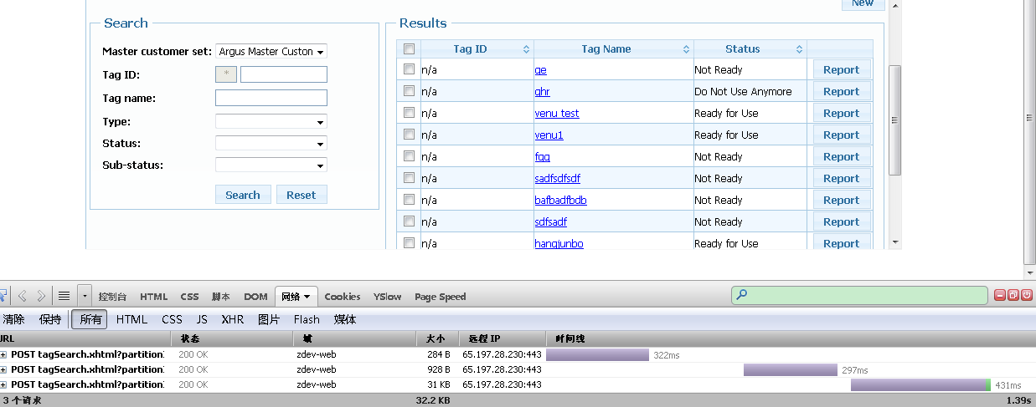

Figure 8 Search Function in Tag Application

**User Experience Design Analysis**

As mentioned in section 3.1.4, reducing the page size is a method to improve performance from a technology perspective. This also makes sense from a user experience design perspective. When other applications are developed, the page size of 10 comes out for the purpose that it will not make the scroll bar appearing on the page. The user experience is better than the one that requires the user to scroll a lot to find their record. Plus, in this way there could be too many records on one page to take users’ time to find their desired record.

The only advantage of displaying more records on one page is that user can select them at one time, but this function is disabled in the DrugList application (select record 1 on page1, go to page 2, the selection on page 1 will disappear). But by using the method applied in other JSF applications, it can also achieve the same goal even in a small page size (select record 1 on page1, go to page2, select record 1 on page2, 2 records are all selected when viewing).

So it's reasonable to reduce the page size in this scenario and the select behavior can be changed accordingly if needed.

**Solutions and Verification**

Other issues related to this are #1, #2, #5, #7, #8, #11, #35, #38 in DL and #3, #12, #15, #16, #17 in MC. Page size has been changed and a quick verification to some of the issues is done.

***Below is the list of the related issues in Drug List and Mass Changes and the tuning results:***

**Issue#1**: Search to find a list to getting results.

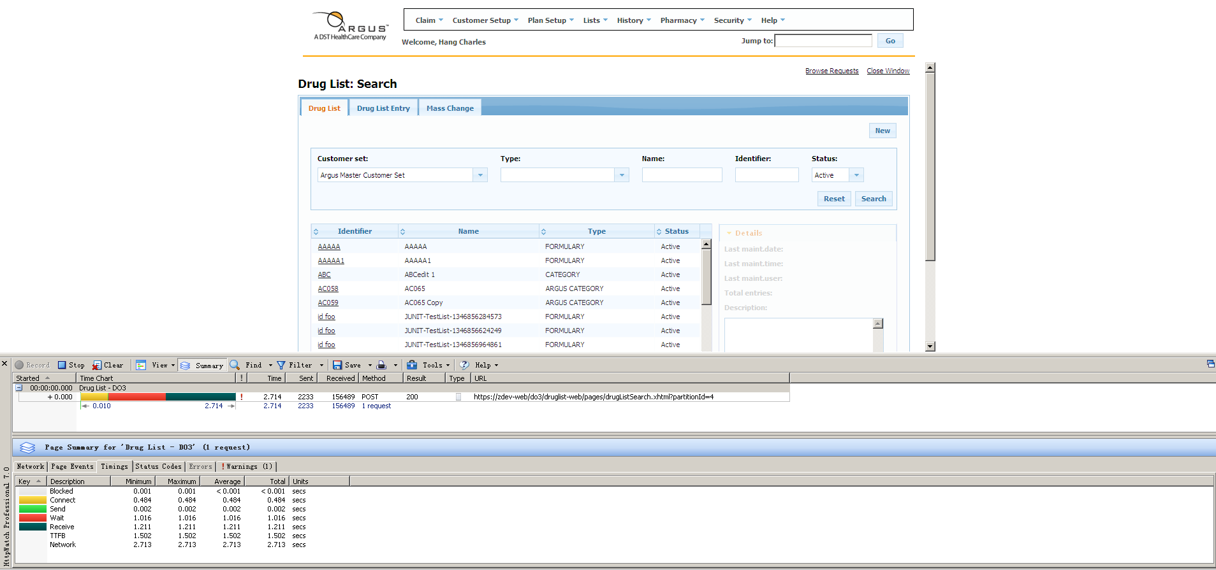

Figure 9 Druglis Search Function

Table 6 Response Time of Search for Different Page Size

|  |  |  |  |  |
| --- | --- | --- | --- | --- |
| **Page size** | **Waiting** | **Receive** | **Total** | **SW** |
| 10 | 0.6635 | 0.2507 | 0.9142 | 1.7509 |
| 20 | 1.2962 | 0.3547 | 1.6509 | 2.9146 |
| 50 | 0.7676 | 1.230 | 1.9976 | 4.034 |

**Issue#8:** Selecting a list with approx 88,448 entries to view to the time the page opens with the entries displaying.

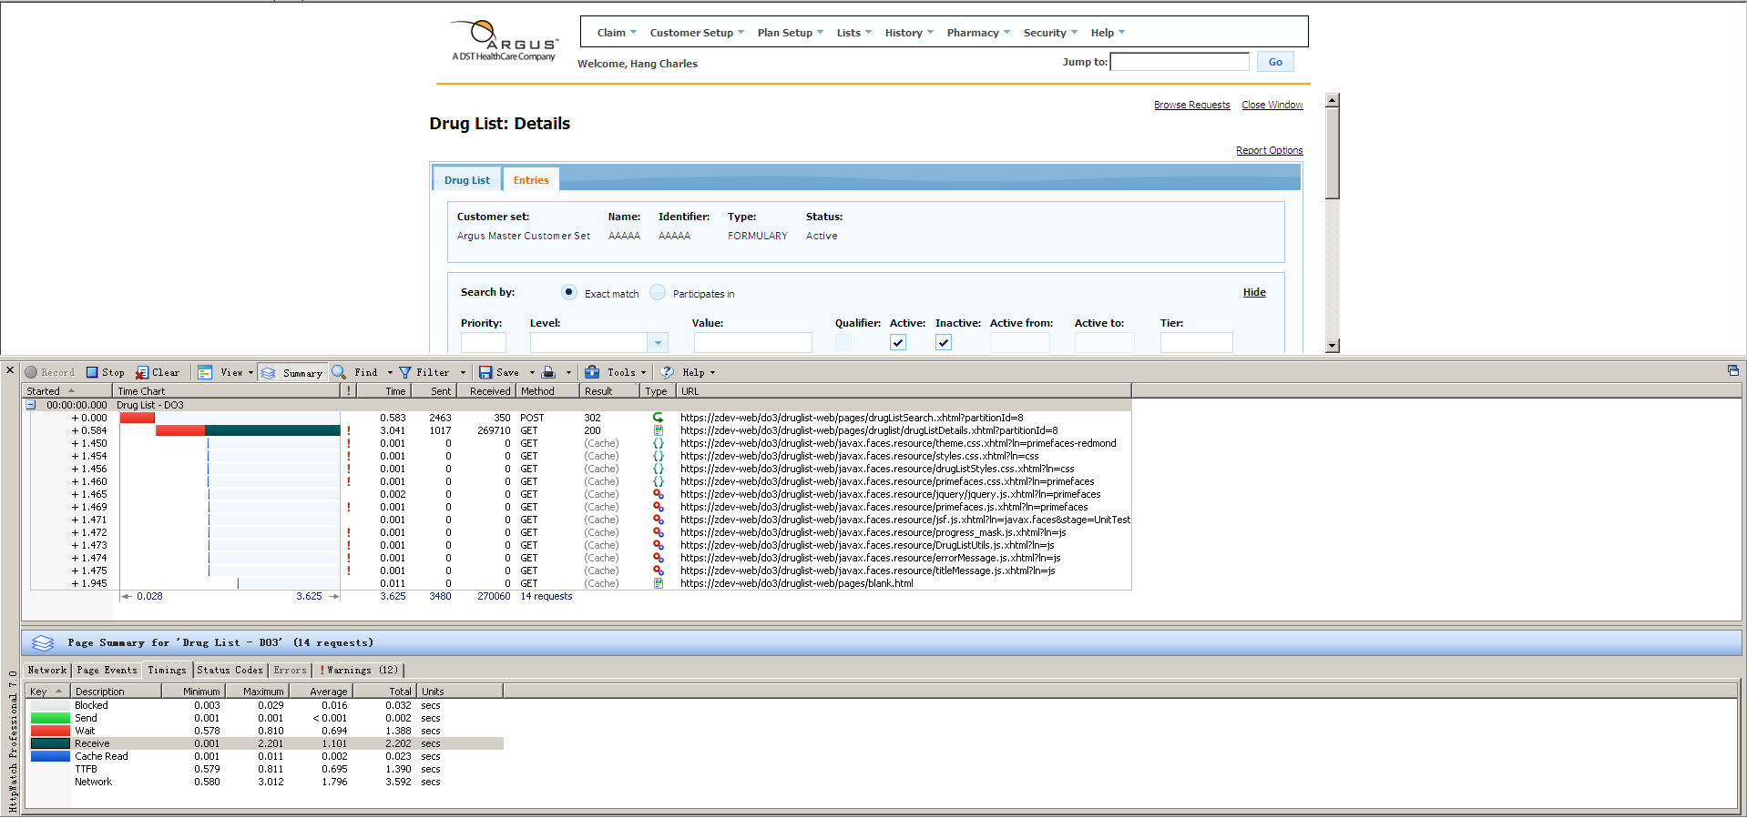

Figure 10 Entry Selection Function

Table 7 Resonpse Time of Entry Selection for Different Page Size

|  |  |  |  |  |
| --- | --- | --- | --- | --- |
| **Page size** | **Waiting** | **Receive** | **Total** | **SW** |
| 10 | 0.6635 | 0.2507 | 0.9142 | 1.7509 |
| 20 | 1.3707 | 0.9081 | 2.2788 | 3.1723 |
| 50 | 1.7666 | 2.1446 | 3.9112 | 4.5077 |

**Issue#35:**New One- closing the edit entry pop up screen. Very slow. No entries changed, just selecting the close button.

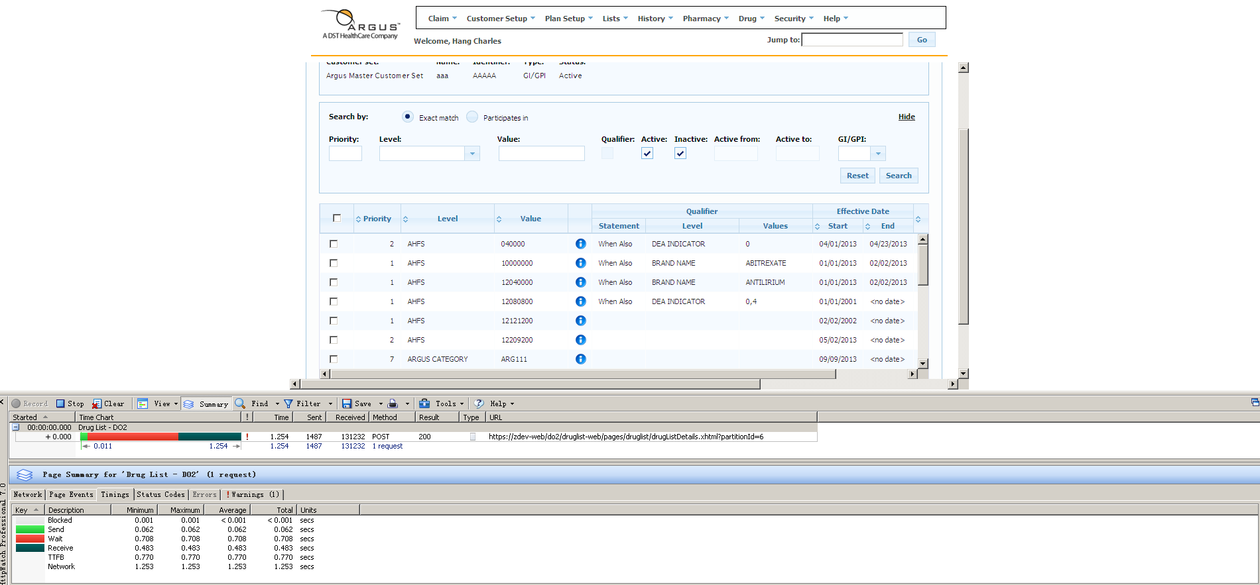

Figure 11 Dialog Close Operation

Table 8 Response Time of Dialog Close for Different Page Size

|  |  |  |  |  |
| --- | --- | --- | --- | --- |
| **Page size** | **Waiting** | **Receive** | **Total** | **SW** |
| 10 | 0.7334 | 0.3781 | 1.1115 | 2.4936 |
| 20 | 0.6093 | 0.4923 | 1.1016 | 2.7538 |
| 50 | 0.7817 | 0.5263 | 1.308 | 3.1087 |

**Issue#3:** Search for an existing MC from search text, OK, to results.

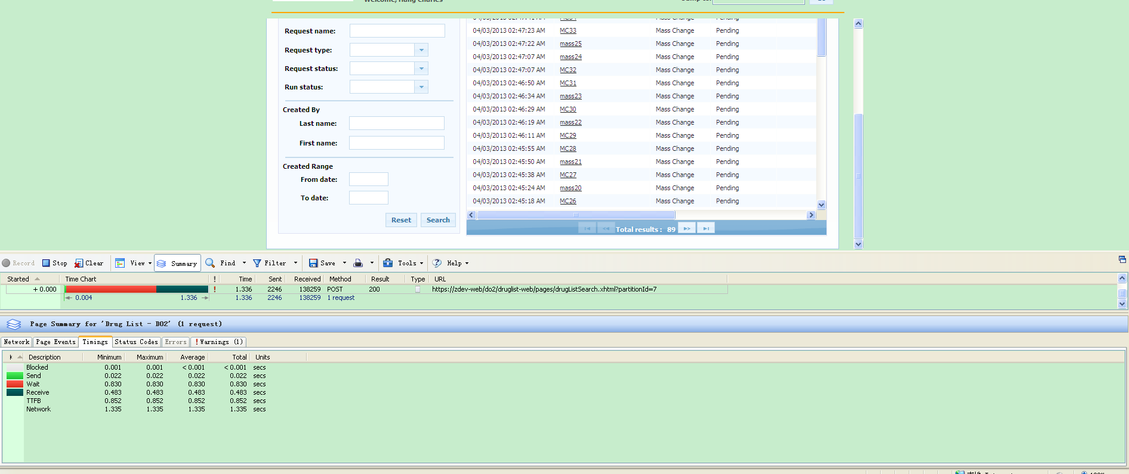

Figure 12 Search Function in Mass Change

Table 9 Response Time of Search for Different Page Size

|  |  |  |  |  |
| --- | --- | --- | --- | --- |
| **Page size** | **Waiting** | **Receive** | **Total** | **SW** |
| 10 | 1.0917 | 0.0949 | 1.1866 | 1.8566 |
| 20 | 0.9786 | 0.3668 | 1.3454 | 2.1557 |
| 50 | 1.4538 | 0.9458 | 2.3996 | 3.6293 |

**Issue#15:** Searching for a Customer Set, type, partial STC value to when results appear.

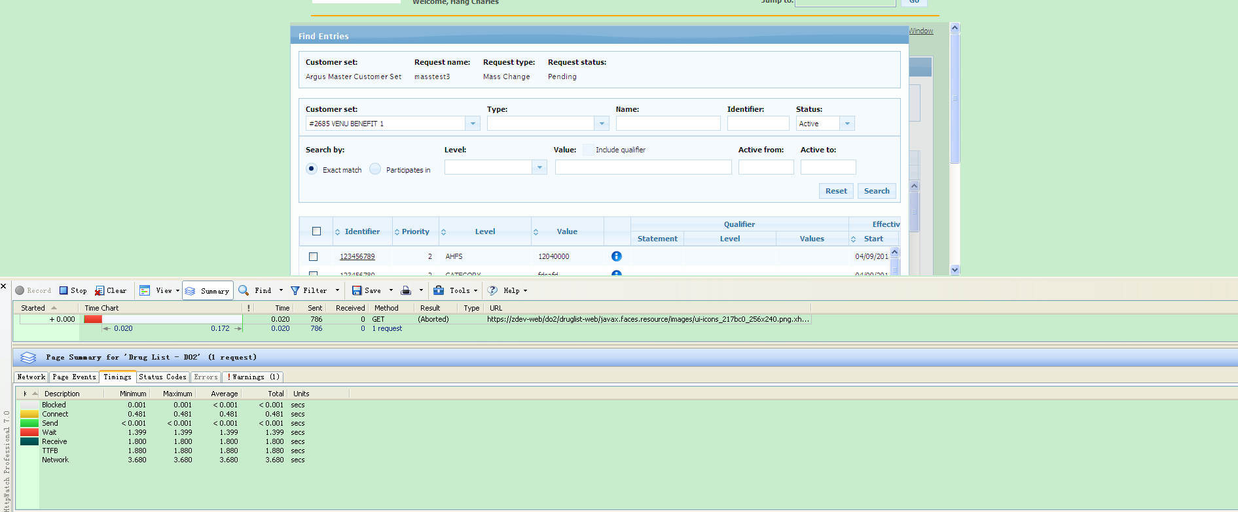

Figure 13 Search Customer Set in Mass Change

Table 10 Response Time of Search Customer Set for Different Page Size

|  |  |  |  |  |
| --- | --- | --- | --- | --- |
| **Page size** | **Waiting** | **Receive** | **Total** | **SW** |
| 10 | 1.0101 | 0.5488 | 1.5589 | 3.0679 |
| 20 | 1.1549 | 0.8027 | 1.9576 | 4.8597 |
| 50 | 1.2403 | 1.3284 | 2.5687 | 7.7152 |

### 3.1.5 No backend interaction

**Symptom Analysis**

It was noticed that some issues in the issue list are marked as either immediate or less than 1 second in the Flex application but much slower, usually more than 1 second, in the JSF application.

***Issue #1 Analysis***:

"Choosing customer set name on main drug list search screen". Below are the screen shots in HttpWatch for both Flex and JSF applications.

|  |  |
| --- | --- |
| Flex Application: | JSF Application: |
|  |  |
| Figure Select Customer Set in Flex | Figure Select Customer Set in JSF |

The category field is different when Customer Set option changed. It takes 391ms in the JSF application but is immediate in the Flex application to complete this operation. From HttpWatch it can be seen why this happens: the Flex application doesn't send any request to the backend, but the JSF application has a request to the backend. In further looking at the response content displayed below, the content of search form is requested from the server side together with some other content which is not relevant to this operation.

<?xml version=*'1.0'* encoding=*'UTF-8'*?>

<partial-response>

<changes>

<update id=*"general_error_form:j_idt18"*><![CDATA[<span id="general_error_form:j_idt18">

<div id="general_msg_panel"><input id="general_error_form:general_error_msg" type="hidden" name="general_error_form:general_error_msg" /><input id="general_error_form:general_info_msg" type="hidden" name="general_error_form:general_info_msg" /><div id="general_error_form:general_error"></div><div id="general_error_form:globalMessages" class="ui-messages ui-widget"></div><div id="general_error_form:general_info"></div>

</div></span>]]></update>

<update id=*"browseRequestsDlgForm:j_idt22"*><![CDATA[<span id="browseRequestsDlgForm:j_idt22">

<div id="popup_general_msg_panel" class="drugdisplayDialogErrorContent"><input id="browseRequestsDlgForm:browse_general_msgs" type="hidden" name="browseRequestsDlgForm:browse_general_msgs" /><input id="browseRequestsDlgForm:browse_general_info_msg" type="hidden" name="browseRequestsDlgForm:browse_general_info_msg" /><div id="browseRequestsDlgForm:browse_general_msg"></div><div id="browseRequestsDlgForm:general_info"></div><div id="browseRequestsDlgForm:browse_globalMessages" class="ui-messages ui-widget"></div>

</div></span>]]></update>

<update id=*"drugListDetailsForm:j_idt101"*><![CDATA[<span id="drugListDetailsForm:j_idt101">

<div id="general_msg_panel"><input id="drugListDetailsForm:general_error_msg" type="hidden" name="drugListDetailsForm:general_error_msg" /><input id="drugListDetailsForm:general_info_msg" type="hidden" name="drugListDetailsForm:general_info_msg" /><div id="drugListDetailsForm:general_error"></div><div id="drugListDetailsForm:globalMessages" class="ui-messages ui-widget"></div><div id="drugListDetailsForm:general_info"></div>

</div></span>]]></update>

<update

id=*"drugListDeatails_tabView:copyDrugListPopupForm:copy_globalMessages"*><![CDATA[<div id="drugListDeatails_tabView:copyDrugListPopupForm:copy_globalMessages" class="ui-messages ui-widget"></div>]]></update>

<update

id=*"drugListDeatails_tabView:editDrugListPopupForm:globalMessages"*><![CDATA[<div id="drugListDeatails_tabView:editDrugListPopupForm:globalMessages" class="ui-messages ui-widget"></div>]]></update>

<update

id=*"drugListDeatails_tabView:drugListDetailEntriesForm:levelValuePanel"*><![CDATA[<span id="drugListDeatails_tabView:drugListDetailEntriesForm:levelValuePanel"><input id="drugListDeatails_tabView:drugListDetailEntriesForm:levelValueTxt" name="drugListDeatails_tabView:drugListDetailEntriesForm:levelValueTxt" type="text" style="width:120px;float:left;" class="ui-inputfield ui-inputtext ui-widget ui-state-default ui-corner-all" /><script id="drugListDeatails_tabView:drugListDetailEntriesForm:levelValueTxt_s" type="text/javascript">PrimeFaces.cw('InputText','widget_drugListDeatails_tabView_drugListDetailEntriesForm_levelValueTxt',{id:'drugListDeatails_tabView:drugListDetailEntriesForm:levelValueTxt',behaviors:{change:function(event) {PrimeFaces.ab({source:'drugListDeatails_tabView:drugListDetailEntriesForm:levelValueTxt',event:'valueChange',process:'drugListDeatails_tabView:drugListDetailEntriesForm:levelValueTxt'}, arguments[1]);}}});</script><div id="drugListDeatails_tabView:drugListDetailEntriesForm:j_idt395"></div><div id="drugListDeatails_tabView:drugListDetailEntriesForm:j_idt397"></div><div id="drugListDeatails_tabView:drugListDetailEntriesForm:j_idt399"></div></span>]]></update>

<update

id=*"drugListDeatails_tabView:drugListDetailEntriesForm:btnEditSelected"*><![CDATA[<button id="drugListDeatails_tabView:drugListDetailEntriesForm:btnEditSelected" name="drugListDeatails_tabView:drugListDetailEntriesForm:btnEditSelected" class="ui-button ui-widget ui-state-default ui-corner-all ui-button-text-only" onclick="PrimeFaces.ab({source:'drugListDeatails_tabView:drugListDetailEntriesForm:btnEditSelected',update:'drugListDeatails_tabView:drugListEditEntriesForm',onstart:function(cfg){progressMask.showProcess();;},oncomplete:function(xhr,status,args){drugListEditEntriesPopUpWV.show();;}});return false;" type="submit"><span class="ui-button-text">Edit Selected</span></button><script id="drugListDeatails_tabView:drugListDetailEntriesForm:btnEditSelected_s" type="text/javascript">PrimeFaces.cw('CommandButton','editButtonWV',{id:'drugListDeatails_tabView:drugListDetailEntriesForm:btnEditSelected'});</script>]]></update>

<update

id=*"drugListDeatails_tabView:drugListDetailEntriesForm:btnDeleteSelected"*><![CDATA[<button id="drugListDeatails_tabView:drugListDetailEntriesForm:btnDeleteSelected" name="drugListDeatails_tabView:drugListDetailEntriesForm:btnDeleteSelected" class="ui-button ui-widget ui-state-default ui-corner-all ui-button-text-only" onclick="PrimeFaces.ab({source:'drugListDeatails_tabView:drugListDetailEntriesForm:btnDeleteSelected',onstart:function(cfg){progressMask.showProcess();;},oncomplete:function(xhr,status,args){progressMask.hideProcess();drugListDeleteEntriesWV.show();;}});return false;" type="submit"><span class="ui-button-text">Delete Selected</span></button><script id="drugListDeatails_tabView:drugListDetailEntriesForm:btnDeleteSelected_s" type="text/javascript">PrimeFaces.cw('CommandButton','deleteButtonWV',{id:'drugListDeatails_tabView:drugListDetailEntriesForm:btnDeleteSelected'});</script>]]></update>

<update

id=*"drugListDeatails_tabView:drugListNDCSearchDlgForm:globalMessages"*><![CDATA[<div id="drugListDeatails_tabView:drugListNDCSearchDlgForm:globalMessages" class="ui-messages ui-widget"></div>]]></update>

<update

id=*"drugListDeatails_tabView:drugListAddEntriesForm:globalMessages"*><![CDATA[<div id="drugListDeatails_tabView:drugListAddEntriesForm:globalMessages" class="ui-messages ui-widget"></div>]]></update>

<update id=*"drugListDeatails_tabView:drugListAddEntriesForm:j_idt512"*><![CDATA[<span id="drugListDeatails_tabView:drugListAddEntriesForm:j_idt512"><table id="drugListDeatails_tabView:drugListAddEntriesForm:j_idt513" class="ui-panelgrid ui-widget" role="grid"><tbody><tr class="ui-widget-content" role="row"><td role="gridcell"><label>

Customer set:</label></td><td role="gridcell"><label>

Name:</label></td><td role="gridcell"><label>

Identifier:</label></td><td role="gridcell"><label>

Type:</label></td><td role="gridcell"><label>

Status:</label></td><td role="gridcell"><label>

</label></td></tr><tr class="ui-widget-content" role="row"><td role="gridcell"></td><td role="gridcell"></td><td role="gridcell"></td><td role="gridcell"></td><td role="gridcell"></td><td role="gridcell"></td></tr></tbody></table></span>]]></update>

<update id=*"drugListDeatails_tabView:drugListAddEntriesForm:j_idt598"*><![CDATA[<span id="drugListDeatails_tabView:drugListAddEntriesForm:j_idt598"><table id="drugListDeatails_tabView:drugListAddEntriesForm:j_idt599" class="ui-panelgrid ui-widget mainpanforadd" style="margin-left:10px;" role="grid"><tbody><tr class="ui-widget-content" role="row"><td role="gridcell"><label>

Level</label></td><td role="gridcell"><label>

Value</label></td><td role="gridcell"><label>

</label></td><td role="gridcell"><label>

Start date</label></td><td role="gridcell"><label>

End date</label></td></tr><tr class="ui-widget-content" role="row"><td role="gridcell" colspan="7"><img id="drugListDeatails_tabView:drugListAddEntriesForm:j_idt625" height="5px" alt="" src="/druglist-web/javax.faces.resource/spacer/dot_clear.gif.xhtml?ln=primefaces" /></td></tr><tr class="ui-widget-content" role="row"><td role="gridcell"><div id="drugListDeatails_tabView:drugListAddEntriesForm:level" class="ui-selectonemenu ui-widget ui-state-default ui-corner-all ui-helper-clearfix searchSelectDiv" style=" width: 150px;float:left;"><div class="ui-helper-hidden-accessible"><select id="drugListDeatails_tabView:drugListAddEntriesForm:level_input" name="drugListDeatails_tabView:drugListAddEntriesForm:level_input"><option value="" selected="selected"></option></select></div><label id="drugListDeatails_tabView:drugListAddEntriesForm:level_label" class="ui-selectonemenu-label ui-inputfield ui-corner-all">&nbsp;</label><div class="ui-selectonemenu-trigger ui-state-default ui-corner-right"><span class="ui-icon ui-icon-triangle-1-s"></span></div><div id="drugListDeatails_tabView:drugListAddEntriesForm:level_panel" class="ui-selectonemenu-panel ui-widget-content ui-corner-all ui-helper-hidden ui-shadow"><ul class="ui-selectonemenu-items ui-selectonemenu-list ui-widget-content ui-widget ui-corner-all ui-helper-reset"><li class="ui-selectonemenu-item ui-selectonemenu-list-item ui-corner-all">&nbsp;</li></ul></div></div><script id="drugListDeatails_tabView:drugListAddEntriesForm:level_s" type="text/javascript">$(function(){PrimeFaces.cw('SelectOneMenu','widget_drugListDeatails_tabView_drugListAddEntriesForm_level',{id:'drugListDeatails_tabView:drugListAddEntriesForm:level',effect:'fade',behaviors:{change:function(event) {PrimeFaces.ab({source:'drugListDeatails_tabView:drugListAddEntriesForm:level',event:'change',process:'drugListDeatails_tabView:drugListAddEntriesForm drugListDeatails_tabView:drugListAddEntriesForm:level',update:'drugListDeatails_tabView:drugListAddEntriesForm:j_idt629 drugListDeatails_tabView:drugListAddEntriesForm:editEntryQualifierButton',onstart:function(cfg){progressMask.showProcess();;},oncomplete:function(xhr,status,args){progressMask.hideProcess();setDropDownFocus('drugListDeatails_tabView:drugListAddEntriesForm:level');;}}, arguments[1]);}}});});</script><div id="drugListDeatails_tabView:drugListAddEntriesForm:j_idt632"></div></td><td role="gridcell"><table id="drugListDeatails_tabView:drugListAddEntriesForm:levelGrid" class="ui-panelgrid ui-widget" role="grid"><tbody><tr class="ui-widget-content" role="row"><td role="gridcell"><input id="drugListDeatails_tabView:drugListAddEntriesForm:theValueId" name="drugListDeatails_tabView:drugListAddEntriesForm:theValueId" type="text" style="float:left;" class="ui-inputfield ui-inputtext ui-widget ui-state-default ui-corner-all" /><script id="drugListDeatails_tabView:drugListAddEntriesForm:theValueId_s" type="text/javascript">PrimeFaces.cw('InputText','widget_drugListDeatails_tabView_drugListAddEntriesForm_theValueId',{id:'drugListDeatails_tabView:drugListAddEntriesForm:theValueId'});</script><div id="drugListDeatails_tabView:drugListAddEntriesForm:j_idt636"></div></td></tr></tbody></table></td><td role="gridcell"><button id="drugListDeatails_tabView:drugListAddEntriesForm:SearchNDC" name="drugListDeatails_tabView:drugListAddEntriesForm:SearchNDC" class="ui-button ui-widget ui-state-default ui-corner-all ui-button-text-only" onclick="PrimeFaces.ab({source:'drugListDeatails_tabView:drugListAddEntriesForm:SearchNDC',process:'drugListDeatails_tabView:drugListAddEntriesForm',update:'drugListDeatails_tabView:drugListAddEntriesForm:levelGrid drugListDeatails_tabView:drugListNDCSearchDlgForm',oncomplete:function(xhr,status,args){drugListNDCSearchWV.show();;}});return false;" type="submit"><span class="ui-button-text">Search NDC</span></button><script id="drugListDeatails_tabView:drugListAddEntriesForm:SearchNDC_s" type="text/javascript">PrimeFaces.cw('CommandButton','widget_drugListDeatails_tabView_drugListAddEntriesForm_SearchNDC',{id:'drugListDeatails_tabView:drugListAddEntriesForm:SearchNDC'});</script></td><td role="gridcell"><input id="drugListDeatails_tabView:drugListAddEntriesForm:popupButtonStartDate" name="drugListDeatails_tabView:drugListAddEntriesForm:popupButtonStartDate" type="text" maxlength="10" onblur="return validateDate(this);" style="float:left;width:55px;" class="ui-inputfield ui-inputtext ui-widget ui-state-default ui-corner-all" /><script id="drugListDeatails_tabView:drugListAddEntriesForm:popupButtonStartDate_s" type="text/javascript">PrimeFaces.cw('InputText','widget_drugListDeatails_tabView_drugListAddEntriesForm_popupButtonStartDate',{id:'drugListDeatails_tabView:drugListAddEntriesForm:popupButtonStartDate'});</script><div id="drugListDeatails_tabView:drugListAddEntriesForm:j_idt647"></div></td><td role="gridcell"><input id="drugListDeatails_tabView:drugListAddEntriesForm:popupButtonEndDate" name="drugListDeatails_tabView:drugListAddEntriesForm:popupButtonEndDate" type="text" maxlength="10" onblur="return validateDate(this);" style="float:left;width:55px;" class="ui-inputfield ui-inputtext ui-widget ui-state-default ui-corner-all" /><script id="drugListDeatails_tabView:drugListAddEntriesForm:popupButtonEndDate_s" type="text/javascript">PrimeFaces.cw('InputText','widget_drugListDeatails_tabView_drugListAddEntriesForm_popupButtonEndDate',{id:'drugListDeatails_tabView:drugListAddEntriesForm:popupButtonEndDate'});</script><div id="drugListDeatails_tabView:drugListAddEntriesForm:j_idt649"></div></td></tr></tbody></table></span>]]></update>

<update

id=*"drugListDeatails_tabView:drugListEditEntriesForm:globalMessages"*><![CDATA[<div id="drugListDeatails_tabView:drugListEditEntriesForm:globalMessages" class="ui-messages ui-widget"></div>]]></update>

<update

id=*"drugListDeatails_tabView:drugListDeleteEntriesForm:globalMessages"*><![CDATA[<div id="drugListDeatails_tabView:drugListDeleteEntriesForm:globalMessages" class="ui-messages ui-widget"></div>]]></update>

<update id=*"drugListDeatails_tabView:editQualifier_Form:globalMessages"*><![CDATA[<div id="drugListDeatails_tabView:editQualifier_Form:globalMessages" class="ui-messages ui-widget"></div>]]></update>

<update

id=*"drugListDeatails_tabView:levelValueDescription_Form:j_idt1312"*><![CDATA[<span id="drugListDeatails_tabView:levelValueDescription_Form:j_idt1312"><table id="drugListDeatails_tabView:levelValueDescription_Form:levelValueDescription_Form_pannel_grid" class="ui-panelgrid ui-widget" style="width:100%;" role="grid"><tbody><tr class="ui-widget-content" role="row"><td role="gridcell" style="vertical-align: top;width:50%;"><table id="drugListDeatails_tabView:levelValueDescription_Form:j_idt1315" class="ui-panelgrid ui-widget leveldes" role="grid"><tbody><tr class="ui-widget-content" role="row"><td role="gridcell" style="width:90px;"><label>

Level:</label></td><td role="gridcell" style="width:210px;"></td></tr><tr class="ui-widget-content" role="row"><td role="gridcell"><label>

Value:</label></td><td role="gridcell"></td></tr><tr class="ui-widget-content" role="row"><td role="gridcell"><label>

Description:</label></td><td role="gridcell"></td></tr><tr class="ui-widget-content" role="row"><td role="gridcell"><label>

Start date:</label></td><td role="gridcell"></td></tr><tr class="ui-widget-content" role="row"><td role="gridcell"><label>

End date:</label></td><td role="gridcell"></td></tr></tbody></table></td><td role="gridcell" style="vertical-align: top;width:50%;"><table id="drugListDeatails_tabView:levelValueDescription_Form:j_idt1372" class="ui-panelgrid ui-widget leveldes" role="grid"><tbody><tr class="ui-widget-content" role="row"><td role="gridcell" style="width:120px;"><label>

Qualifier statement:</label></td><td role="gridcell" style="width:150px;"></td></tr><tr class="ui-widget-content" role="row"><td role="gridcell"><label>

Qualifier level:</label></td><td role="gridcell"></td></tr><tr class="ui-widget-content" role="row"><td role="gridcell" colspan="2"><label>

Qualifier values:</label></td></tr><tr class="ui-widget-content" role="row"><td role="gridcell" colspan="2"><textarea id="drugListDeatails_tabView:levelValueDescription_Form:j_idt1388" name="drugListDeatails_tabView:levelValueDescription_Form:j_idt1388" cols="20" rows="3" disabled="disabled" readonly="readonly" style="width:260px;height:60px;" class="ui-inputfield ui-inputtextarea ui-widget ui-state-default ui-corner-all ui-state-disabled readonlytextarea"></textarea><script id="drugListDeatails_tabView:levelValueDescription_Form:j_idt1388_s" type="text/javascript">PrimeFaces.cw('InputTextarea','widget_drugListDeatails_tabView_levelValueDescription_Form_j_idt1388',{id:'drugListDeatails_tabView:levelValueDescription_Form:j_idt1388',autoResize:false});</script></td></tr></tbody></table></td></tr></tbody></table></span>]]></update>

<update id=*"reportingOptionsPopup"*><![CDATA[<span id="reportingOptionsPopup"><img id="j_idt1474" height="10px" alt="" src="/druglist-web/javax.faces.resource/spacer/dot_clear.gif.xhtml?ln=primefaces" />

<form id="j_idt1475" name="j_idt1475" method="post" action="/druglist-web/pages/druglist/drugListDetails.xhtml?partitionId=2" enctype="application/x-www-form-urlencoded">

<input type="hidden" name="j_idt1475" value="j_idt1475" />

<div id="drugdisplayContent"><table id="j_idt1475:j_idt1477" class="ui-panelgrid ui-widget" role="grid"><tbody><tr class="ui-widget-content" role="row"><td role="gridcell"><label>

Report type:</label></td><td role="gridcell"><div id="j_idt1475:reportingOptions" class="ui-selectonemenu ui-widget ui-state-default ui-corner-all ui-helper-clearfix"><div class="ui-helper-hidden-accessible"><select id="j_idt1475:reportingOptions_input" name="j_idt1475:reportingOptions_input"><option value="Null"></option><option value="SIMPLE_CONTENT_REPORT">SIMPLE CONTENT REPORT</option><option value="NDC_DETAIL_REPORT">NDC DETAIL REPORT</option></select></div><label id="j_idt1475:reportingOptions_label" class="ui-selectonemenu-label ui-inputfield ui-corner-all">&nbsp;</label><div class="ui-selectonemenu-trigger ui-state-default ui-corner-right"><span class="ui-icon ui-icon-triangle-1-s"></span></div><div id="j_idt1475:reportingOptions_panel" class="ui-selectonemenu-panel ui-widget-content ui-corner-all ui-helper-hidden ui-shadow"><ul class="ui-selectonemenu-items ui-selectonemenu-list ui-widget-content ui-widget ui-corner-all ui-helper-reset"><li class="ui-selectonemenu-item ui-selectonemenu-list-item ui-corner-all">&nbsp;</li><li class="ui-selectonemenu-item ui-selectonemenu-list-item ui-corner-all">SIMPLE CONTENT REPORT</li><li class="ui-selectonemenu-item ui-selectonemenu-list-item ui-corner-all">NDC DETAIL REPORT</li></ul></div></div><script id="j_idt1475:reportingOptions_s" type="text/javascript">$(function(){PrimeFaces.cw('SelectOneMenu','widget_j_idt1475_reportingOptions',{id:'j_idt1475:reportingOptions',effect:'blind',behaviors:{change:function(event) {PrimeFaces.ab({source:'j_idt1475:reportingOptions',event:'change',process:'j_idt1475:reportingOptions',update:'j_idt1475',onstart:function(cfg){progressMask.showProcess();;},oncomplete:function(xhr,status,args){progressMask.hideProcess();;}}, arguments[1]);}}});});</script></td></tr><tr class="ui-widget-content" role="row"><td role="gridcell"><label style="color:#D3D3D3">

Report format:</label></td><td role="gridcell"><div id="j_idt1475:reportingformatType" class="ui-selectonemenu ui-widget ui-state-default ui-corner-all ui-helper-clearfix searchSelectDiv ui-state-disabled" style="width:75px;"><div class="ui-helper-hidden-accessible"><select id="j_idt1475:reportingformatType_input" name="j_idt1475:reportingformatType_input" disabled="disabled"></select></div><label id="j_idt1475:reportingformatType_label" class="ui-selectonemenu-label ui-inputfield ui-corner-all">&nbsp;</label><div class="ui-selectonemenu-trigger ui-state-default ui-corner-right"><span class="ui-icon ui-icon-triangle-1-s"></span></div><div id="j_idt1475:reportingformatType_panel" class="ui-selectonemenu-panel ui-widget-content ui-corner-all ui-helper-hidden ui-shadow"><ul class="ui-selectonemenu-items ui-selectonemenu-list ui-widget-content ui-widget ui-corner-all ui-helper-reset"></ul></div></div><script id="j_idt1475:reportingformatType_s" type="text/javascript">$(function(){PrimeFaces.cw('SelectOneMenu','widget_j_idt1475_reportingformatType',{id:'j_idt1475:reportingformatType',effect:'fade',behaviors:{change:function(event) {PrimeFaces.ab({source:'j_idt1475:reportingformatType',event:'change',process:'j_idt1475:reportingformatType',update:'j_idt1475',onstart:function(cfg){progressMask.showProcess();;},oncomplete:function(xhr,status,args){progressMask.hideProcess();;}}, arguments[1]);}}});});</script></td></tr></tbody></table>

</div>

<div id="drugList_searchButtons"><button id="j_idt1475:reportingOptionsSubmit" name="j_idt1475:reportingOptionsSubmit" class="ui-button ui-widget ui-state-default ui-corner-all ui-button-text-only ui-state-disabled" onclick="confirmPopupWV.show();PrimeFaces.ab({source:'j_idt1475:reportingOptionsSubmit'});return false;" type="submit" disabled="disabled"><span class="ui-button-text">Submit</span></button><script id="j_idt1475:reportingOptionsSubmit_s" type="text/javascript">PrimeFaces.cw('CommandButton','widget_j_idt1475_reportingOptionsSubmit',{id:'j_idt1475:reportingOptionsSubmit'});</script><img id="j_idt1475:j_idt1483" width="5px" alt="" src="/druglist-web/javax.faces.resource/spacer/dot_clear.gif.xhtml?ln=primefaces" /><button id="j_idt1475:reportingOptionsReset" name="j_idt1475:reportingOptionsReset" class="ui-button ui-widget ui-state-default ui-corner-all ui-button-text-only" onclick="reportingOptionsWV.hide();;PrimeFaces.ab({source:'j_idt1475:reportingOptionsReset'});return false;" type="submit"><span class="ui-button-text">Cancel</span></button><script id="j_idt1475:reportingOptionsReset_s" type="text/javascript">PrimeFaces.cw('CommandButton','widget_j_idt1475_reportingOptionsReset',{id:'j_idt1475:reportingOptionsReset'});</script>

</div>

</form></span>]]></update>

<update id=*"j_idt1486:j_idt1487"*><![CDATA[<span id="j_idt1486:j_idt1487">

A report request will be systematically created and submitted. The name of the request is <b></b>. Select the Browse Requests button to view the status of your request.<br />

Do you want to continue?

</span>]]></update>

<update id=*"javax.faces.ViewState"*><![CDATA[-8223052837643883921:3440961399404153834]]></update>

</changes>

</partial-response>

***Issue #15 Analysis***:

"Choosing 1 entry to edit (check box selection) to the time the edit selected button enables" below are the screen shots from both Flex and JSF applications.

|  |  |
| --- | --- |
| Flex Application: | JSF Application: |
|  |  |
| Figure Select Edit Entry in Flex | Figure Select Edit Entry in JSF |

The "Edit Selected" button is enabled in the Flex application immediately but takes 4.78 seconds in the JSF application. Since the Flex application also doesn't send any request to the backend, whereas the JSF application has a 22K request to the backend. The button is enabled/disabled after all requests has been received. By looking at the below response content it appears that the button area has been refreshed by the response in order to make it enabled/disabled; it also returns other content, which is not related to this operation.

<?xml version=*'1.0'* encoding=*'UTF-8'*?>

<partial-response>

<changes>

<update id=*"general_error_form:j_idt18"*><![CDATA[<span id="general_error_form:j_idt18">

<div id="general_msg_panel"><input id="general_error_form:general_error_msg" type="hidden" name="general_error_form:general_error_msg" /><input id="general_error_form:general_info_msg" type="hidden" name="general_error_form:general_info_msg" /><div id="general_error_form:general_error"></div><div id="general_error_form:globalMessages" class="ui-messages ui-widget"></div><div id="general_error_form:general_info"></div>

</div></span>]]></update>

<update id=*"browseRequestsDlgForm:j_idt22"*><![CDATA[<span id="browseRequestsDlgForm:j_idt22">

<div id="popup_general_msg_panel" class="drugdisplayDialogErrorContent"><input id="browseRequestsDlgForm:browse_general_msgs" type="hidden" name="browseRequestsDlgForm:browse_general_msgs" /><input id="browseRequestsDlgForm:browse_general_info_msg" type="hidden" name="browseRequestsDlgForm:browse_general_info_msg" /><div id="browseRequestsDlgForm:browse_general_msg"></div><div id="browseRequestsDlgForm:general_info"></div><div id="browseRequestsDlgForm:browse_globalMessages" class="ui-messages ui-widget"></div>

</div></span>]]></update>

<update id=*"drugListSearch_tabView:drugListSearch_DrugListTab_form:new"*><![CDATA[<button id="drugListSearch_tabView:drugListSearch_DrugListTab_form:new" name="drugListSearch_tabView:drugListSearch_DrugListTab_form:new" class="ui-button ui-widget ui-state-default ui-corner-all ui-button-text-only" onclick="newDrugListWV.show();" tabindex="3" type="button"><span class="ui-button-text">New</span></button><script id="drugListSearch_tabView:drugListSearch_DrugListTab_form:new_s" type="text/javascript">PrimeFaces.cw('CommandButton','widget_drugListSearch_tabView_drugListSearch_DrugListTab_form_new',{id:'drugListSearch_tabView:drugListSearch_DrugListTab_form:new'});</script>]]></update>

<update

id=*"drugListSearch_tabView:drugListSearch_DrugListTab_form:drugType"*><![CDATA[<div id="drugListSearch_tabView:drugListSearch_DrugListTab_form:drugType" class="ui-selectonemenu ui-widget ui-state-default ui-corner-all ui-helper-clearfix searchSelectDiv" style=" width: 200px;"><div class="ui-helper-hidden-accessible"><select id="drugListSearch_tabView:drugListSearch_DrugListTab_form:drugType_input" name="drugListSearch_tabView:drugListSearch_DrugListTab_form:drugType_input" tabindex="5"><option></option><option value="2">CATEGORY</option><option value="15">DRUG MESSAGING</option><option value="16">FLAT PRICE</option><option value="4">FORMULARY</option><option value="8">GI/GPI</option><option value="7">MAINTENANCE</option><option value="9">MAXIMUM ALLOWABLE COST</option><option value="10">PRE-AUTHORIZATION</option><option value="1">UNCLASSIFIED SET OF DRUGS</option></select></div><label id="drugListSearch_tabView:drugListSearch_DrugListTab_form:drugType_label" class="ui-selectonemenu-label ui-inputfield ui-corner-all">&nbsp;</label><div class="ui-selectonemenu-trigger ui-state-default ui-corner-right"><span class="ui-icon ui-icon-triangle-1-s"></span></div><div id="drugListSearch_tabView:drugListSearch_DrugListTab_form:drugType_panel" class="ui-selectonemenu-panel ui-widget-content ui-corner-all ui-helper-hidden ui-shadow"><ul class="ui-selectonemenu-items ui-selectonemenu-list ui-widget-content ui-widget ui-corner-all ui-helper-reset"><li class="ui-selectonemenu-item ui-selectonemenu-list-item ui-corner-all">&nbsp;</li><li class="ui-selectonemenu-item ui-selectonemenu-list-item ui-corner-all">CATEGORY</li><li class="ui-selectonemenu-item ui-selectonemenu-list-item ui-corner-all">DRUG MESSAGING</li><li class="ui-selectonemenu-item ui-selectonemenu-list-item ui-corner-all">FLAT PRICE</li><li class="ui-selectonemenu-item ui-selectonemenu-list-item ui-corner-all">FORMULARY</li><li class="ui-selectonemenu-item ui-selectonemenu-list-item ui-corner-all">GI/GPI</li><li class="ui-selectonemenu-item ui-selectonemenu-list-item ui-corner-all">MAINTENANCE</li><li class="ui-selectonemenu-item ui-selectonemenu-list-item ui-corner-all">MAXIMUM ALLOWABLE COST</li><li class="ui-selectonemenu-item ui-selectonemenu-list-item ui-corner-all">PRE-AUTHORIZATION</li><li class="ui-selectonemenu-item ui-selectonemenu-list-item ui-corner-all">UNCLASSIFIED SET OF DRUGS</li></ul></div></div><script id="drugListSearch_tabView:drugListSearch_DrugListTab_form:drugType_s" type="text/javascript">$(function(){PrimeFaces.cw('SelectOneMenu','widget_drugListSearch_tabView_drugListSearch_DrugListTab_form_drugType',{id:'drugListSearch_tabView:drugListSearch_DrugListTab_form:drugType',effect:'fade',behaviors:{change:function(event) {PrimeFaces.ab({source:'drugListSearch_tabView:drugListSearch_DrugListTab_form:drugType',event:'change',process:'drugListSearch_tabView:drugListSearch_DrugListTab_form'}, arguments[1]);}}});});</script>]]></update>

<update id=*"drugListSearch_tabView:opPanelNewDrugListPopup"*><![CDATA[<span id="drugListSearch_tabView:opPanelNewDrugListPopup">

<form id="drugListSearch_tabView:newDrugListPopupForm" name="drugListSearch_tabView:newDrugListPopupForm" method="post" action="/druglist-web/pages/drugListSearch.xhtml?partitionId=2" enctype="application/x-www-form-urlencoded">

<input type="hidden" name="drugListSearch_tabView:newDrugListPopupForm" value="drugListSearch_tabView:newDrugListPopupForm" />

<input id="drugListSearch_tabView:newDrugListPopupForm:isTabMove" type="hidden" name="drugListSearch_tabView:newDrugListPopupForm:isTabMove" value="0" />

<script>

$('form[id*="drugListSearch_tabView:newDrugListPopupForm"]').keypress(function(event) {

var charCode = (event.which) ? event.which : event.keyCode;

if (charCode == 13) {

if(event.target.nodeName != 'TEXTAREA'){

return false;

}

}

});

</script>

<div id="popup_general_msg_panel" class="drugdisplayDialogErrorContent"><input id="drugListSearch_tabView:newDrugListPopupForm:general_error_msgs" type="hidden" name="drugListSearch_tabView:newDrugListPopupForm:general_error_msgs" /><div id="drugListSearch_tabView:newDrugListPopupForm:general_error"></div><div id="drugListSearch_tabView:newDrugListPopupForm:globalMessages" class="ui-messages ui-widget"></div>

</div>

<div id="drugdisplayContent" onmousedown="cancelBlur('drugListSearch_tabView:newDrugListPopupForm:isTabMove');"><table id="drugListSearch_tabView:newDrugListPopupForm:j_idt220" class="ui-panelgrid ui-widget" role="grid"><tbody><tr class="ui-widget-content" role="row"><td role="gridcell"><label>

Tracking ID:</label></td><td role="gridcell"><input id="drugListSearch_tabView:newDrugListPopupForm:trackingId" name="drugListSearch_tabView:newDrugListPopupForm:trackingId" type="text" maxlength="15" style="width:312px;float:left;" class="ui-inputfield ui-inputtext ui-widget ui-state-default ui-corner-all" /><script id="drugListSearch_tabView:newDrugListPopupForm:trackingId_s" type="text/javascript">PrimeFaces.cw('InputText','widget_drugListSearch_tabView_newDrugListPopupForm_trackingId',{id:'drugListSearch_tabView:newDrugListPopupForm:trackingId'});</script><div id="drugListSearch_tabView:newDrugListPopupForm:j_idt225"></div></td></tr><tr class="ui-widget-content" role="row"><td role="gridcell"><label>

Reason:</label></td><td role="gridcell"><input id="drugListSearch_tabView:newDrugListPopupForm:reason" name="drugListSearch_tabView:newDrugListPopupForm:reason" type="text" maxlength="30" style="width:312px;float:left;" class="ui-inputfield ui-inputtext ui-widget ui-state-default ui-corner-all" /><script id="drugListSearch_tabView:newDrugListPopupForm:reason_s" type="text/javascript">PrimeFaces.cw('InputText','widget_drugListSearch_tabView_newDrugListPopupForm_reason',{id:'drugListSearch_tabView:newDrugListPopupForm:reason'});</script><div id="drugListSearch_tabView:newDrugListPopupForm:j_idt230"></div></td></tr><tr class="ui-widget-content" role="row"><td role="gridcell" style="vertical-align:top;"><label>

Notes:</label></td><td role="gridcell" style="vertical-align:top;"><textarea id="drugListSearch_tabView:newDrugListPopupForm:notes" name="drugListSearch_tabView:newDrugListPopupForm:notes" cols="20" rows="3" onkeypress="return lengthRestriction(this, 254);" style="width:312px; height: 45px;float:left;" class="ui-inputfield ui-inputtextarea ui-widget ui-state-default ui-corner-all"></textarea><script id="drugListSearch_tabView:newDrugListPopupForm:notes_s" type="text/javascript">PrimeFaces.cw('InputTextarea','widget_drugListSearch_tabView_newDrugListPopupForm_notes',{id:'drugListSearch_tabView:newDrugListPopupForm:notes',autoResize:false,maxlength:255});</script><div id="drugListSearch_tabView:newDrugListPopupForm:j_idt235"></div></td></tr></tbody></table>

</div><img id="drugListSearch_tabView:newDrugListPopupForm:j_idt237" width="100%" height="10px" alt="" src="/druglist-web/javax.faces.resource/spacer/dot_clear.gif.xhtml?ln=primefaces" />

<div id="drugdisplayContent" onmousedown="cancelBlur('drugListSearch_tabView:newDrugListPopupForm:isTabMove');"><table id="drugListSearch_tabView:newDrugListPopupForm:j_idt239" class="ui-panelgrid ui-widget" role="grid"><tbody><tr class="ui-widget-content" role="row"><td role="gridcell"><label>

Customer set:</label></td><td role="gridcell"><div id="drugListSearch_tabView:newDrugListPopupForm:customerSet" class="ui-selectonemenu ui-widget ui-state-default ui-corner-all ui-helper-clearfix" style=" width: 265px;float:left;"><div class="ui-helper-hidden-accessible"><select id="drugListSearch_tabView:newDrugListPopupForm:customerSet_input" name="drugListSearch_tabView:newDrugListPopupForm:customerSet_input"><option value="" selected="selected"></option><option value="85">#2685 VENU BENEFIT 1</option><option value="86">#2685 VENU BENEFIT 2</option><option value="87">#2686 BENFIT 5</option><option value="23">pp benefits</option><option value="88">pp benefits 2</option><option value="54">Benefit</option><option value="53">Benefit</option><option value="52">Benefit</option><option value="51">Benefit</option><option value="58">Benefit</option><option value="57">Benefit</option><option value="56">Benefit</option><option value="55">Benefit</option><option value="59">Benefit 59</option><option value="60">Benefit 60</option><option value="61">Benefit 61</option><option value="62">Benefit 62</option><option value="63">Benefit 63</option><option value="64">Benefit 64</option><option value="65">Benefit 65</option><option value="66">Benefit 66</option><option value="67">Benefit 67</option><option value="68">Benefit 68</option><option value="69">Benefit 69</option><option value="15">Blogumas Benefits</option><option value="30">Commercial</option><option value="8">Commercial</option><option value="77">COPY CUSTOMER 9352</option><option value="90">DHARMABENEFIT</option><option value="45">Ginger Test Benefet</option><option value="46">Ginger Test Benefet2</option><option value="19">Jason Benefit</option><option value="12">Joel Test Benefits</option><option value="28">JACKIE'S BENEFIT CUST SET ONE</option><option value="29">JACKIE'S BENEFIT CUST SET TWO</option><option value="13">JOCELYNS TEST 1125</option><option value="38">Kinder Customer Set</option><option value="34">Marias Benefit Set</option><option value="32">PerformRx</option><option value="36">Pricing Customer Benefit Set</option><option value="17">Providence Benefits Set</option><option value="25">Rob's test set</option><option value="92">SAIBENEFIT</option><option value="91">SAIMASTER</option><option value="48">Wayne Test Benefet</option><option value="47">Wayne Test Benefet2</option><option value="39">001 Customer Set</option><option value="71">349 NEW BENEFIT TEST</option><option value="98">351 BENEFIT</option><option value="72">382 NEW BENEFIT TEST</option></select></div><label id="drugListSearch_tabView:newDrugListPopupForm:customerSet_label" class="ui-selectonemenu-label ui-inputfield ui-corner-all">&nbsp;</label><div class="ui-selectonemenu-trigger ui-state-default ui-corner-right"><span class="ui-icon ui-icon-triangle-1-s"></span></div><div id="drugListSearch_tabView:newDrugListPopupForm:customerSet_panel" class="ui-selectonemenu-panel ui-widget-content ui-corner-all ui-helper-hidden ui-shadow" style=";height:200px"><ul class="ui-selectonemenu-items ui-selectonemenu-list ui-widget-content ui-widget ui-corner-all ui-helper-reset"><li class="ui-selectonemenu-item ui-selectonemenu-list-item ui-corner-all">&nbsp;</li><li class="ui-selectonemenu-item ui-selectonemenu-list-item ui-corner-all">#2685 VENU BENEFIT 1</li><li class="ui-selectonemenu-item ui-selectonemenu-list-item ui-corner-all">#2685 VENU BENEFIT 2</li><li class="ui-selectonemenu-item ui-selectonemenu-list-item ui-corner-all">#2686 BENFIT 5</li><li class="ui-selectonemenu-item ui-selectonemenu-list-item ui-corner-all">pp benefits</li><li class="ui-selectonemenu-item ui-selectonemenu-list-item ui-corner-all">pp benefits 2</li><li class="ui-selectonemenu-item ui-selectonemenu-list-item ui-corner-all">Benefit</li><li class="ui-selectonemenu-item ui-selectonemenu-list-item ui-corner-all">Benefit</li><li class="ui-selectonemenu-item ui-selectonemenu-list-item ui-corner-all">Benefit</li><li class="ui-selectonemenu-item ui-selectonemenu-list-item ui-corner-all">Benefit</li><li class="ui-selectonemenu-item ui-selectonemenu-list-item ui-corner-all">Benefit</li><li class="ui-selectonemenu-item ui-selectonemenu-list-item ui-corner-all">Benefit</li><li class="ui-selectonemenu-item ui-selectonemenu-list-item ui-corner-all">Benefit</li><li class="ui-selectonemenu-item ui-selectonemenu-list-item ui-corner-all">Benefit</li><li class="ui-selectonemenu-item ui-selectonemenu-list-item ui-corner-all">Benefit 59</li><li class="ui-selectonemenu-item ui-selectonemenu-list-item ui-corner-all">Benefit 60</li><li class="ui-selectonemenu-item ui-selectonemenu-list-item ui-corner-all">Benefit 61</li><li class="ui-selectonemenu-item ui-selectonemenu-list-item ui-corner-all">Benefit 62</li><li class="ui-selectonemenu-item ui-selectonemenu-list-item ui-corner-all">Benefit 63</li><li class="ui-selectonemenu-item ui-selectonemenu-list-item ui-corner-all">Benefit 64</li><li class="ui-selectonemenu-item ui-selectonemenu-list-item ui-corner-all">Benefit 65</li><li class="ui-selectonemenu-item ui-selectonemenu-list-item ui-corner-all">Benefit 66</li><li class="ui-selectonemenu-item ui-selectonemenu-list-item ui-corner-all">Benefit 67</li><li class="ui-selectonemenu-item ui-selectonemenu-list-item ui-corner-all">Benefit 68</li><li class="ui-selectonemenu-item ui-selectonemenu-list-item ui-corner-all">Benefit 69</li><li class="ui-selectonemenu-item ui-selectonemenu-list-item ui-corner-all">Blogumas Benefits</li><li class="ui-selectonemenu-item ui-selectonemenu-list-item ui-corner-all">Commercial</li><li class="ui-selectonemenu-item ui-selectonemenu-list-item ui-corner-all">Commercial</li><li class="ui-selectonemenu-item ui-selectonemenu-list-item ui-corner-all">COPY CUSTOMER 9352</li><li class="ui-selectonemenu-item ui-selectonemenu-list-item ui-corner-all">DHARMABENEFIT</li><li class="ui-selectonemenu-item ui-selectonemenu-list-item ui-corner-all">Ginger Test Benefet</li><li class="ui-selectonemenu-item ui-selectonemenu-list-item ui-corner-all">Ginger Test Benefet2</li><li class="ui-selectonemenu-item ui-selectonemenu-list-item ui-corner-all">Jason Benefit</li><li class="ui-selectonemenu-item ui-selectonemenu-list-item ui-corner-all">Joel Test Benefits</li><li class="ui-selectonemenu-item ui-selectonemenu-list-item ui-corner-all">JACKIE'S BENEFIT CUST SET ONE</li><li class="ui-selectonemenu-item ui-selectonemenu-list-item ui-corner-all">JACKIE'S BENEFIT CUST SET TWO</li><li class="ui-selectonemenu-item ui-selectonemenu-list-item ui-corner-all">JOCELYNS TEST 1125</li><li class="ui-selectonemenu-item ui-selectonemenu-list-item ui-corner-all">Kinder Customer Set</li><li class="ui-selectonemenu-item ui-selectonemenu-list-item ui-corner-all">Marias Benefit Set</li><li class="ui-selectonemenu-item ui-selectonemenu-list-item ui-corner-all">PerformRx</li><li class="ui-selectonemenu-item ui-selectonemenu-list-item ui-corner-all">Pricing Customer Benefit Set</li><li class="ui-selectonemenu-item ui-selectonemenu-list-item ui-corner-all">Providence Benefits Set</li><li class="ui-selectonemenu-item ui-selectonemenu-list-item ui-corner-all">Rob's test set</li><li class="ui-selectonemenu-item ui-selectonemenu-list-item ui-corner-all">SAIBENEFIT</li><li class="ui-selectonemenu-item ui-selectonemenu-list-item ui-corner-all">SAIMASTER</li><li class="ui-selectonemenu-item ui-selectonemenu-list-item ui-corner-all">Wayne Test Benefet</li><li class="ui-selectonemenu-item ui-selectonemenu-list-item ui-corner-all">Wayne Test Benefet2</li><li class="ui-selectonemenu-item ui-selectonemenu-list-item ui-corner-all">001 Customer Set</li><li class="ui-selectonemenu-item ui-selectonemenu-list-item ui-corner-all">349 NEW BENEFIT TEST</li><li class="ui-selectonemenu-item ui-selectonemenu-list-item ui-corner-all">351 BENEFIT</li><li class="ui-selectonemenu-item ui-selectonemenu-list-item ui-corner-all">382 NEW BENEFIT TEST</li></ul></div></div><script id="drugListSearch_tabView:newDrugListPopupForm:customerSet_s" type="text/javascript">$(function(){PrimeFaces.cw('SelectOneMenu','widget_drugListSearch_tabView_newDrugListPopupForm_customerSet',{id:'drugListSearch_tabView:newDrugListPopupForm:customerSet',effect:'fade',behaviors:{change:function(event) {PrimeFaces.ab({source:'drugListSearch_tabView:newDrugListPopupForm:customerSet',event:'change',process:'drugListSearch_tabView:newDrugListPopupForm',update:'drugListSearch_tabView:newDrugListPopupForm:drugType123 drugListSearch_tabView:newDrugListPopupForm:defaultClaimError',onstart:function(cfg){progressMask.showProcess();;},oncomplete:function(xhr,status,args){progressMask.hideProcess();setFocusInSelectedField('drugListSearch_tabView:newDrugListPopupForm','customerSet','isTabMove');;}}, arguments[1]);}}});});</script><div id="drugListSearch_tabView:newDrugListPopupForm:j_idt245"></div></td></tr><tr class="ui-widget-content" role="row"><td role="gridcell"><label>

Type:</label></td><td role="gridcell"><div id="drugListSearch_tabView:newDrugListPopupForm:type" class="ui-selectonemenu ui-widget ui-state-default ui-corner-all ui-helper-clearfix" style=" width: 265px;float:left;"><div class="ui-helper-hidden-accessible"><select id="drugListSearch_tabView:newDrugListPopupForm:type_input" name="drugListSearch_tabView:newDrugListPopupForm:type_input"><option selected="selected"></option><option value="2">CATEGORY</option><option value="15">DRUG MESSAGING</option><option value="16">FLAT PRICE</option><option value="4">FORMULARY</option><option value="8">GI/GPI</option><option value="7">MAINTENANCE</option><option value="9">MAXIMUM ALLOWABLE COST</option><option value="10">PRE-AUTHORIZATION</option><option value="1">UNCLASSIFIED SET OF DRUGS</option></select></div><label id="drugListSearch_tabView:newDrugListPopupForm:type_label" class="ui-selectonemenu-label ui-inputfield ui-corner-all">&nbsp;</label><div class="ui-selectonemenu-trigger ui-state-default ui-corner-right"><span class="ui-icon ui-icon-triangle-1-s"></span></div><div id="drugListSearch_tabView:newDrugListPopupForm:type_panel" class="ui-selectonemenu-panel ui-widget-content ui-corner-all ui-helper-hidden ui-shadow"><ul class="ui-selectonemenu-items ui-selectonemenu-list ui-widget-content ui-widget ui-corner-all ui-helper-reset"><li class="ui-selectonemenu-item ui-selectonemenu-list-item ui-corner-all">&nbsp;</li><li class="ui-selectonemenu-item ui-selectonemenu-list-item ui-corner-all">CATEGORY</li><li class="ui-selectonemenu-item ui-selectonemenu-list-item ui-corner-all">DRUG MESSAGING</li><li class="ui-selectonemenu-item ui-selectonemenu-list-item ui-corner-all">FLAT PRICE</li><li class="ui-selectonemenu-item ui-selectonemenu-list-item ui-corner-all">FORMULARY</li><li class="ui-selectonemenu-item ui-selectonemenu-list-item ui-corner-all">GI/GPI</li><li class="ui-selectonemenu-item ui-selectonemenu-list-item ui-corner-all">MAINTENANCE</li><li class="ui-selectonemenu-item ui-selectonemenu-list-item ui-corner-all">MAXIMUM ALLOWABLE COST</li><li class="ui-selectonemenu-item ui-selectonemenu-list-item ui-corner-all">PRE-AUTHORIZATION</li><li class="ui-selectonemenu-item ui-selectonemenu-list-item ui-corner-all">UNCLASSIFIED SET OF DRUGS</li></ul></div></div><script id="drugListSearch_tabView:newDrugListPopupForm:type_s" type="text/javascript">$(function(){PrimeFaces.cw('SelectOneMenu','widget_drugListSearch_tabView_newDrugListPopupForm_type',{id:'drugListSearch_tabView:newDrugListPopupForm:type',effect:'fade',behaviors:{change:function(event) {PrimeFaces.ab({source:'drugListSearch_tabView:newDrugListPopupForm:type',event:'change',process:'drugListSearch_tabView:newDrugListPopupForm',update:'drugListSearch_tabView:newDrugListPopupForm:defaultClaimError123',onstart:function(cfg){progressMask.showProcess();;},oncomplete:function(xhr,status,args){progressMask.hideProcess();setDropDownFocus('drugListSearch_tabView:newDrugListPopupForm:type');;}}, arguments[1]);}}});});</script><div id="drugListSearch_tabView:newDrugListPopupForm:j_idt250"></div></td></tr><tr class="ui-widget-content" role="row"><td role="gridcell"><label>

Name:</label></td><td role="gridcell"><input id="drugListSearch_tabView:newDrugListPopupForm:drugListName" name="drugListSearch_tabView:newDrugListPopupForm:drugListName" type="text" maxlength="35" style="width:257px;float:left;" class="ui-inputfield ui-inputtext ui-widget ui-state-default ui-corner-all" /><script id="drugListSearch_tabView:newDrugListPopupForm:drugListName_s" type="text/javascript">PrimeFaces.cw('InputText','widget_drugListSearch_tabView_newDrugListPopupForm_drugListName',{id:'drugListSearch_tabView:newDrugListPopupForm:drugListName'});</script><div id="drugListSearch_tabView:newDrugListPopupForm:j_idt255"></div></td></tr><tr class="ui-widget-content" role="row"><td role="gridcell"><label>

Identifier:</label></td><td role="gridcell"><input id="drugListSearch_tabView:newDrugListPopupForm:identifier" name="drugListSearch_tabView:newDrugListPopupForm:identifier" type="text" maxlength="9" style="width:257px;float:left;" class="ui-inputfield ui-inputtext ui-widget ui-state-default ui-corner-all" /><script id="drugListSearch_tabView:newDrugListPopupForm:identifier_s" type="text/javascript">PrimeFaces.cw('InputText','widget_drugListSearch_tabView_newDrugListPopupForm_identifier',{id:'drugListSearch_tabView:newDrugListPopupForm:identifier'});</script><div id="drugListSearch_tabView:newDrugListPopupForm:j_idt260"></div></td></tr><tr class="ui-widget-content" role="row"><td role="gridcell" style="width:120px;"><label>

Status:</label></td><td role="gridcell"><div id="drugListSearch_tabView:newDrugListPopupForm:status" class="ui-selectonemenu ui-widget ui-state-default ui-corner-all ui-helper-clearfix searchSelectDiv" style="float:left;"><div class="ui-helper-hidden-accessible"><select id="drugListSearch_tabView:newDrugListPopupForm:status_input" name="drugListSearch_tabView:newDrugListPopupForm:status_input"><option value="Active" selected="selected">Active</option><option value="Inactive">Inactive</option></select></div><label id="drugListSearch_tabView:newDrugListPopupForm:status_label" class="ui-selectonemenu-label ui-inputfield ui-corner-all">&nbsp;</label><div class="ui-selectonemenu-trigger ui-state-default ui-corner-right"><span class="ui-icon ui-icon-triangle-1-s"></span></div><div id="drugListSearch_tabView:newDrugListPopupForm:status_panel" class="ui-selectonemenu-panel ui-widget-content ui-corner-all ui-helper-hidden ui-shadow"><ul class="ui-selectonemenu-items ui-selectonemenu-list ui-widget-content ui-widget ui-corner-all ui-helper-reset"><li class="ui-selectonemenu-item ui-selectonemenu-list-item ui-corner-all">Active</li><li class="ui-selectonemenu-item ui-selectonemenu-list-item ui-corner-all">Inactive</li></ul></div></div><script id="drugListSearch_tabView:newDrugListPopupForm:status_s" type="text/javascript">$(function(){PrimeFaces.cw('SelectOneMenu','widget_drugListSearch_tabView_newDrugListPopupForm_status',{id:'drugListSearch_tabView:newDrugListPopupForm:status',effect:'fade'});});</script><div id="drugListSearch_tabView:newDrugListPopupForm:j_idt266"></div></td></tr><tr class="ui-widget-content" role="row"><td role="gridcell" colspan="2"><label>

Description:</label></td></tr><tr class="ui-widget-content" role="row"><td role="gridcell" colspan="2"><textarea id="drugListSearch_tabView:newDrugListPopupForm:description" name="drugListSearch_tabView:newDrugListPopupForm:description" cols="20" rows="3" onkeypress="return lengthRestriction(this, 254);" style="width:397px; height: 45px;" class="ui-inputfield ui-inputtextarea ui-widget ui-state-default ui-corner-all"></textarea><script id="drugListSearch_tabView:newDrugListPopupForm:description_s" type="text/javascript">PrimeFaces.cw('InputTextarea','widget_drugListSearch_tabView_newDrugListPopupForm_description',{id:'drugListSearch_tabView:newDrugListPopupForm:description',autoResize:false,maxlength:255});</script></td></tr></tbody></table>

</div>

<div id="drugList_searchButtons"><button id="drugListSearch_tabView:newDrugListPopupForm:btnSubmit1" name="drugListSearch_tabView:newDrugListPopupForm:btnSubmit1" class="ui-button ui-widget ui-state-default ui-corner-all ui-button-text-only" onclick="PrimeFaces.ab({source:'drugListSearch_tabView:newDrugListPopupForm:btnSubmit1',onstart:function(cfg){progressMask.showProcess();},oncomplete:function(xhr,status,args){progressMask.hideProcess();}});return false;" type="submit"><span class="ui-button-text">Submit</span></button><script id="drugListSearch_tabView:newDrugListPopupForm:btnSubmit1_s" type="text/javascript">PrimeFaces.cw('CommandButton','widget_drugListSearch_tabView_newDrugListPopupForm_btnSubmit1',{id:'drugListSearch_tabView:newDrugListPopupForm:btnSubmit1'});</script><img id="drugListSearch_tabView:newDrugListPopupForm:j_idt277" width="5px" alt="" src="/druglist-web/javax.faces.resource/spacer/dot_clear.gif.xhtml?ln=primefaces" /><button id="drugListSearch_tabView:newDrugListPopupForm:btnReset" name="drugListSearch_tabView:newDrugListPopupForm:btnReset" class="ui-button ui-widget ui-state-default ui-corner-all ui-button-text-only" onclick="newDrugListWV.hide();;PrimeFaces.ab({source:'drugListSearch_tabView:newDrugListPopupForm:btnReset'});return false;" type="submit"><span class="ui-button-text">Cancel</span></button><script id="drugListSearch_tabView:newDrugListPopupForm:btnReset_s" type="text/javascript">PrimeFaces.cw('CommandButton','widget_drugListSearch_tabView_newDrugListPopupForm_btnReset',{id:'drugListSearch_tabView:newDrugListPopupForm:btnReset'});</script>

</div>

</form></span>]]></update>

<update id=*"drugListSearch_tabView:editDrugListPopupForm:globalMessages"*><![CDATA[<div id="drugListSearch_tabView:editDrugListPopupForm:globalMessages" class="ui-messages ui-widget"></div>]]></update>

<update

id=*"drugListSearch_tabView:copyDrugListPopupForm:copy_globalMessages"*><![CDATA[<div id="drugListSearch_tabView:copyDrugListPopupForm:copy_globalMessages" class="ui-messages ui-widget"></div>]]></update>

<update id=*"drugListSearch_tabView:j_idt446:j_idt447"*><![CDATA[<span id="drugListSearch_tabView:j_idt446:j_idt447">

A report request will be systematically created and submitted. The name of the request is <b></b>. Select the Browse Requests button to view the status of your request.<br />

Do you want to continue?

</span>]]></update>

<update id=*"drugListSearch_tabView:drugListEntrySearchForm:j_idt505"*><![CDATA[<span id="drugListSearch_tabView:drugListEntrySearchForm:j_idt505"><input id="drugListSearch_tabView:drugListEntrySearchForm:levelValue" name="drugListSearch_tabView:drugListEntrySearchForm:levelValue" type="text" style="width:260px;float:left;" class="ui-inputfield ui-inputtext ui-widget ui-state-default ui-corner-all" /><script id="drugListSearch_tabView:drugListEntrySearchForm:levelValue_s" type="text/javascript">PrimeFaces.cw('InputText','widget_drugListSearch_tabView_drugListEntrySearchForm_levelValue',{id:'drugListSearch_tabView:drugListEntrySearchForm:levelValue'});</script><div id="drugListSearch_tabView:drugListEntrySearchForm:j_idt506"></div><div id="drugListSearch_tabView:drugListEntrySearchForm:j_idt509"></div><div id="drugListSearch_tabView:drugListEntrySearchForm:j_idt512"></div><div id="drugListSearch_tabView:drugListEntrySearchForm:j_idt515"></div><div id="drugListSearch_tabView:drugListEntrySearchForm:j_idt518"></div><div id="drugListSearch_tabView:drugListEntrySearchForm:j_idt521"></div></span>]]></update>

<update id=*"drugListSearch_tabView:levelValueDescription_Form:j_idt668"*><![CDATA[<span id="drugListSearch_tabView:levelValueDescription_Form:j_idt668"><table id="drugListSearch_tabView:levelValueDescription_Form:levelValueDescription_Form_pannel_grid" class="ui-panelgrid ui-widget" style="width:100%;" role="grid"><tbody><tr class="ui-widget-content" role="row"><td role="gridcell" style="vertical-align: top;width:50%;"><table id="drugListSearch_tabView:levelValueDescription_Form:j_idt671" class="ui-panelgrid ui-widget leveldes" role="grid"><tbody><tr class="ui-widget-content" role="row"><td role="gridcell" style="width:90px;"><label>

Level:</label></td><td role="gridcell" style="width:210px;"></td></tr><tr class="ui-widget-content" role="row"><td role="gridcell"><label>

Value:</label></td><td role="gridcell"></td></tr><tr class="ui-widget-content" role="row"><td role="gridcell"><label>

Description:</label></td><td role="gridcell"></td></tr><tr class="ui-widget-content" role="row"><td role="gridcell"><label>

Start date:</label></td><td role="gridcell"></td></tr><tr class="ui-widget-content" role="row"><td role="gridcell"><label>

End date:</label></td><td role="gridcell"></td></tr></tbody></table></td><td role="gridcell" style="vertical-align: top;width:50%;"><table id="drugListSearch_tabView:levelValueDescription_Form:j_idt728" class="ui-panelgrid ui-widget leveldes" role="grid"><tbody><tr class="ui-widget-content" role="row"><td role="gridcell" style="width:120px;"><label>

Qualifier statement:</label></td><td role="gridcell" style="width:150px;"></td></tr><tr class="ui-widget-content" role="row"><td role="gridcell"><label>

Qualifier level:</label></td><td role="gridcell"></td></tr><tr class="ui-widget-content" role="row"><td role="gridcell" colspan="2"><label>

Qualifier values:</label></td></tr><tr class="ui-widget-content" role="row"><td role="gridcell" colspan="2"><textarea id="drugListSearch_tabView:levelValueDescription_Form:j_idt744" name="drugListSearch_tabView:levelValueDescription_Form:j_idt744" cols="20" rows="3" disabled="disabled" readonly="readonly" style="width:260px;height:60px;" class="ui-inputfield ui-inputtextarea ui-widget ui-state-default ui-corner-all ui-state-disabled readonlytextarea"></textarea><script id="drugListSearch_tabView:levelValueDescription_Form:j_idt744_s" type="text/javascript">PrimeFaces.cw('InputTextarea','widget_drugListSearch_tabView_levelValueDescription_Form_j_idt744',{id:'drugListSearch_tabView:levelValueDescription_Form:j_idt744',autoResize:false});</script></td></tr></tbody></table></td></tr></tbody></table></span>]]></update>

<update id=*"drugListSearch_tabView:opPanelNewMassChangeRequest"*><![CDATA[<span id="drugListSearch_tabView:opPanelNewMassChangeRequest">

<form id="drugListSearch_tabView:newMassChangeRequestForm" name="drugListSearch_tabView:newMassChangeRequestForm" method="post" action="/druglist-web/pages/drugListSearch.xhtml?partitionId=2" enctype="application/x-www-form-urlencoded">

<input type="hidden" name="drugListSearch_tabView:newMassChangeRequestForm" value="drugListSearch_tabView:newMassChangeRequestForm" />

<script>

$('form[id*="drugListSearch_tabView:newMassChangeRequestForm"]').keypress(function(event) {

var charCode = (event.which) ? event.which : event.keyCode;

if (charCode == 13) {

if(event.target.nodeName != 'TEXTAREA'){

return false;

}

}

});

</script>

<script>

$('input').keypress(function(event) {

var charCode = (event.which) ? event.which : event.keyCode;

if (charCode == 13) {

return false;

}

});

</script>

<div id="popup_general_msg_panel" class="drugdisplayDialogErrorContent"><input id="drugListSearch_tabView:newMassChangeRequestForm:general_error_msg" type="hidden" name="drugListSearch_tabView:newMassChangeRequestForm:general_error_msg" /><div id="drugListSearch_tabView:newMassChangeRequestForm:general_error"></div><div id="drugListSearch_tabView:newMassChangeRequestForm:globalMessages" class="ui-messages ui-widget"></div>

</div>

<div id="drugdisplayContent"><table id="drugListSearch_tabView:newMassChangeRequestForm:j_idt1155" class="ui-panelgrid ui-widget" role="grid"><tbody><tr class="ui-widget-content" role="row"><td role="gridcell"><label>

Tracking ID:</label></td><td role="gridcell"><input id="drugListSearch_tabView:newMassChangeRequestForm:requestTrackingId" name="drugListSearch_tabView:newMassChangeRequestForm:requestTrackingId" type="text" maxlength="15" style="width:312px;float:left;" class="ui-inputfield ui-inputtext ui-widget ui-state-default ui-corner-all" /><script id="drugListSearch_tabView:newMassChangeRequestForm:requestTrackingId_s" type="text/javascript">PrimeFaces.cw('InputText','widget_drugListSearch_tabView_newMassChangeRequestForm_requestTrackingId',{id:'drugListSearch_tabView:newMassChangeRequestForm:requestTrackingId'});</script><div id="drugListSearch_tabView:newMassChangeRequestForm:j_idt1160"></div></td></tr><tr class="ui-widget-content" role="row"><td role="gridcell"><label>

Reason:</label></td><td role="gridcell"><input id="drugListSearch_tabView:newMassChangeRequestForm:requestReason" name="drugListSearch_tabView:newMassChangeRequestForm:requestReason" type="text" maxlength="30" style="width:312px;float:left;" class="ui-inputfield ui-inputtext ui-widget ui-state-default ui-corner-all" /><script id="drugListSearch_tabView:newMassChangeRequestForm:requestReason_s" type="text/javascript">PrimeFaces.cw('InputText','widget_drugListSearch_tabView_newMassChangeRequestForm_requestReason',{id:'drugListSearch_tabView:newMassChangeRequestForm:requestReason'});</script><div id="drugListSearch_tabView:newMassChangeRequestForm:j_idt1165"></div></td></tr><tr class="ui-widget-content" role="row"><td role="gridcell" style="vertical-align:top;"><label>

Notes:</label></td><td role="gridcell" style="vertical-align:top;"><textarea id="drugListSearch_tabView:newMassChangeRequestForm:requestNotes" name="drugListSearch_tabView:newMassChangeRequestForm:requestNotes" cols="20" rows="3" onkeypress="return lengthRestriction(this, 254);" style="width:312px; height: 50px;float:left;" class="ui-inputfield ui-inputtextarea ui-widget ui-state-default ui-corner-all"></textarea><script id="drugListSearch_tabView:newMassChangeRequestForm:requestNotes_s" type="text/javascript">PrimeFaces.cw('InputTextarea','widget_drugListSearch_tabView_newMassChangeRequestForm_requestNotes',{id:'drugListSearch_tabView:newMassChangeRequestForm:requestNotes',autoResize:false,maxlength:255});</script><div id="drugListSearch_tabView:newMassChangeRequestForm:j_idt1170"></div></td></tr></tbody></table>

</div><img id="drugListSearch_tabView:newMassChangeRequestForm:j_idt1172" width="100%" height="10px" alt="" src="/druglist-web/javax.faces.resource/spacer/dot_clear.gif.xhtml?ln=primefaces" />

<div id="drugdisplayContent"><table id="drugListSearch_tabView:newMassChangeRequestForm:j_idt1174" class="ui-panelgrid ui-widget" role="grid"><tbody><tr class="ui-widget-content" role="row"><td role="gridcell"><label>

Customer set:</label></td><td role="gridcell"><div id="drugListSearch_tabView:newMassChangeRequestForm:customerSet" class="ui-selectonemenu ui-widget ui-state-default ui-corner-all ui-helper-clearfix searchSelectDiv" style=" width: 265px;float:left;"><div class="ui-helper-hidden-accessible"><select id="drugListSearch_tabView:newMassChangeRequestForm:customerSet_input" name="drugListSearch_tabView:newMassChangeRequestForm:customerSet_input"><option value=""></option><option value="85">#2685 VENU BENEFIT 1</option><option value="86">#2685 VENU BENEFIT 2</option><option value="87">#2686 BENFIT 5</option><option value="23">pp benefits</option><option value="88">pp benefits 2</option><option value="51">Benefit</option><option value="55">Benefit</option><option value="54">Benefit</option><option value="53">Benefit</option><option value="52">Benefit</option><option value="58">Benefit</option><option value="57">Benefit</option><option value="56">Benefit</option><option value="59">Benefit 59</option><option value="60">Benefit 60</option><option value="61">Benefit 61</option><option value="62">Benefit 62</option><option value="63">Benefit 63</option><option value="64">Benefit 64</option><option value="65">Benefit 65</option><option value="66">Benefit 66</option><option value="67">Benefit 67</option><option value="68">Benefit 68</option><option value="69">Benefit 69</option><option value="15">Blogumas Benefits</option><option value="8">Commercial</option><option value="30">Commercial</option><option value="77">COPY CUSTOMER 9352</option><option value="90">DHARMABENEFIT</option><option value="45">Ginger Test Benefet</option><option value="46">Ginger Test Benefet2</option><option value="19">Jason Benefit</option><option value="12">Joel Test Benefits</option><option value="28">JACKIE'S BENEFIT CUST SET ONE</option><option value="29">JACKIE'S BENEFIT CUST SET TWO</option><option value="13">JOCELYNS TEST 1125</option><option value="38">Kinder Customer Set</option><option value="34">Marias Benefit Set</option><option value="32">PerformRx</option><option value="36">Pricing Customer Benefit Set</option><option value="17">Providence Benefits Set</option><option value="25">Rob's test set</option><option value="92">SAIBENEFIT</option><option value="91">SAIMASTER</option><option value="48">Wayne Test Benefet</option><option value="47">Wayne Test Benefet2</option><option value="39">001 Customer Set</option><option value="71">349 NEW BENEFIT TEST</option><option value="98">351 BENEFIT</option><option value="72">382 NEW BENEFIT TEST</option></select></div><label id="drugListSearch_tabView:newMassChangeRequestForm:customerSet_label" class="ui-selectonemenu-label ui-inputfield ui-corner-all">&nbsp;</label><div class="ui-selectonemenu-trigger ui-state-default ui-corner-right"><span class="ui-icon ui-icon-triangle-1-s"></span></div><div id="drugListSearch_tabView:newMassChangeRequestForm:customerSet_panel" class="ui-selectonemenu-panel ui-widget-content ui-corner-all ui-helper-hidden ui-shadow" style=";height:200px"><ul class="ui-selectonemenu-items ui-selectonemenu-list ui-widget-content ui-widget ui-corner-all ui-helper-reset"><li class="ui-selectonemenu-item ui-selectonemenu-list-item ui-corner-all">&nbsp;</li><li class="ui-selectonemenu-item ui-selectonemenu-list-item ui-corner-all">#2685 VENU BENEFIT 1</li><li class="ui-selectonemenu-item ui-selectonemenu-list-item ui-corner-all">#2685 VENU BENEFIT 2</li><li class="ui-selectonemenu-item ui-selectonemenu-list-item ui-corner-all">#2686 BENFIT 5</li><li class="ui-selectonemenu-item ui-selectonemenu-list-item ui-corner-all">pp benefits</li><li class="ui-selectonemenu-item ui-selectonemenu-list-item ui-corner-all">pp benefits 2</li><li class="ui-selectonemenu-item ui-selectonemenu-list-item ui-corner-all">Benefit</li><li class="ui-selectonemenu-item ui-selectonemenu-list-item ui-corner-all">Benefit</li><li class="ui-selectonemenu-item ui-selectonemenu-list-item ui-corner-all">Benefit</li><li class="ui-selectonemenu-item ui-selectonemenu-list-item ui-corner-all">Benefit</li><li class="ui-selectonemenu-item ui-selectonemenu-list-item ui-corner-all">Benefit</li><li class="ui-selectonemenu-item ui-selectonemenu-list-item ui-corner-all">Benefit</li><li class="ui-selectonemenu-item ui-selectonemenu-list-item ui-corner-all">Benefit</li><li class="ui-selectonemenu-item ui-selectonemenu-list-item ui-corner-all">Benefit</li><li class="ui-selectonemenu-item ui-selectonemenu-list-item ui-corner-all">Benefit 59</li><li class="ui-selectonemenu-item ui-selectonemenu-list-item ui-corner-all">Benefit 60</li><li class="ui-selectonemenu-item ui-selectonemenu-list-item ui-corner-all">Benefit 61</li><li class="ui-selectonemenu-item ui-selectonemenu-list-item ui-corner-all">Benefit 62</li><li class="ui-selectonemenu-item ui-selectonemenu-list-item ui-corner-all">Benefit 63</li><li class="ui-selectonemenu-item ui-selectonemenu-list-item ui-corner-all">Benefit 64</li><li class="ui-selectonemenu-item ui-selectonemenu-list-item ui-corner-all">Benefit 65</li><li class="ui-selectonemenu-item ui-selectonemenu-list-item ui-corner-all">Benefit 66</li><li class="ui-selectonemenu-item ui-selectonemenu-list-item ui-corner-all">Benefit 67</li><li class="ui-selectonemenu-item ui-selectonemenu-list-item ui-corner-all">Benefit 68</li><li class="ui-selectonemenu-item ui-selectonemenu-list-item ui-corner-all">Benefit 69</li><li class="ui-selectonemenu-item ui-selectonemenu-list-item ui-corner-all">Blogumas Benefits</li><li class="ui-selectonemenu-item ui-selectonemenu-list-item ui-corner-all">Commercial</li><li class="ui-selectonemenu-item ui-selectonemenu-list-item ui-corner-all">Commercial</li><li class="ui-selectonemenu-item ui-selectonemenu-list-item ui-corner-all">COPY CUSTOMER 9352</li><li class="ui-selectonemenu-item ui-selectonemenu-list-item ui-corner-all">DHARMABENEFIT</li><li class="ui-selectonemenu-item ui-selectonemenu-list-item ui-corner-all">Ginger Test Benefet</li><li class="ui-selectonemenu-item ui-selectonemenu-list-item ui-corner-all">Ginger Test Benefet2</li><li class="ui-selectonemenu-item ui-selectonemenu-list-item ui-corner-all">Jason Benefit</li><li class="ui-selectonemenu-item ui-selectonemenu-list-item ui-corner-all">Joel Test Benefits</li><li class="ui-selectonemenu-item ui-selectonemenu-list-item ui-corner-all">JACKIE'S BENEFIT CUST SET ONE</li><li class="ui-selectonemenu-item ui-selectonemenu-list-item ui-corner-all">JACKIE'S BENEFIT CUST SET TWO</li><li class="ui-selectonemenu-item ui-selectonemenu-list-item ui-corner-all">JOCELYNS TEST 1125</li><li class="ui-selectonemenu-item ui-selectonemenu-list-item ui-corner-all">Kinder Customer Set</li><li class="ui-selectonemenu-item ui-selectonemenu-list-item ui-corner-all">Marias Benefit Set</li><li class="ui-selectonemenu-item ui-selectonemenu-list-item ui-corner-all">PerformRx</li><li class="ui-selectonemenu-item ui-selectonemenu-list-item ui-corner-all">Pricing Customer Benefit Set</li><li class="ui-selectonemenu-item ui-selectonemenu-list-item ui-corner-all">Providence Benefits Set</li><li class="ui-selectonemenu-item ui-selectonemenu-list-item ui-corner-all">Rob's test set</li><li class="ui-selectonemenu-item ui-selectonemenu-list-item ui-corner-all">SAIBENEFIT</li><li class="ui-selectonemenu-item ui-selectonemenu-list-item ui-corner-all">SAIMASTER</li><li class="ui-selectonemenu-item ui-selectonemenu-list-item ui-corner-all">Wayne Test Benefet</li><li class="ui-selectonemenu-item ui-selectonemenu-list-item ui-corner-all">Wayne Test Benefet2</li><li class="ui-selectonemenu-item ui-selectonemenu-list-item ui-corner-all">001 Customer Set</li><li class="ui-selectonemenu-item ui-selectonemenu-list-item ui-corner-all">349 NEW BENEFIT TEST</li><li class="ui-selectonemenu-item ui-selectonemenu-list-item ui-corner-all">351 BENEFIT</li><li class="ui-selectonemenu-item ui-selectonemenu-list-item ui-corner-all">382 NEW BENEFIT TEST</li></ul></div></div><script id="drugListSearch_tabView:newMassChangeRequestForm:customerSet_s" type="text/javascript">$(function(){PrimeFaces.cw('SelectOneMenu','widget_drugListSearch_tabView_newMassChangeRequestForm_customerSet',{id:'drugListSearch_tabView:newMassChangeRequestForm:customerSet',effect:'fade'});});</script><div id="drugListSearch_tabView:newMassChangeRequestForm:j_idt1180"></div></td></tr><tr class="ui-widget-content" role="row"><td role="gridcell"><label>

Name:</label></td><td role="gridcell"><input id="drugListSearch_tabView:newMassChangeRequestForm:requestName" name="drugListSearch_tabView:newMassChangeRequestForm:requestName" type="text" maxlength="50" style="width:257px;float:left;" class="ui-inputfield ui-inputtext ui-widget ui-state-default ui-corner-all" /><script id="drugListSearch_tabView:newMassChangeRequestForm:requestName_s" type="text/javascript">PrimeFaces.cw('InputText','widget_drugListSearch_tabView_newMassChangeRequestForm_requestName',{id:'drugListSearch_tabView:newMassChangeRequestForm:requestName'});</script><div id="drugListSearch_tabView:newMassChangeRequestForm:j_idt1185"></div></td></tr><tr class="ui-widget-content" role="row"><td role="gridcell"><label>

Type:</label></td><td role="gridcell"><span id="drugListSearch_tabView:newMassChangeRequestForm:requestType">Mass Change</span></td></tr><tr class="ui-widget-content" role="row"><td role="gridcell" style="width:120px;"><label>

Status:</label></td><td role="gridcell"><span id="drugListSearch_tabView:newMassChangeRequestForm:requestStatus">Pending</span></td></tr><tr class="ui-widget-content" role="row"><td role="gridcell" colspan="2"><label>

Description:</label></td></tr><tr class="ui-widget-content" role="row"><td role="gridcell" colspan="2"><textarea id="drugListSearch_tabView:newMassChangeRequestForm:requestDescription" name="drugListSearch_tabView:newMassChangeRequestForm:requestDescription" cols="20" rows="3" onkeypress="return lengthRestriction(this, 254);" style="width:397px; height: 50px;" class="ui-inputfield ui-inputtextarea ui-widget ui-state-default ui-corner-all"></textarea><script id="drugListSearch_tabView:newMassChangeRequestForm:requestDescription_s" type="text/javascript">PrimeFaces.cw('InputTextarea','widget_drugListSearch_tabView_newMassChangeRequestForm_requestDescription',{id:'drugListSearch_tabView:newMassChangeRequestForm:requestDescription',autoResize:false,maxlength:255});</script></td></tr></tbody></table>

</div>

<div id="drugList_searchButtons"><button id="drugListSearch_tabView:newMassChangeRequestForm:btnSubmit" name="drugListSearch_tabView:newMassChangeRequestForm:btnSubmit" class="ui-button ui-widget ui-state-default ui-corner-all ui-button-text-only" onclick="progressMask.showProcess();;PrimeFaces.ab({source:'drugListSearch_tabView:newMassChangeRequestForm:btnSubmit',update:'drugListSearch_tabView:newMassChangeRequestForm:general_error_msg',oncomplete:function(xhr,status,args){progressMask.hideProcess();;}});return false;" type="submit"><span class="ui-button-text">Submit</span></button><script id="drugListSearch_tabView:newMassChangeRequestForm:btnSubmit_s" type="text/javascript">PrimeFaces.cw('CommandButton','widget_drugListSearch_tabView_newMassChangeRequestForm_btnSubmit',{id:'drugListSearch_tabView:newMassChangeRequestForm:btnSubmit'});</script><img id="drugListSearch_tabView:newMassChangeRequestForm:j_idt1200" width="5px" alt="" src="/druglist-web/javax.faces.resource/spacer/dot_clear.gif.xhtml?ln=primefaces" /><button id="drugListSearch_tabView:newMassChangeRequestForm:btnMSCancel" name="drugListSearch_tabView:newMassChangeRequestForm:btnMSCancel" class="ui-button ui-widget ui-state-default ui-corner-all ui-button-text-only" onclick="newMassChangeRequestWV.hide();;PrimeFaces.ab({source:'drugListSearch_tabView:newMassChangeRequestForm:btnMSCancel'});return false;" type="submit"><span class="ui-button-text">Cancel</span></button><script id="drugListSearch_tabView:newMassChangeRequestForm:btnMSCancel_s" type="text/javascript">PrimeFaces.cw('CommandButton','widget_drugListSearch_tabView_newMassChangeRequestForm_btnMSCancel',{id:'drugListSearch_tabView:newMassChangeRequestForm:btnMSCancel'});</script>

</div>

</form></span>]]></update>

<update id=*"javax.faces.ViewState"*><![CDATA[-8223052837643883921:4812283643470134097]]></update>

</changes>

</partial-response>

**Tech Stack Analysis**

Flex is a rich interface application (RIA) technology, which means its UI (Flash) has features to complete some behaviors without interacting with the backend. In issue #1 and #15, the content, which needs to be changed during the Customer Set select changing, is complete inside the front end (Flash). **But the common way for the JSF application is to request these content from the server and then refresh the page,** **which is the key cause of this issue.**

**Compare with other JSF application**

There is some other JSF application that has the same scenario, Conditions for example, also takes 544 ms for Customer Set change, during which the searched criteria area is refreshed, see below figure.

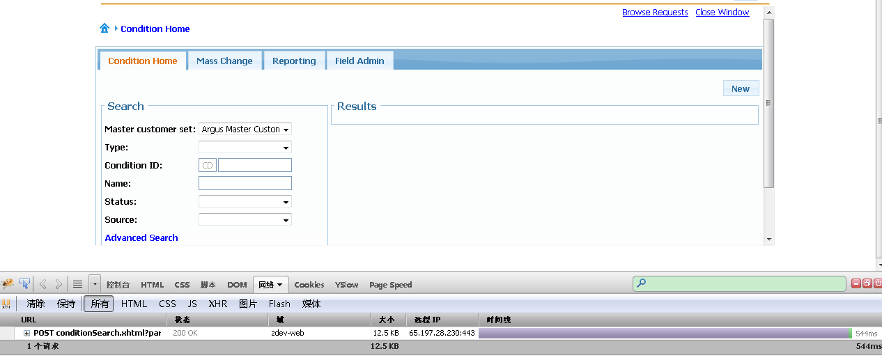

Figure 18 Condition Search

But it indicates that the "View Selected" button enabled immediately in Condition application when the checkbox is chosen,

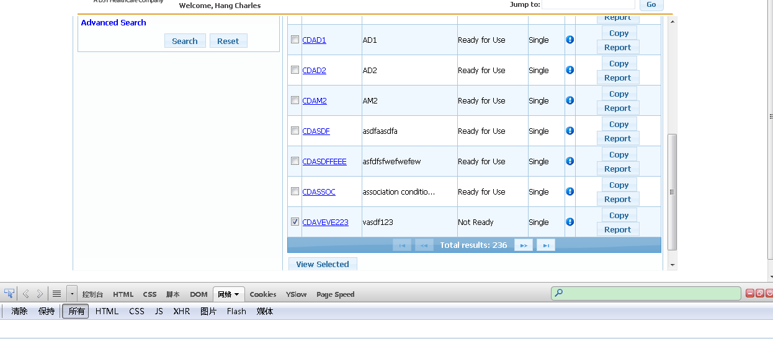

Figure 19 Condition View Selected

As shown above, there's also no request to the server during this operation. So there's no standard way of handling this behavior, however, performance can be optimized by changing the backend interaction to only the front-end event.

**Code Analysis**

By looking at each request to the backend, the response content is larger than it should be, which means, for example, in issue #1, besides the new content of the search criteria area is returned from the server, there is a lot of other content that is also returned from server.

<update id=*"general_error_form:j_idt18"*>

<update id=*"browseRequestsDlgForm:j_idt22"*>

<update id=*"drugListDetailsForm:j_idt101"*>

<update id=*"drugListDeatails_tabView:copyDrugListPopupForm:copy_globalMessages"*>

<update id=*"drugListDeatails_tabView:editDrugListPopupForm:globalMessages"*>

<update id=*"drugListDeatails_tabView:drugListDetailEntriesForm:levelValuePanel"*>

<update id=*"drugListDeatails_tabView:drugListDetailEntriesForm:btnEditSelected"*>

<update id=*"drugListDeatails_tabView:drugListDetailEntriesForm:btnDeleteSelected"*>

<update id=*"drugListDeatails_tabView:drugListNDCSearchDlgForm:globalMessages"*>

<update id=*"drugListDeatails_tabView:drugListAddEntriesForm:globalMessages"*>

<update id=*"drugListDeatails_tabView:drugListAddEntriesForm:j_idt512"*>

<update id=*"drugListDeatails_tabView:drugListAddEntriesForm:j_idt598"*>

<update id=*"reportingOptionsPopup"*>

...

In the code, the update scope is extended by setting many of the panels to "autoUpdate". While this may not be the key cause for the issue, it will certainly increase the page rendering time.

**Solutions and Verification**

There're also several other issues related to this kind of cause, like #22, #28, #29 in DL and #8, #9, #11, #18, #19, #27, #28, #29 in MC. The solution is to change the backend interaction to the front end just like "View Selected" button in the Conditions application. However, it is also a poor practice to destroy the common pattern of JSF, so the change is only made to the issues which are larger than 3 seconds.

### 3.1.6 Unnecessary SQL execution

**Symptom Analysis**

There are certain types of issues where the user does not have much operation, but the response time of the application is relatively large. The gap between the JSF and the Flex application is not acceptable in these scenarios.

***Issue #6 Analysis:***

" Close an empty request to the blank search results screen". The operation is pretty simple and straightforward, just click the close button on below screen shot. 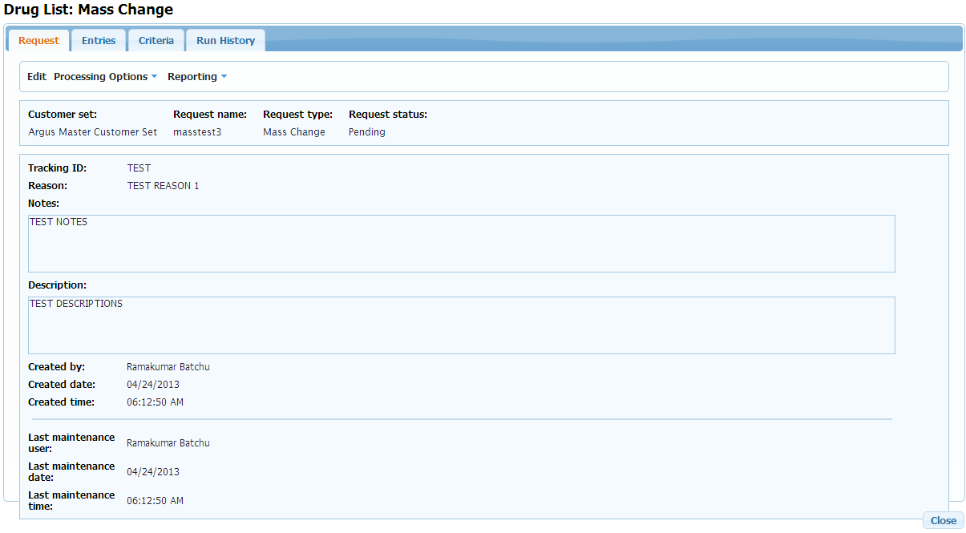

Figure 20 Close Empty Request

But the response time is unusually slow for this operation; it takes almost 2 seconds for the HTTPWatch and 3.4 seconds in StopWatch. The request appears to be fine, which doesn't have any redundant sub-requests. But by looking at the server log listed below, it shows that the server is obviously executing the DB query to get CustomerSet information when closing the request dialog, which is the main reason why the page is slower than the Flex page.

[#|2013-04-13T11:47:06.279+0800|INFO|glassfish3.1.2|javax.enterprise.system.std.com.sun.enterprise.server.logging|_ThreadID=549;_ThreadName=Thread-2;|11:47:06.279 [p: thread-pool-1; w: 4] DEBUG org.eclipse.persistence - SELECT t1.CUSTOMER_SET_ID, t1.CUSTOMER_SET_STATUS_EFFV_DT, t1.LAST_MNT_OPID, t1.LAST_MNT_TS, t1.TEST_CLM_STD_SET_CLM_CT, t1.TEST_CLM_STD_SET_SCENARIO_CT, t1.TST_CLM_STD_SET_TST_CRN_CT, t1.CUSTOMER_SET_LONG_NM, t1.SET_LEVEL_BENEFIT_MAINT_CD, t1.CUSTOMER_SET_STATUS_CD, t1.CUSTOMER_SET_TYPE_ID, t1.MASTER_CUSTOMER_SET_ID, t0.CUSTOMER_SET_TYPE_ID, t0.CUSTOMER_SET_TYPE_LNG_NM, t0.CUSTOMER_SET_TYPE_CD, t2.CUSTOMER_SET_ID, t2.CUSTOMER_SET_STATUS_EFFV_DT, t2.LAST_MNT_OPID, t2.LAST_MNT_TS, t2.MASTER_CUSTOMER_SET_ID, t2.CUSTOMER_SET_LONG_NM, t2.SET_LEVEL_BENEFIT_MAINT_CD, t2.CUSTOMER_SET_STATUS_CD, t3.CUSTOMER_ID, t3.CUSTOMER_SET_TYPE_ID, t3.CUSTOMER_SET_ID FROM ARGDO2.C76_A999 t1 LEFT OUTER JOIN ARGDO2.E21_A999 t3 ON (t3.CUSTOMER_SET_ID = t1.CUSTOMER_SET_ID), ARGDO2.C76_A999 t2, ARGDO2.E20_A999 t0 WHERE ((t0.CUSTOMER_SET_TYPE_CD = ?) AND ((t0.CUSTOMER_SET_TYPE_ID = t1.CUSTOMER_SET_TYPE_ID) AND (t2.CUSTOMER_SET_ID = t1.MASTER_CUSTOMER_SET_ID))) ORDER BY t1.CUSTOMER_SET_LONG_NM ASC

|#]

[#|2013-04-13T11:47:06.838+0800|INFO|glassfish3.1.2|javax.enterprise.system.std.com.sun.enterprise.server.logging|_ThreadID=565;_ThreadName=Thread-2;|11:47:06.838 [p: thread-pool-1; w: 8] INFO c.a.c.service.CustomerSetServiceBean - starting findAllSetsForType

|#]

[#|2013-04-13T11:47:06.839+0800|INFO|glassfish3.1.2|javax.enterprise.system.std.com.sun.enterprise.server.logging|_ThreadID=565;_ThreadName=Thread-2;|11:47:06.839 [p: thread-pool-1; w: 8] DEBUG c.a.c.service.CustomerSetServiceBean - findAllSetsForType with type: BENEFIT

|#]

[#|2013-04-13T11:47:06.839+0800|INFO|glassfish3.1.2|javax.enterprise.system.std.com.sun.enterprise.server.logging|_ThreadID=565;_ThreadName=Thread-2;|11:47:06.839 [p: thread-pool-1; w: 8] DEBUG c.a.c.service.CustomerSetServiceBean - creating named query for CUSTOMER_SETS_FOR_ONLY_TYPE_JPQL

|#]

[#|2013-04-13T11:47:06.839+0800|INFO|glassfish3.1.2|javax.enterprise.system.std.com.sun.enterprise.server.logging|_ThreadID=565;_ThreadName=Thread-2;|11:47:06.839 [p: thread-pool-1; w: 8] DEBUG c.a.c.service.CustomerSetServiceBean - setting typeCode parameter

|#]

[#|2013-04-13T11:47:06.840+0800|INFO|glassfish3.1.2|javax.enterprise.system.std.com.sun.enterprise.server.logging|_ThreadID=565;_ThreadName=Thread-2;|11:47:06.840 [p: thread-pool-1; w: 8] DEBUG c.a.c.service.CustomerSetServiceBean - retrieving result list

|#]

[#|2013-04-13T11:47:06.840+0800|INFO|glassfish3.1.2|javax.enterprise.system.std.com.sun.enterprise.server.logging|_ThreadID=565;_ThreadName=Thread-2;|11:47:06.840 [p: thread-pool-1; w: 8] DEBUG org.eclipse.persistence - SELECT t1.CUSTOMER_SET_ID, t1.CUSTOMER_SET_STATUS_EFFV_DT, t1.LAST_MNT_OPID, t1.LAST_MNT_TS, t1.TEST_CLM_STD_SET_CLM_CT, t1.TEST_CLM_STD_SET_SCENARIO_CT, t1.TST_CLM_STD_SET_TST_CRN_CT, t1.CUSTOMER_SET_LONG_NM, t1.SET_LEVEL_BENEFIT_MAINT_CD, t1.CUSTOMER_SET_STATUS_CD, t1.CUSTOMER_SET_TYPE_ID, t1.MASTER_CUSTOMER_SET_ID, t0.CUSTOMER_SET_TYPE_ID, t0.CUSTOMER_SET_TYPE_LNG_NM, t0.CUSTOMER_SET_TYPE_CD, t2.CUSTOMER_SET_ID, t2.CUSTOMER_SET_STATUS_EFFV_DT, t2.LAST_MNT_OPID, t2.LAST_MNT_TS, t2.MASTER_CUSTOMER_SET_ID, t2.CUSTOMER_SET_LONG_NM, t2.SET_LEVEL_BENEFIT_MAINT_CD, t2.CUSTOMER_SET_STATUS_CD, t3.CUSTOMER_ID, t3.CUSTOMER_SET_TYPE_ID, t3.CUSTOMER_SET_ID FROM ARGDO2.C76_A999 t1 LEFT OUTER JOIN ARGDO2.E21_A999 t3 ON (t3.CUSTOMER_SET_ID = t1.CUSTOMER_SET_ID), ARGDO2.C76_A999 t2, ARGDO2.E20_A999 t0 WHERE ((t0.CUSTOMER_SET_TYPE_CD = ?) AND ((t0.CUSTOMER_SET_TYPE_ID = t1.CUSTOMER_SET_TYPE_ID) AND (t2.CUSTOMER_SET_ID = t1.MASTER_CUSTOMER_SET_ID))) ORDER BY t1.CUSTOMER_SET_LONG_NM ASC

|#]

[#|2013-04-13T11:47:07.459+0800|INFO|glassfish3.1.2|javax.enterprise.system.std.com.sun.enterprise.server.logging|_ThreadID=563;_ThreadName=Thread-2;|11:47:07.459 [p: thread-pool-1; w: 6] INFO c.a.c.service.CustomerSetServiceBean - starting findAllSetsForType

|#]

[#|2013-04-13T11:47:07.460+0800|INFO|glassfish3.1.2|javax.enterprise.system.std.com.sun.enterprise.server.logging|_ThreadID=563;_ThreadName=Thread-2;|11:47:07.460 [p: thread-pool-1; w: 6] DEBUG c.a.c.service.CustomerSetServiceBean - findAllSetsForType with type: BENEFIT

|#]

[#|2013-04-13T11:47:07.460+0800|INFO|glassfish3.1.2|javax.enterprise.system.std.com.sun.enterprise.server.logging|_ThreadID=563;_ThreadName=Thread-2;|11:47:07.460 [p: thread-pool-1; w: 6] DEBUG c.a.c.service.CustomerSetServiceBean - creating named query for CUSTOMER_SETS_FOR_ONLY_TYPE_JPQL

|#]

[#|2013-04-13T11:47:07.460+0800|INFO|glassfish3.1.2|javax.enterprise.system.std.com.sun.enterprise.server.logging|_ThreadID=563;_ThreadName=Thread-2;|11:47:07.460 [p: thread-pool-1; w: 6] DEBUG c.a.c.service.CustomerSetServiceBean - setting typeCode parameter

|#]

[#|2013-04-13T11:47:07.461+0800|INFO|glassfish3.1.2|javax.enterprise.system.std.com.sun.enterprise.server.logging|_ThreadID=563;_ThreadName=Thread-2;|11:47:07.460 [p: thread-pool-1; w: 6] DEBUG c.a.c.service.CustomerSetServiceBean - retrieving result list

|#]

[#|2013-04-13T11:47:07.461+0800|INFO|glassfish3.1.2|javax.enterprise.system.std.com.sun.enterprise.server.logging|_ThreadID=563;_ThreadName=Thread-2;|11:47:07.461 [p: thread-pool-1; w: 6] DEBUG org.eclipse.persistence - SELECT t1.CUSTOMER_SET_ID, t1.CUSTOMER_SET_STATUS_EFFV_DT, t1.LAST_MNT_OPID, t1.LAST_MNT_TS, t1.TEST_CLM_STD_SET_CLM_CT, t1.TEST_CLM_STD_SET_SCENARIO_CT, t1.TST_CLM_STD_SET_TST_CRN_CT, t1.CUSTOMER_SET_LONG_NM, t1.SET_LEVEL_BENEFIT_MAINT_CD, t1.CUSTOMER_SET_STATUS_CD, t1.CUSTOMER_SET_TYPE_ID, t1.MASTER_CUSTOMER_SET_ID, t0.CUSTOMER_SET_TYPE_ID, t0.CUSTOMER_SET_TYPE_LNG_NM, t0.CUSTOMER_SET_TYPE_CD, t2.CUSTOMER_SET_ID, t2.CUSTOMER_SET_STATUS_EFFV_DT, t2.LAST_MNT_OPID, t2.LAST_MNT_TS, t2.MASTER_CUSTOMER_SET_ID, t2.CUSTOMER_SET_LONG_NM, t2.SET_LEVEL_BENEFIT_MAINT_CD, t2.CUSTOMER_SET_STATUS_CD, t3.CUSTOMER_ID, t3.CUSTOMER_SET_TYPE_ID, t3.CUSTOMER_SET_ID FROM ARGDO2.C76_A999 t1 LEFT OUTER JOIN ARGDO2.E21_A999 t3 ON (t3.CUSTOMER_SET_ID = t1.CUSTOMER_SET_ID), ARGDO2.C76_A999 t2, ARGDO2.E20_A999 t0 WHERE ((t0.CUSTOMER_SET_TYPE_CD = ?) AND ((t0.CUSTOMER_SET_TYPE_ID = t1.CUSTOMER_SET_TYPE_ID) AND (t2.CUSTOMER_SET_ID = t1.MASTER_CUSTOMER_SET_ID))) ORDER BY t1.CUSTOMER_SET_LONG_NM ASC

bind => [BN]

|#]

[#|2013-04-13T11:47:08.024+0800|INFO|glassfish3.1.2|javax.enterprise.system.std.com.sun.enterprise.server.logging|_ThreadID=562;_ThreadName=Thread-2;|11:47:08.024 [p: thread-pool-1; w: 5] INFO c.a.c.service.CustomerSetServiceBean - starting findAllSetsForType

|#]

[#|2013-04-13T11:47:08.025+0800|INFO|glassfish3.1.2|javax.enterprise.system.std.com.sun.enterprise.server.logging|_ThreadID=562;_ThreadName=Thread-2;|11:47:08.025 [p: thread-pool-1; w: 5] DEBUG c.a.c.service.CustomerSetServiceBean - findAllSetsForType with type: BENEFIT

|#]

[#|2013-04-13T11:47:08.025+0800|INFO|glassfish3.1.2|javax.enterprise.system.std.com.sun.enterprise.server.logging|_ThreadID=562;_ThreadName=Thread-2;|11:47:08.025 [p: thread-pool-1; w: 5] DEBUG c.a.c.service.CustomerSetServiceBean - creating named query for CUSTOMER_SETS_FOR_ONLY_TYPE_JPQL

|#]

[#|2013-04-13T11:47:08.025+0800|INFO|glassfish3.1.2|javax.enterprise.system.std.com.sun.enterprise.server.logging|_ThreadID=562;_ThreadName=Thread-2;|11:47:08.025 [p: thread-pool-1; w: 5] DEBUG c.a.c.service.CustomerSetServiceBean - setting typeCode parameter

|#]

[#|2013-04-13T11:47:08.026+0800|INFO|glassfish3.1.2|javax.enterprise.system.std.com.sun.enterprise.server.logging|_ThreadID=562;_ThreadName=Thread-2;|11:47:08.026 [p: thread-pool-1; w: 5] DEBUG c.a.c.service.CustomerSetServiceBean - retrieving result list

|#]

[#|2013-04-13T11:47:08.026+0800|INFO|glassfish3.1.2|javax.enterprise.system.std.com.sun.enterprise.server.logging|_ThreadID=562;_ThreadName=Thread-2;|11:47:08.026 [p: thread-pool-1; w: 5] DEBUG org.eclipse.persistence - SELECT t1.CUSTOMER_SET_ID, t1.CUSTOMER_SET_STATUS_EFFV_DT, t1.LAST_MNT_OPID, t1.LAST_MNT_TS, t1.TEST_CLM_STD_SET_CLM_CT, t1.TEST_CLM_STD_SET_SCENARIO_CT, t1.TST_CLM_STD_SET_TST_CRN_CT, t1.CUSTOMER_SET_LONG_NM, t1.SET_LEVEL_BENEFIT_MAINT_CD, t1.CUSTOMER_SET_STATUS_CD, t1.CUSTOMER_SET_TYPE_ID, t1.MASTER_CUSTOMER_SET_ID, t0.CUSTOMER_SET_TYPE_ID, t0.CUSTOMER_SET_TYPE_LNG_NM, t0.CUSTOMER_SET_TYPE_CD, t2.CUSTOMER_SET_ID, t2.CUSTOMER_SET_STATUS_EFFV_DT, t2.LAST_MNT_OPID, t2.LAST_MNT_TS, t2.MASTER_CUSTOMER_SET_ID, t2.CUSTOMER_SET_LONG_NM, t2.SET_LEVEL_BENEFIT_MAINT_CD, t2.CUSTOMER_SET_STATUS_CD, t3.CUSTOMER_ID, t3.CUSTOMER_SET_TYPE_ID, t3.CUSTOMER_SET_ID FROM ARGDO2.C76_A999 t1 LEFT OUTER JOIN ARGDO2.E21_A999 t3 ON (t3.CUSTOMER_SET_ID = t1.CUSTOMER_SET_ID), ARGDO2.C76_A999 t2, ARGDO2.E20_A999 t0 WHERE ((t0.CUSTOMER_SET_TYPE_CD = ?) AND ((t0.CUSTOMER_SET_TYPE_ID = t1.CUSTOMER_SET_TYPE_ID) AND (t2.CUSTOMER_SET_ID = t1.MASTER_CUSTOMER_SET_ID))) ORDER BY t1.CUSTOMER_SET_LONG_NM ASC

bind => [BN]

|#]

***“Find Entry” Issue Analysis***

"In Mass Change, find entries or related operations is very slow". See blow issue logs, the operation is straightforward, and in DrugList, there is a similar operation, which is finding the entries according to the search criteria, please refer to figure 21,

Table 11 Response Time of Find Entries Operation

|  |  |  |  |  |  |  |
| --- | --- | --- | --- | --- | --- | --- |
| Windows 7 Compt (SW timed) | My Computer (SW timed) | My Computer (SW Timed) |  |  |  |  |
| 1st 2.0 2nd 1.8 | 1st 4.3 2nd 3.8 | 8349 entries 1st time 6.2 2nd time 11.8 3rd time 11.8 4th 12.6 5th 12.3 | 2.5 | 16 | H | Clicking to the next page when 135 results are returned |
| 1st 1.8 2nd 2.1 | 1st 4.2 2nd 4.6 | 8349 entries 1st time 11.8 2nd 11.1 3rd 10.4 4th 10.6 5th 15.4 | N/A | 17 | H | Clicking on >> icon to go to last result- clicking on the paging to the screen notcing you clicked on it to the time it actually moves is very long. I get confused on whether it accepted my click |
| 1st time 3.5, 2nd time 1.9 | 1st time 6.2 2nd 2.1 | 1st 26.5 2nd 13.1 3rd 3.8 4th 11.6 5th 13.1 | 3.1 | 22 | H4 | OK to entry screen |
| 1st 11.5 2nd 7.4 | 1st 22.4 2nd 19.1 | 13.5 10 9.8 9.8 9.3 | 5.566 (flex on 4-8) | 15A |  | Mass Change Find Entries. Searched by Customer set, GCN and value (57901), aprx 5 entries returned |

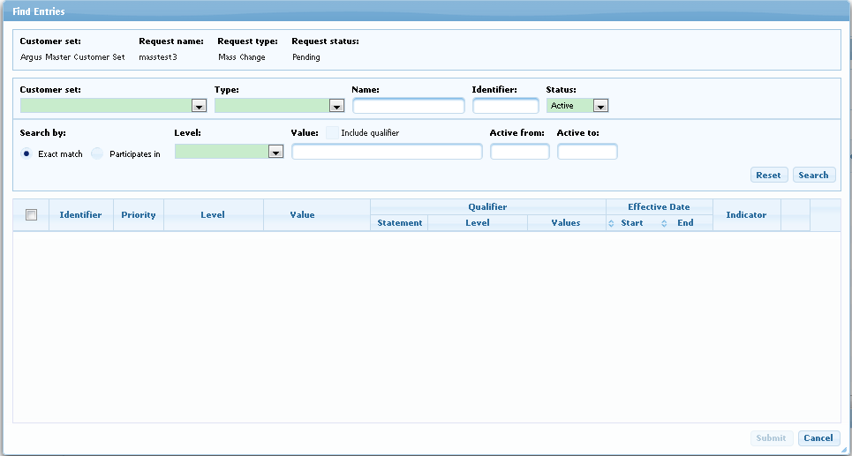

Figure 21 Find Entries Page

The request also seems normal which doesn't have redundant sub-requests, but when looking at the SQL it executes, it shows that the search query is not optimized; each search operation will trigger the process below.

 DB Hit 1: SELECT COUNT(*)   FROM ARGDO2.F06_A999 F06   INNER JOIN ARGDO2.F04_A999 F04     ON F04.DRUG_LIST_ID = F06.DRUG_LIST_ID   INNER JOIN ARGDO2.F02_A999 F02     ON F04.DRUG_LIST_TYPE_ID = F02.DRUG_LIST_TYPE_ID   LEFT OUTER JOIN ARGDO2.P35 P35     ON F04.FREE_FORM_MESSAGE_ID = P35.FREE_FORM_MESSAGE_ID   WHERE F02.DRUG_LIST_TYPE_STATUS_CD = ?typeStatusCode     AND F02.DRG_LIST_TYP_BENEFIT_PLAN_CD = ?benefitPlanCode         AND F06.CUSTOMER_SET_ID = ?customerSetId      AND F06.DRUG_LIST_STATUS_CD = ?drugListStatusCode      AND ((F04.DRUG_LIST_ENTRY_LIST_ID IS NULL           )       OR (F04.DRUG_LIST_ENTRY_LIST_ID IS NOT NULL           AND EXISTS (SELECT 1                       FROM ARGDO2.F04_A999 F04C                       WHERE F04C.DRUG_LIST_ID = F04.DRUG_LIST_ENTRY_LIST_ID                         )       OR ( F04.DRUG_LIST_ENTRY_LIST_ID IS NOT NULL  )  )                  )  FOR READ ONLY WITH UR

DB Hit 2: entry_ids = SELECT F04.DRUG_LIST_ENTRY_ID, F06.DRUG_LIST_ID FROM ARGDO2.F04 F04 INNER JOIN ARGDO2.F06 F06 ON F04.DRUG_LIST_ID = F06.DRUG_LIST_ID WHERE F04.DRUG_LIST_ENTRY_ID IN (368138, 366145, 366146, 366151, 366147, 366148, 366150, 366153, 366152, 366149, 366154, 368137, 366156, 366158, 366157, 366159, 366160, 366161, 366163, 366162, 366164, 366165, 366166, 366167, 366168, 366170, 366169, 366171, 366172, 366174, 366173, 366175, 366176, 366179, 366178, 366177, 366180, 366183, 366182, 366181, 366184, 366185, 366186, 366187, 366188, 366190, 366189, 366192, 366191, 366199);

for each id in entry_ids

          do

                 DB Hit 3: fetch entry from F04

                 DB Hit 4:fetch druglist from F06 associated with the entry

                  DB Hit 5: fetch druglist from F06 associated with the entry (duplicated SQL call)

            end

             add the entry to result list

end

There is actually a loop invocation of SQL to find detail information for each entry, for each look, it has 3 queries, which means if the current page size is 50, there will be 150 DB hits for one operation. This is the reason why it is very slow.

**Technical Analysis**

Every backend operation, especially those containing DB interaction takes a long time. The database query is treated as a very heavy operation for an Internet application, so it should be used very carefully, as minimal as possible.

**Code Analysis**

For this performance issue, it can be avoided by reducing the unnecessary SQL queries when doing the operation. Approaches could be 1. introducing cache mechanism, such as Customer Set; or 2.reducing the DB hits, such as entries search. All of these have one faith, which is doing the minimum SQL invocation to complete the task, since the DB operation requires a lot of time occasionally.

**Solutions and Verification**

For the close request dialog, the team has accommodated the code to use cached Customer Set information, and the response time is reduced to 537ms.

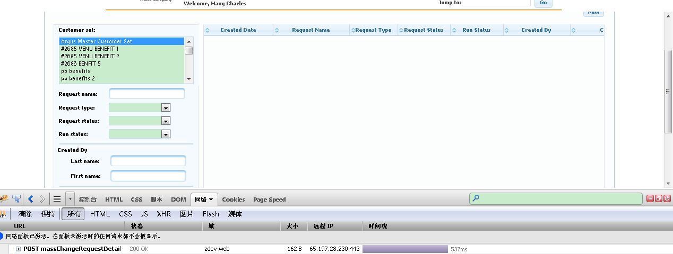

Figure 22 Close Mass Chane Request Dialog

For the search entries, a quick tuning is to eliminate the duplicate DB hit #5. Testing on ZDEV shows that it's getting better backend timing as shown below:

Table 12 Response Time after Tuning

|  |  |  |
| --- | --- | --- |
| **# of Attempt** | **Current Time** | **After DB hit 5 was eliminated** |
| 1 | 3.42 | 3.68 |
| 2 | 2.15 | 2.29 |
| 3 | 4.29 | 2.15 |
| 4 | 2.04 | 2.27 |
| 5 | 3.43 | 2.17 |
| 6 | 7 | 2.39 |
| 7 | 3.18 | 2.01 |
| 8 | 2.76 | 2.17 |
| 9 | 2.61 | 2.7 |
| AVG | 3.43 | 2.42 (29% gain) |

There is a 29% performance improvement for the quick tuning strategy, by removing #5 from the loop. If optimizing the search SQL to a single one, further performance can be gained..

### 3.1.7 Misc

There are also several other issues that are not the main cause of a specific performance issue but may affect the performance of almost every scenario. A quick performance tuning has also been done for these.

**Performance Optimization with Caching for Permission Check**

***Issue* Description*:***

The new Druglist application has data level permission check which calls the database recursively to do a complex evaluation before real business logic every time. The DB access is expensive and unnecessary when the permission is already checked for one record. Current permission check does not use cache properly which means every time it needs permission check, it will call the database to get the security data.

***Solution:***

Add caching mechanism to permission check component so that it only performs at the first time.

***Test* Result*:***

Below are some comparisons of typical scenarios after the optimization. Note that the total time is ignored here since the network is very unstable at this point in time and the network transfer time is inadequate. Note:

* The section in yellow background is the time spent with permission check caching.
* The section in white background is the time spent without permission check caching.

1) Click a druglist record in the druglist result table.

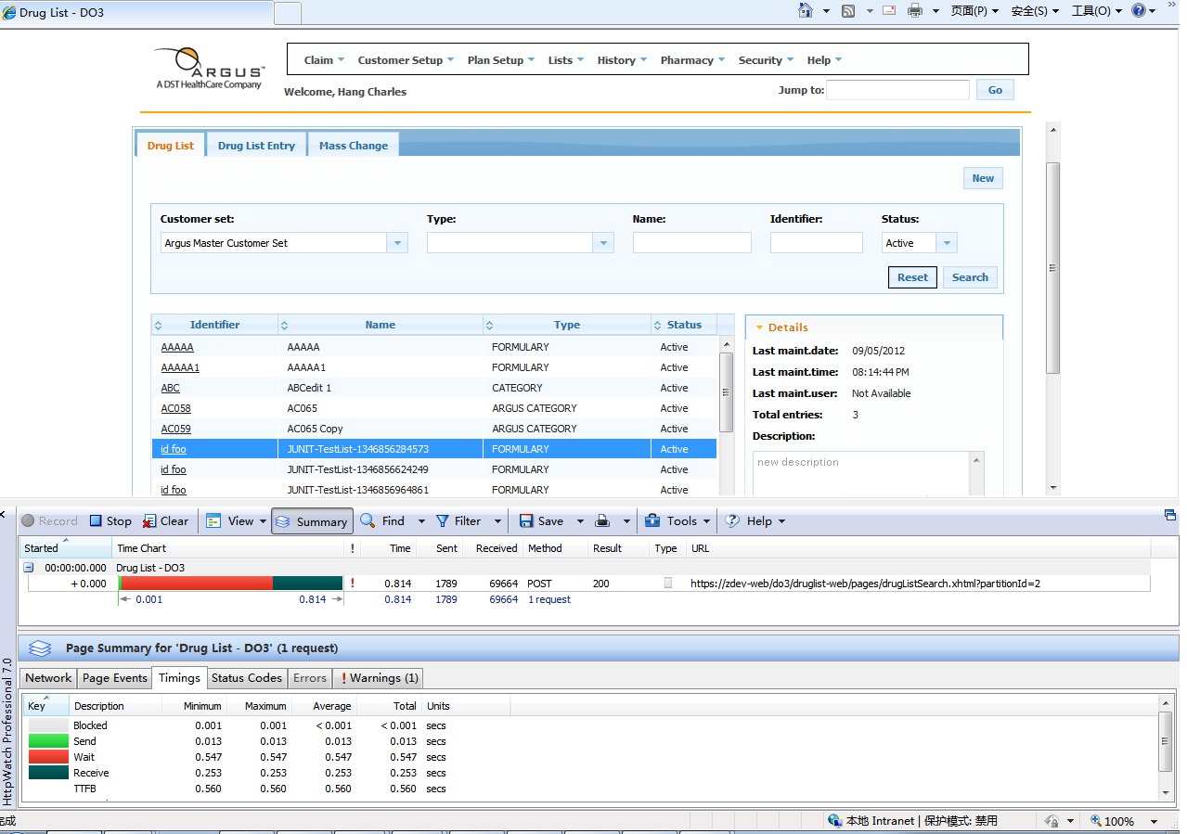

Figure 23 View Durglist Record

Table 13 Response Time of View Durglist Record

|  |  |  |
| --- | --- | --- |
|  | **Backend(wait time in Http Watch)** | |
|  | **Without Permission Cache** | **With Permission Cache** |
| 1 | 0.748 | 0.644 |
| 2 | 1.116 | 0.535 |
| 3 | 0.976 | 0.547 |
| 4 | 0.879 | 0.584 |
| 5 | 1.008 | 0.867 |
| 6 | 0.601 | 0.574 |
| 7 | 0.647 | 0.592 |
| 8 | 0.714 | 0.522 |
| 9 | 0.564 | 0.918 |
| 10 | 1.172 | 0.794 |
| AVG | 0.8425 | 0.6577, reduced by 22% |

2) Click the Detail accordion in the right side of the druglist result table.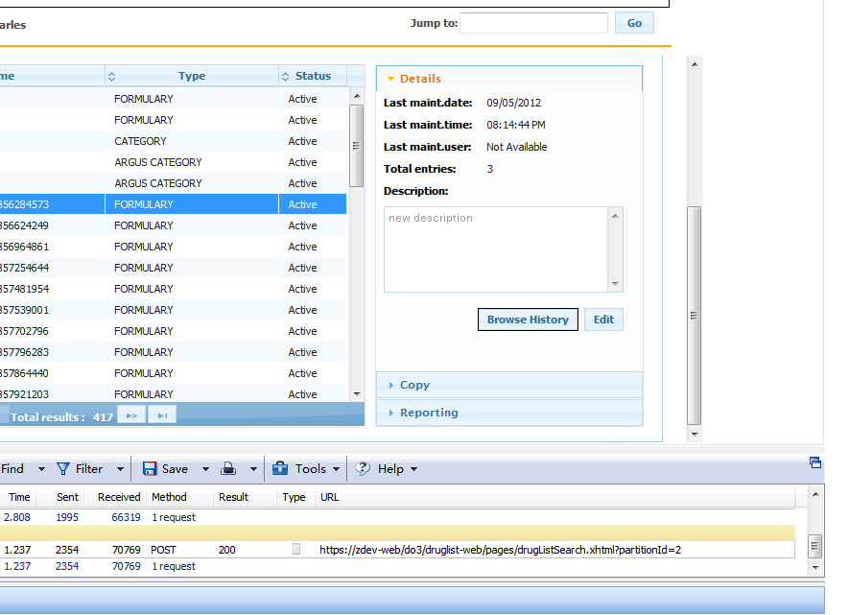

Figure 24 Click Detail Accordion

Table 14 Response Time of Click Detail Accordion

|  |  |  |
| --- | --- | --- |
|  | **Backend(wait time in Http Watch)** | |
|  | Without Permission Cache | With Permission Cache |
| 1 | 0.945 | 0.516 |
| 2 | 0.697 | 0.521 |
| 3 | 0.854 | 0.516 |
| 4 | 0.732 | 0.509 |
| 5 | 0.956 | 1.093 |
| 6 | 0.683 | 0.808 |
| 7 | 0.678 | 0.554 |
| 8 | 1.442 | 0.733 |
| 9 | 0.782 | 0.623 |
| 10 | 0.735 | 0.579 |
| AVG | 0.8504 | 0.6452, reduced by 24% |

3) Click Submit button to create a new druglist on the New Drug List pop up.

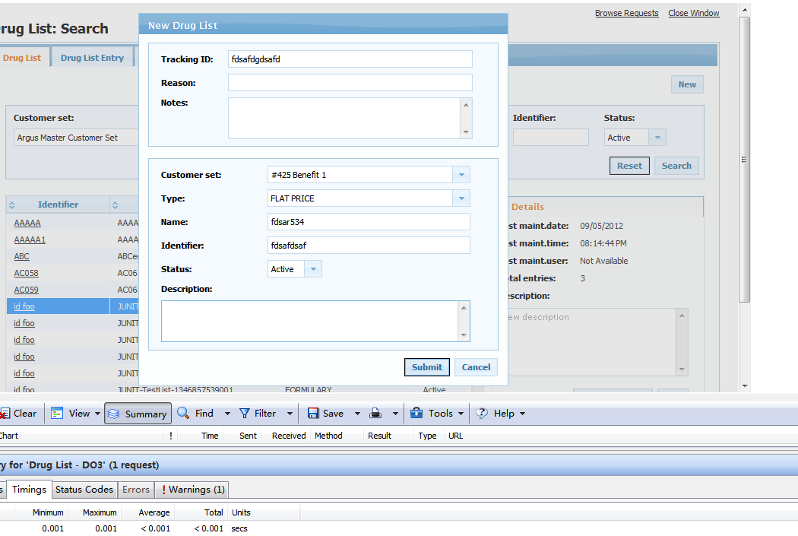

Figure 25 Create DurgList Dialog

Table 15 Response Time of Open Create DurgList Dialog

|  |  |  |
| --- | --- | --- |
|  | **Backend(wait time in Http Watch)** | |
|  | Without Permission Cache | With Permission Cache |
| 1 | 3.651 | 2.434 |
| 2 | 1.658 | 2.882 |
| 3 | 2.701 | 1.891 |
| 4 | 7.238 | 1.6 |
| 5 | 1.701 | 1.706 |
| 6 | 3.501 | 1.732 |
| 7 | 3.373 | 1.595 |
| 8 | 1.703 | 1.713 |
| 9 | 1.584 | 1.697 |
| 10 | 1.882 | 1.614 |
| AVG | 2.8992 | 1.8864, reduced by 35% |

4) Click Submit button to update a Druglist on the Edit Drug List pop up.

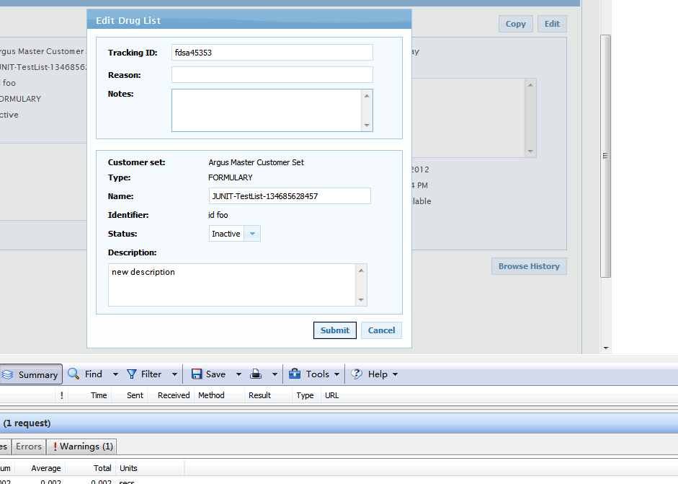

Figure 26 Update DrugList

Table 16 Response Time of Update DrugList

|  |  |  |
| --- | --- | --- |
|  | **Backend(wait time in Http Watch)** | |
|  | Without Permission Cache | With Permission Cache |
| 1 | 1.067 | 0.821 |
| 2 | 1.253 | 0.77 |
| 3 | 0.965 | 0.833 |
| 4 | 0.636 | 0.639 |
| 5 | 0.651 | 0.667 |
| 6 | 1.084 | 0.602 |
| 7 | 0.727 | 0.619 |
| 8 | 2 | 0.676 |
| 9 | 1.423 | 0.629 |
| 10 | 1.041 | 0.619 |
| AVG | 1.0847 | 0.6875, reduced by 37% |

**Summary*:***

This solution has created an overall performance improvement on not only Druglist, but also on all the other existing re-engineered applications. It may not solve a specific issue since most of issues are caused by the front-end in Druglist, but it is believed to have architectural benefit on all applications.

**Change Page Block Scope**

***Issue* Description*:***

Currently, the re-engineering applications widely use page block behavior. When the user executes an operation, the page will be blocked by an ajax icon, and the user will wait for the operation to complete before doing the next action. See screenshot below, it is the search operation for Mass Change, the operation blocks all the page during the search.

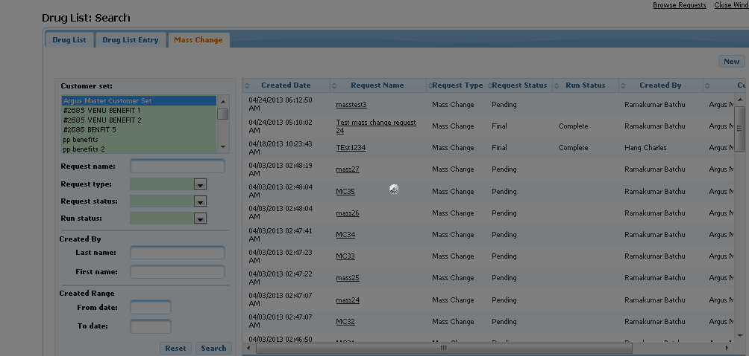

Figure 27 Page Block for Mass Change Search before Tuning

For most scenarios, this works perfectly since most of the user action is step by step. However, for some operations, which can be executed at the same time, this behavior will affect the user experience from a performance perspective.

**Solution*:***

A feature in Primefaces called block-ui was used, which can let the developer define the area on the page to block during the operation rather than block all pages. In this case, the user can do other actions during the current operation and bring a better user experience from a performance perspective.

After using block-ui, the search will only block the search result area, which means if the user wants to go to other tap during the search, he can do it.

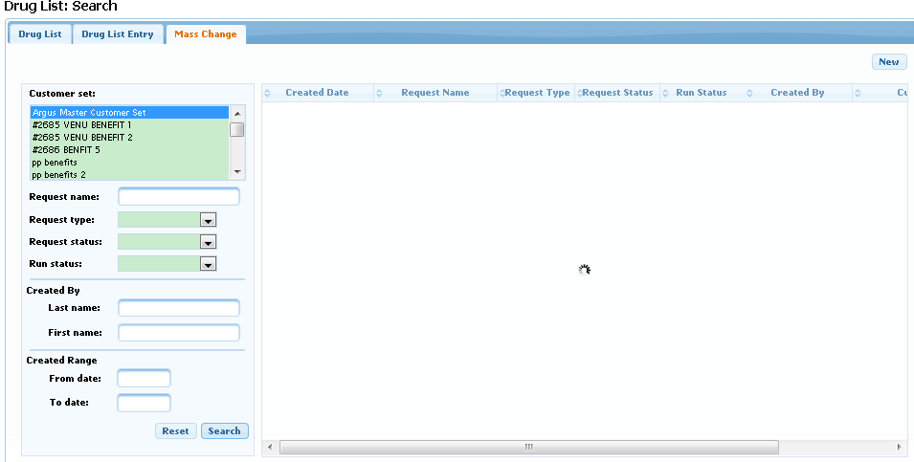

Figure 28 Page Block for Mass Change Search after Tuning

**Summary*:***

Application performance is somehow related to the user experience, which means large server response time can also give the user "fast" expression for the application if it's treated properly, and vice versa. The developer should focus on the real user experience when doing performance tuning.

## 3.2. Summary of Recommendations

Based on the performance tuning that was done for the DrugList application, there are several recommendations that are summarized below that should be applied to future development:

* The resource files should be optimized in the UAT/Prod environment. The resource files should not be compressed for the development environment since it increases the difficulty for a developer to diagnose the bugs reported. However, it must be compressed when released to UAT/Prod, where the user experience is much more important.
* Solving the performance and requirement conflict. Some performance issues are not just about technology, since every technology has its features and limitations. For example, Flex is more user interactive but is not widely supported by certain browsers and does not support an ADA standard. Javascript is much more flexible but is difficult to maintain. JSF has a better standard but the customization and performance is not good ...etc. One needs to balance how to achieve the business goals with the proper use of technology. An issue like page size design is more like performance and requirement conflict which binding to specific technology and requirement. It should be reported and discussed during the development phase.
* Using a client standard to optimize performance. It is not always true the developer should use a client standard like Javascript, since it violates the concept of JSF development. But it does make sense to use a client standard to solve performance issues when required.
* Reduce the unnecessary SQL/EJB invocation, and limit the "update" to the minimal scope. The best practice of allocating the minimal resource to complete the task is always true for every scenario when it needs to determine whether the invocation is necessary, and whether the update is necessary when developing the application.

# Appendix A DurgList Issues 04/10 version

DrugList:

|  |  |  |  |  |
| --- | --- | --- | --- | --- |
| **ID** | **Action** | **Flex Version** | **JSF Version (before tuning 4-11 UA1)** | **JSF Version (after tuning 4-17-13 UA1)** |
| 1 | Choosing customer set name on main drug list search screen |  |  |  |
| 2 | Search to find a list to getting results |  |  |  |
| 3 | Search by partial name/description with * to getting results | 1 |  |  |
| 4 | Searching by partial ID with 8 to getting results | 0.9 |  |  |
| 6 | Selecting a list with approx 1,300 entries to view to the time the page opens with the entries displaying | 1.3 (previous to 4-8-13) 1.073 (2.0 with SW) 1596 entries 4-8-13 | 7.0 | 1st 3.3 2nd 4.3 3rd 2.3 4th 2.1 5th 2.3 |
| 7 | Selecting a list with approx 27,804 entries to view to the time the page opens with the entries displaying | 1.8 (previous to 4-8-13) 1.181 (2.0 with SW) 28362 entries 4-8-13 | 8.2 | 1st 2.3 2nd 2.2 3rd 3.2 4th 2.5 5th 2.6 |
| 8 | Selecting a list with approx 88,448 entries to view to the time the page opens with the entries displaying | 1.6 (previous to 4-8-13) 1.198 (2.3 with SW) 88448 entries 4-8-13 | 9.1 | 1st 4.5 2nd 2.8 3rd 3.1 4th 3.1 5th 3.3 |
| 9 | When multiple results return for drug lists, the time spent clicking between each list description and when the detail accordian changes to the lists data |  |  |  |
| 10 | Selecting 3 entries on a list (only clicking the checkmark in the box) to when the edit selected button enables 4-8-13 Faith Update: The button enables when clicking the first entry. No extra time is spent by selecting any entry after the first |  |  |  |
| 11 | Closing a list from the main entry screen of a drug list |  |  | 1st 2.1 2nd 1.6 3rd 1.9 4th 1.9 5th 2.1 |
| 12 | Clicking on the add button to the time the add pop up appears and is ready for entries |  |  | 2.7 2.0 1.5 1.6 1.6 |
| 13 | On the add pop up the time it takes to choose a level option and the time the system is ready for me to enter a value |  |  | 1.5 1.1 1.1 1.1 1 |
| 14 | Saving one added entry to the drug list | 1.4 | 8.0 | 1st 3.2 2nd 1.9 3rd 3.8 4th 2.7 5th 2.0 |
| 16 | Update of 3 entries and the time it takes to save to drug list | 3.3 | 1st 25.4 2nd 20.5 3rd 20.2 total 66.1 | **1 set of 3** 1st 2.3 2nd 3.7 3rd 1.6 **2nd set of 3** 1st 3.1 2nd 1.8 3rd 1.6 |
| 17 | Open blue icon to the level/value description pop up | 0.5 |  |  |
| 18 | Opening browse NDC value from the level/value description (approx 15 NDC's) | 0.5 (previous to 4-8-13) .335 (.8 with SW) with same value 4-8-13 |  |  |
| 19 | Delete 1 entry from a list. Time spent from clicking the delete button to the tracking ID pop up | 0.5 |  |  |
| 20 | Enter tracking ID to the time spent actually deleting entry from list | 0.8 |  |  |
| 21 | **Updating one entry to add a qualifier**  Step 1- clicking on add button to then open the qualifier pop up |  |  |  |
| 22 | Step 2- Choosing qualifier levels from drop down box to the time that I can enter one in or hit search |  |  |  |
| 23 | Step 3- Search for qualifier to the time it shows below (one with only 2 options to return) | 0.5 | 19.6 | 2.4 |
| 24 | Step 4- In qualifier pop up choosing all to move over to selected section (only 2 options) | Immediate |  | 1.50 |
| 25 | Step 5- adding qualifier to entry (going from OK to back to add/update entry pop up) | 1.3 | 26.4 | 1st 1.7 2nd 1.8 3rd 1.6 4th 2.0 5th 1.7 |
| 26 | Step 6- Saving entry just updated to have a qualifier | 1.3 | 28.4 | 1st 2.0 2nd 2.0  3rd 3.1 4th 2.2 5th 2.9 |
| 27 | Click on report options button from the drug list tab of the drug list to the time the report pop up is ready to be used |  |  |  |
| 28 | Selecting report type in pop up to the time the next option can be chosen in the pop up |  |  |  |
| 29 | Selecting report format in pop up to the time the next option can be chosen in the pop up |  |  |  |
| 30 | Time between confirm submission pop up OK button selection to the time a successful message is received |  |  |  |
| 31 | Time to click on browse request to the time the pop up opens |  |  |  |
| 32 | Time spent between choosing a report type in the browse request pop up filter to the time it displays the report (only 1 report in there) | 1 |  |  |
| 33 | Deleting a report from the browse request que. Confirm Delete pop up OK button selection to it being gone | 2.7 |  |  |
| 34 | New one- When opening to a drug list screen and I am trying to drag the scroll bar down there is a stall in dragging it down. Like it is waiting for the whole page to render before I can scroll. | N/A |  |  |
| 35 | New One- Closing the edit entry pop up screen. Very slow. No entries changed, just choosing the close button | 1.1 | 31.2 | 0.80 |
| 36 | New One- Entering the tracking ID in the delete pop up screen seems to be very slow to be able to enter text once cursor is in the field. | 10? |  |  |
| 38 | Paging in Drug List entries screen (2nd tab) the > button 26045 entries in UA(JSF), 12450 in UR1 Flex | 2.529 spent between 1st and 2nd page (For search results with 2 pages) 2.262 spent between last page going back to 1st page (same search) | 11 (246 entries) | **1st time Compare to 50 entry times,** 2.9 b/t 1st to next page >, 1.9 b/t 2nd to last page >> **2nd time**, 2.6 b/t 1st to next page >, 1.8 b/t 2nd to last page >> **3rd time** 6.0 b/t 1st to next page >, 4.0 b/t 2nd to last page >> **4th time,** 3.1 b/t 1st to next page >, 1.9 b/t 2nd to last page >> **5th time,** 3.6b/t 1st to next page >, 1.5 b/t 2nd to last page >> |
| 15A | Edit Entries selected button to the edit entries pop up button being enabled for chagnes (one entry selected) | .296 (1.2 with SW) 4-8-13 | 13.8 | 1st 3.3 2nd 1.8 3rd 1.9 4th 1.9 5th 3.0 |

MassChange:

|  |  |  |  |  |
| --- | --- | --- | --- | --- |
|  |  |  | **mycompu** | **My Computer XP+IE8 (SW Timed)** |
| **ID** | **Action** | **Flex Version** | **JSF Version (before tuning 4-11 UA1)** | **JSF Version (after tuning 4-17-13 UA1)** |
| 1 | Submit button for New MC to saving request | 1.5 |  |  |
| 2 | Clicking edit button on a MC to go to the edit pop up and be able to update text | 0.7 |  |  |
| 3 | Search for an existing MC from search text, OK, to results | 1.6 | 3.8 | 1st 1.9 2nd 2.1 3rd 2.0 4th 2.5 5th 2.7 |
| 4 | Opening an existing MC with no entries |  |  |  |
| 5 | Clicking on entries tab from the request tab (selecting different tabs to view). Happens on all tabs |  |  |  |
| 6 | Close an empty request to the blank search results screen |  | 1.8 |  |
| 7 | Add entries button to pop up | 1.1 | 2.6 | 1st 2.2 2nd 1.6 3rd 1.5 4th 3.2 |
| 8 | level chosen in the add entries pop up to when the next box is available for edit | Immediate | 1.9 | 1st 1.4 2nd 1.3 3rd 1.8 4th 1.5 |
| 9 | qualifier level chosen to when the next box open for edit | Immediate | 2.2 | 1st 1.4 2nd 1.7 3rd 1.3 4th 1.4 |
| 10 | Time to return results in available box in qualifier | 0.5 | 3.5 | 1.8, 1.6, 2.0 |
| 11 | move 1 data in this area to the selected box | Immediate | 1.4 | 1st 1.8 2nd 1.3 3rd 1.8 4th 1.4 |
| 12 | From OK to add mass change entries box | 0.7 | 11.1 | 1st 3.1 2nd 2.4 3rd 2.1 4th 1.9 |
| 13 | Save entries button to mass change page | 1.3 | 2.5 | 1st 2.3 2nd 2.3 3rd 2.3 4th 1.6 |
| 14 | Find entries tab to next pop up screen to input search data | 0.9 | 7.4 | 1st 1.2 2nd 1.3 3rd 1.0 4th 1.8 |
| 15 | Searching for a Customer Set, type, partical STC value to when results appear | 2.1, 2.1 | 4.8 | 1st 4.0 2nd 4.0 3rd 5.7 4th 4.5 |
| 16 | Clicking to the next page when 135 results are returned | 1.3 (for 135), 11.5 and 8.1 (12450 entries) | 7.3 | 8503 Entries 8.2, 7.4, |
| 17 | Clicking on >> icon to go to last result- clicking on the paging to the screen notcing you clicked on it to the time it actually moves is very long. I get confused on whether it accepted my click | 1.6 (Use jump to page feature 135 entries) , 8.5 and 8.8 (12450 entries) | 4.5 | 8503 entries 4.7, 5.4 |
| 18 | Select one entry to use |  |  |  |
| 19 | select three entries to use |  |  |  |
| 20 | Submit button to next screen | 1.7 | 4.6 | 4.6, 3.8 |
| 21 | Upload Load button to confirm submission box | 0.4 |  | 1st 1.7 2nd 1.4 3rd 1.7 4th 1.4 5th 1.4 |
| 22 | OK to entry screen | 3 | 3.1 | 3.3 |
| 23 | Delete Entry from MC OK button to confirm delete box | 2.3 |  | 0.7 |
| 24 | Edit three selected to edit pop up | 1 | 4.1 | 1st 2.7 2nd 2.0 3rd 2.0 |
| 25 | Editing the entries to actually saving to the mass change | 2 4-8-13 Flex UR 1st one .616 (1.3 with SW) 2nd one .277 (.9 with SW) 3rd one .377 (1.0 with SW) | 1st 3.8 2nd 4.0 3rd 3.5 | **1st Set** 1st 3.1 2nd 2.9 3rd 2.2 **2nd set of times** 1st 2.3 2nd 2.4 3rd 2.9 **3rd set of times** 1st 2.9 2nd 2.9 3rd 2.7 |
| 26 | Critieria Tab edit to next pop up | 0.8 |  |  |
| 27 | Select Drug List type to apply to search- Seems really slow |  |  |  |
| 28 | Selecting one of the results to move to the selected box - The >> << >< butons are very slow to understand that you clicked them. |  |  |  |
| 29 | Selecting all of the results to move to the selected box |  |  |  |
| 30 | Selecting only three of the results to move to the selecte box- Selection multiple names to carry over is very slow in knowing that you clicked on one (turns blue) |  | 1.5 (the actual clicking on each of the 3 with in the available drug list section is slower then moving them over |  |
| 15A | Mass Change Find Entries. Searched by Customer set, GCN and value (57901), aprx 5 entries returned | 13.2, 9.5, 8.1, 7.0 | 16.1 (with 9 entries returned) | 12.6, 7.2, 7.0, 7.2 |
|  | add button on add entry screen to qualifier pop up |  |  |  |